# z/OSMF Workload Management Hands-On Lab

## Speaker Name: Andreas Henicke

## Introduction:

The IBM z/OS Management Facility (z/OSMF) provides system management solutions for z/OS in a task-oriented, browser-based user interface with integrated user assistance.

The Workload Management application introduced with z/OSMF 1.12 provides a simplified process for administering and operating WLM, and managing and editing WLM service definitions and policies. It is a valuable replacement for the existing WLM ISPF Administrative Application, because apart from a simpler and clearer state-of-the-art graphical user interface, it supports creating and modifying service definitions by best-practice checks and recommendations, and an integrated policy repository with serialization and operation history.

This hands-on lab will give you an opportunity to use the z/OSMF Workload Management function first-hand. Attendees will use z/OSMF Workload Management to create and edit service definitions, observe and implement various best-practice recommendations, and monitor WLM status in the Sysplex.

Trademarks

**The following are trademarks of the International Business Machines Corporation in the United States, other countries, or both.**

Not all common law marks used by IBM are listed on this page. Failure of a mark to appear does not mean that IBM does not use the mark nor does it mean that the product is not actively marketed or is not significant within its relevant market.

Those trademarks followed by ® are registered trademarks of IBM in the United States; all others are trademarks or common law marks of IBM in the United States.

For a complete list of IBM Trademarks, see www.ibm.com/legal/copytrade.shtml:

*, AS/400®, e business(logo)®, DBE, ESCO, eServer, FICON, IBM®, IBM (logo)®, iSeries®, MVS, OS/390®, pSeries®, RS/6000®, S/30, VM/ESA®, VSE/ESA, WebSphere®, xSeries®, z/OS®, zSeries®, z/VM®, System i, System i5, System p, System p5, System x, System z, System z9®, BladeCenter®

**The following are trademarks or registered trademarks of other companies.**

Adobe, the Adobe logo, PostScript, and the PostScript logo are either registered trademarks or trademarks of Adobe Systems Incorporated in the United States, and/or other countries.

Cell Broadband Engine is a trademark of Sony Computer Entertainment, Inc. in the United States, other countries, or both and is used under license therefrom.

Java and all Java-based trademarks are trademarks of Sun Microsystems, Inc. in the United States, other countries, or both.

Microsoft, Windows, Windows NT, and the Windows logo are trademarks of Microsoft Corporation in the United States, other countries, or both.

Intel, Intel logo, Intel Inside, Intel Inside logo, Intel Centrino, Intel Centrino logo, Celeron, Intel Xeon, Intel SpeedStep, Itanium, and Pentium are trademarks or registered trademarks of Intel Corporation or its subsidiaries in the United States and other countries.

UNIX is a registered trademark of The Open Group in the United States and other countries.

Linux is a registered trademark of Linus Torvalds in the United States, other countries, or both.

ITIL is a registered trademark, and a registered community trademark of the Office of Government Commerce, and is registered in the U.S. Patent and Trademark Office.

IT Infrastructure Library is a registered trademark of the Central Computer and Telecommunications Agency, which is now part of the Office of Government Commerce.

* All other products may be trademarks or registered trademarks of their respective companies.

**Notes**:

Performance is in Internal Throughput Rate (ITR) ratio based on measurements and projections using standard IBM benchmarks in a controlled environment. The actual throughput that any user will experience will vary depending upon considerations such as the amount of multiprogramming in the user's job stream, the I/O configuration, the storage configuration, and the workload processed. Therefore, no assurance can be given that an individual user will achieve throughput improvements equivalent to the performance ratios stated here.

IBM hardware products are manufactured from new parts, or new and serviceable used parts. Regardless, our warranty terms apply.

All customer examples cited or described in this presentation are presented as illustrations of the manner in which some customers have used IBM products and the results they may have achieved. Actual environmental costs and performance characteristics will vary depending on individual customer configurations and conditions.

This publication was produced in the United States. IBM may not offer the products, services or features discussed in this document in other countries, and the information may be subject to change without notice. Consult your local IBM business contact for information on the product or services available in your area.

All statements regarding IBM's future direction and intent are subject to change or withdrawal without notice, and represent goals and objectives only.

Information about non-IBM products is obtained from the manufacturers of those products or their published announcements. IBM has not tested those products and cannot confirm the performance, compatibility, or any other claims related to non-IBM products. Questions on the capabilities of non-IBM products should be addressed to the suppliers of those products.

Prices subject to change without notice. Contact your IBM representative or Business Partner for the most current pricing in your geography.

* 1. Connect and Login to z/OSMF

IBM z/OSMF is a Web 2.0 application that runs in a servlet container of the IBM z/OS WebSphere Application Server. Hence, no additional software has to be installed on your workstation. Everything you need is a web browser and then you are ready to connect instantly to the z/OS image where your z/OSMF main application and the corresponding plug-ins have been deployed.

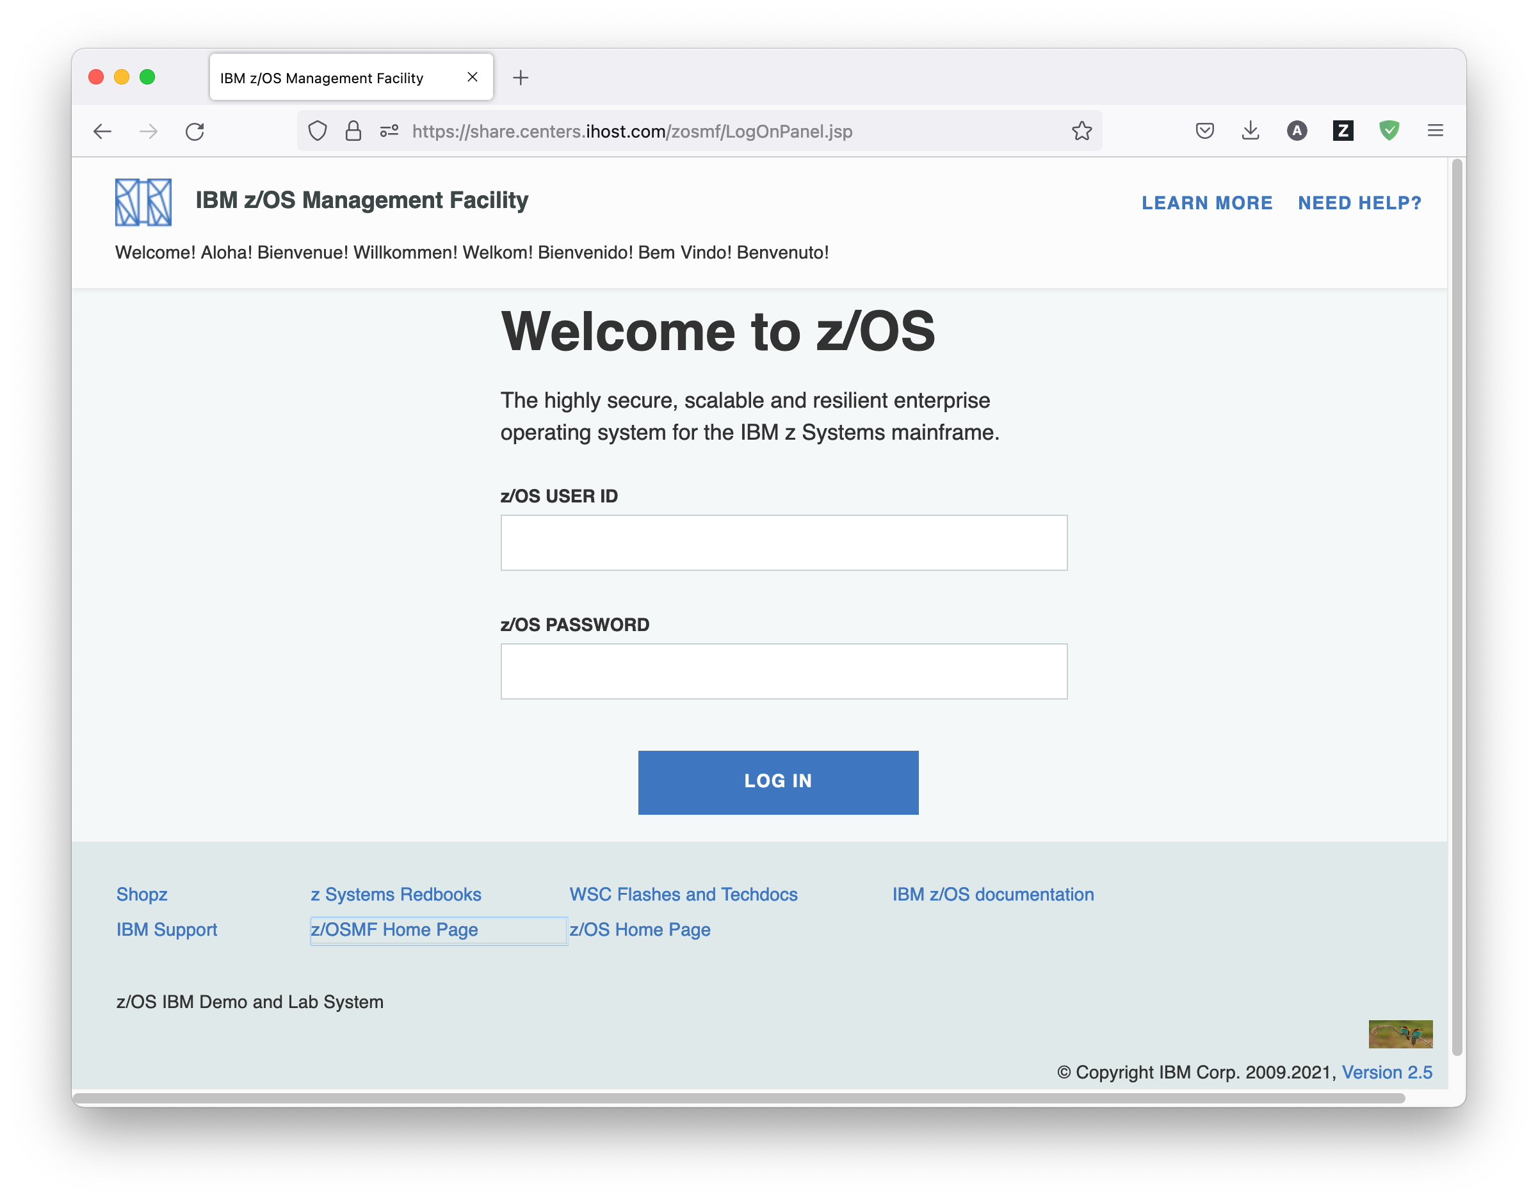

Exercise:

* Launch the Mozilla Firefox browser
* Connect to z/OSMF: <https://share.centers.ihost.com/zosmf/>
* If the browser asks to add exception for certificate, do so
* You might see the warning message IZUG809W (unsupported web browser). Ignore and close this message
* You might see the warning message IZUG810W (performance degradation through Firebug add-on). Ignore and close this message
* Login with your SHARE userid/pw
* Now view zOSMF Desktop pane and examine the various apps with the available tasks

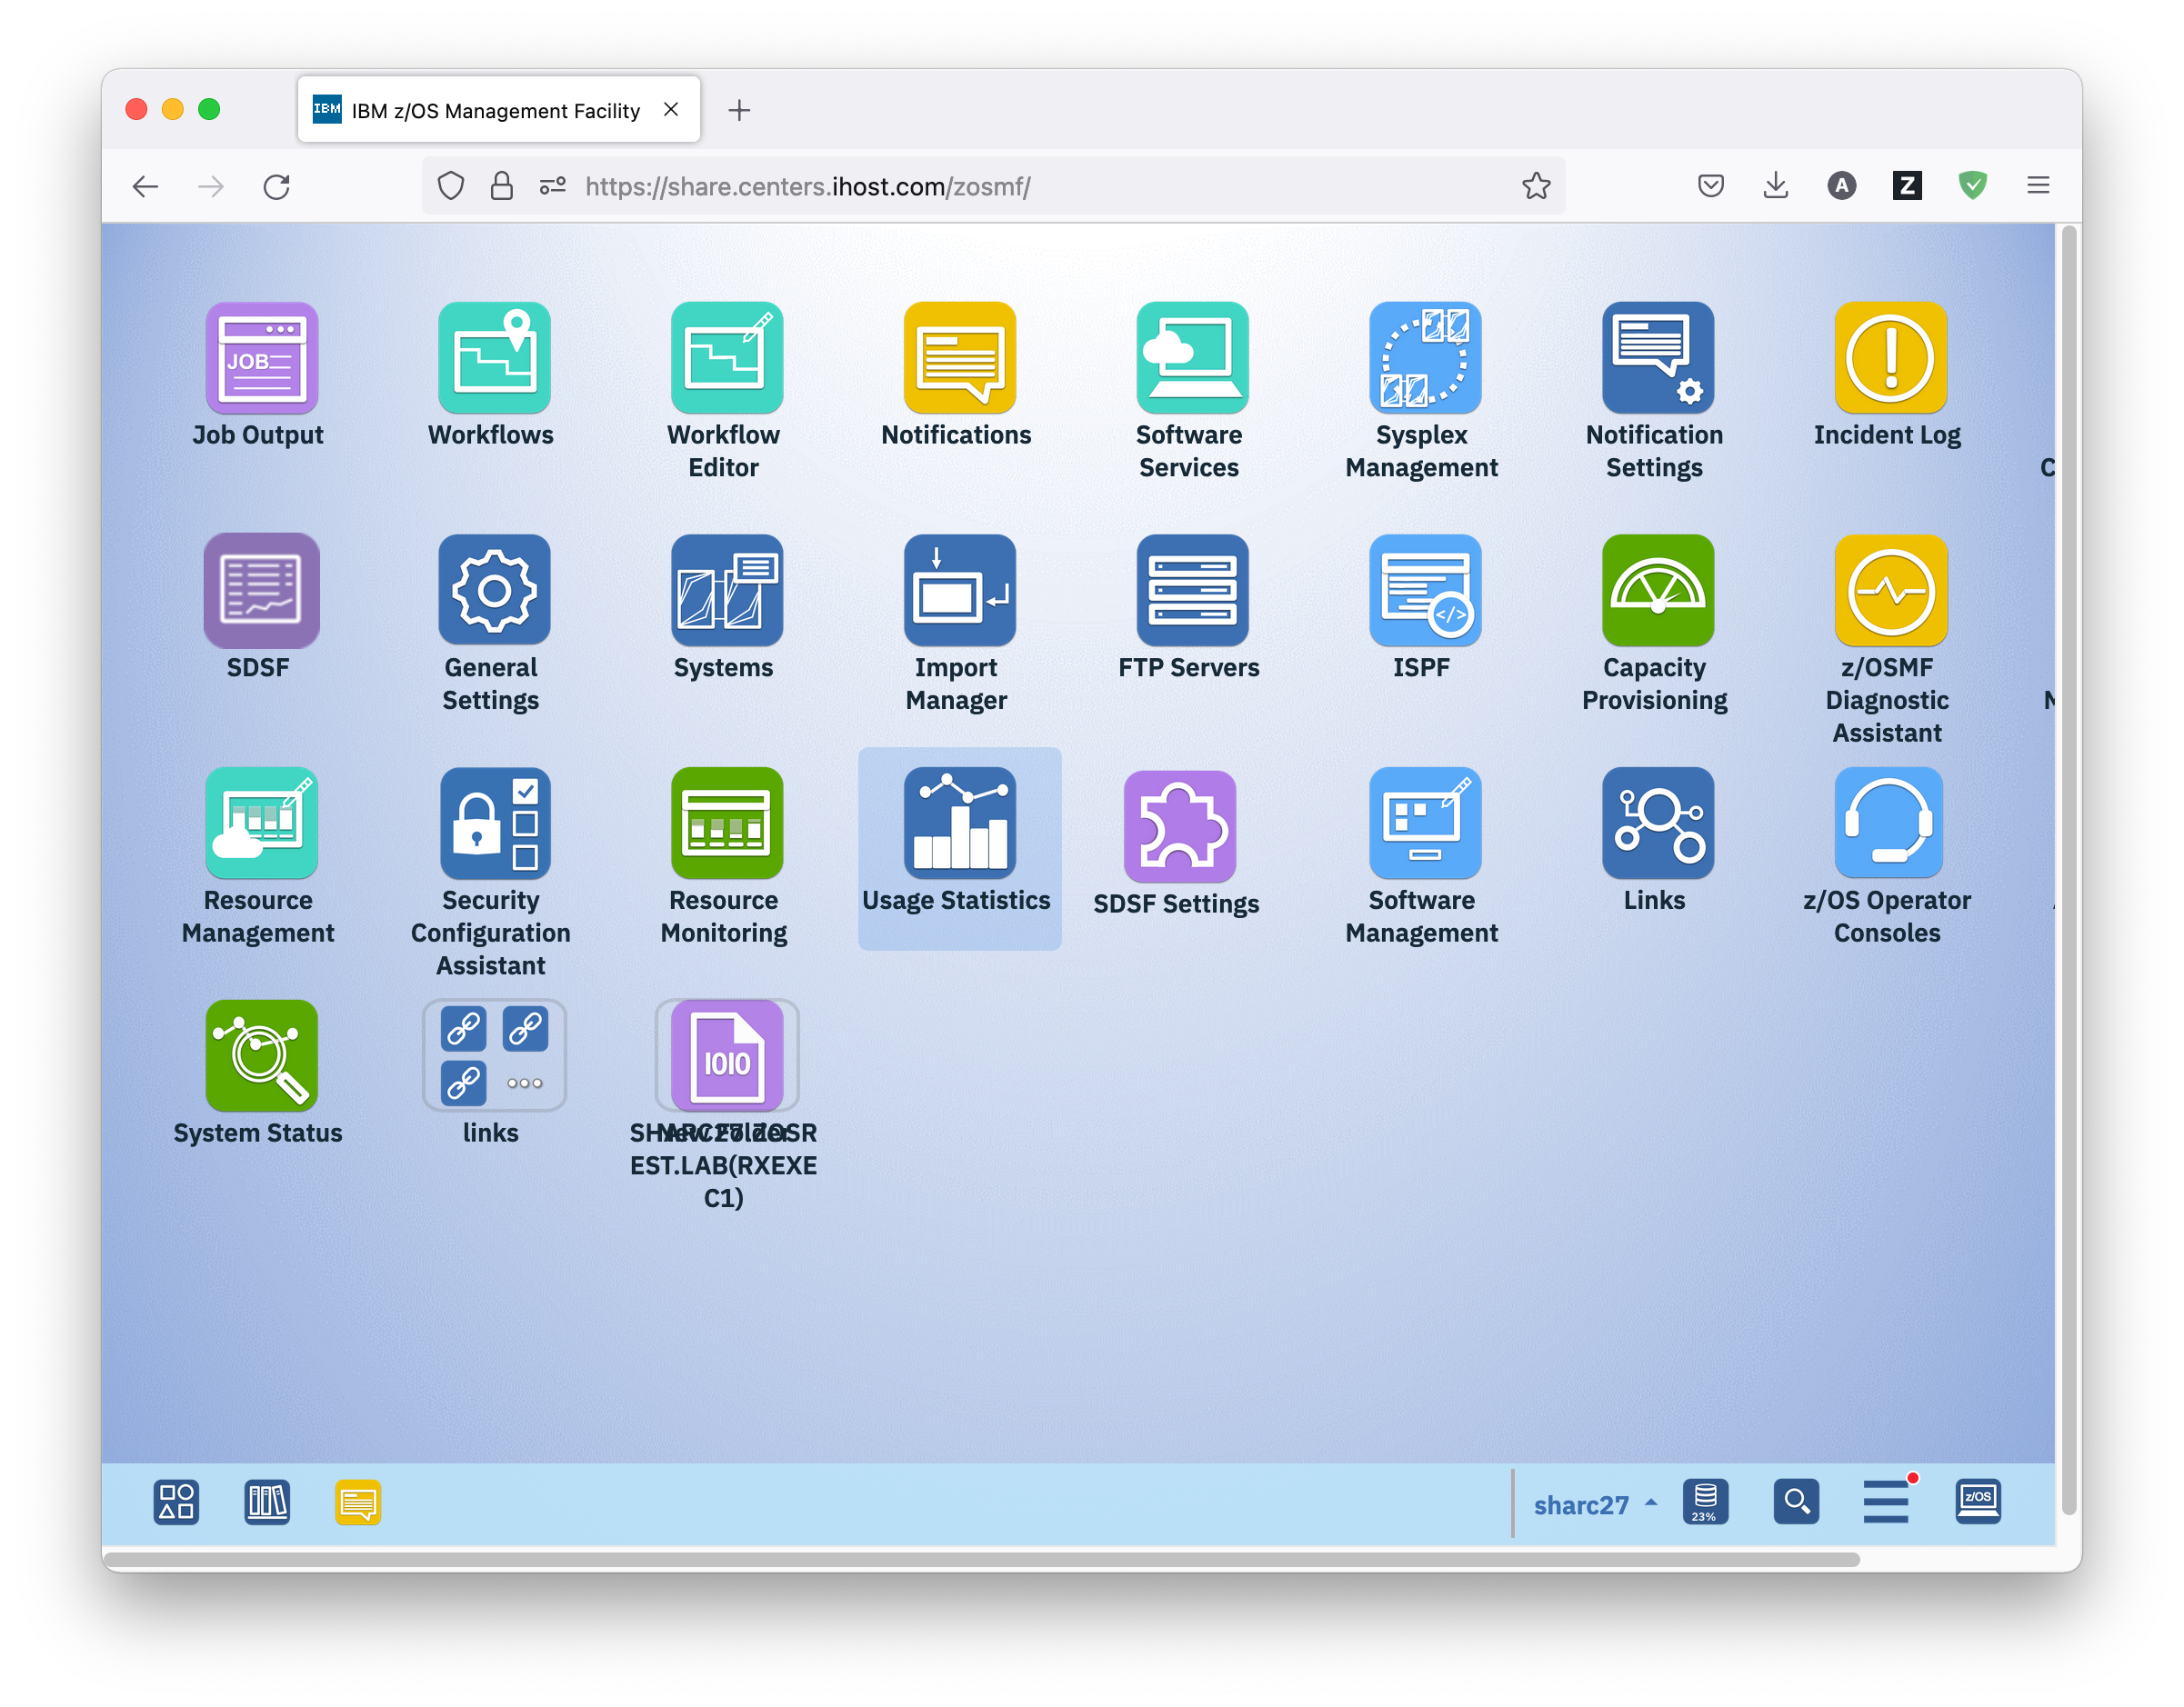

* 1. Start the Workload Management Task

The Workload Management icon is located at the main Desktop panel. The first panel that opens is the Workload Management panel displaying the Overview tab which lists the major tasks.

These major tasks are:

* Service Definitions: Allows defining, modifying, viewing, copying, importing, exporting, printing, or installing WLM service definitions.
* Service Policies for Sysplex: Allows activating or printing one of the service policies that is defined in the installed service definition.
* Settings: Allows setting user preferences and customizing general administrative settings for Workload Management.
* View WLM Status: Allows viewing the status of WLM on each system in the Sysplex.

More information about the Workload Management task is available when you click the *Learn more…* hyperlink. A new browser window opens that displays the requested information.

Furthermore, in the top right corner of the Workload Management panel, there is always a *Help* hyperlink, which opens the help window for the currently active tab.

## Exercise:

* Double click on Workload Management icon
* View the Workload Management panel with the Overview tab
* Click on the *Learn more…* hyperlink and review the information about the Workload Management task
* Click top right on the *Help* hyperlink and review the help for the Overview tab.

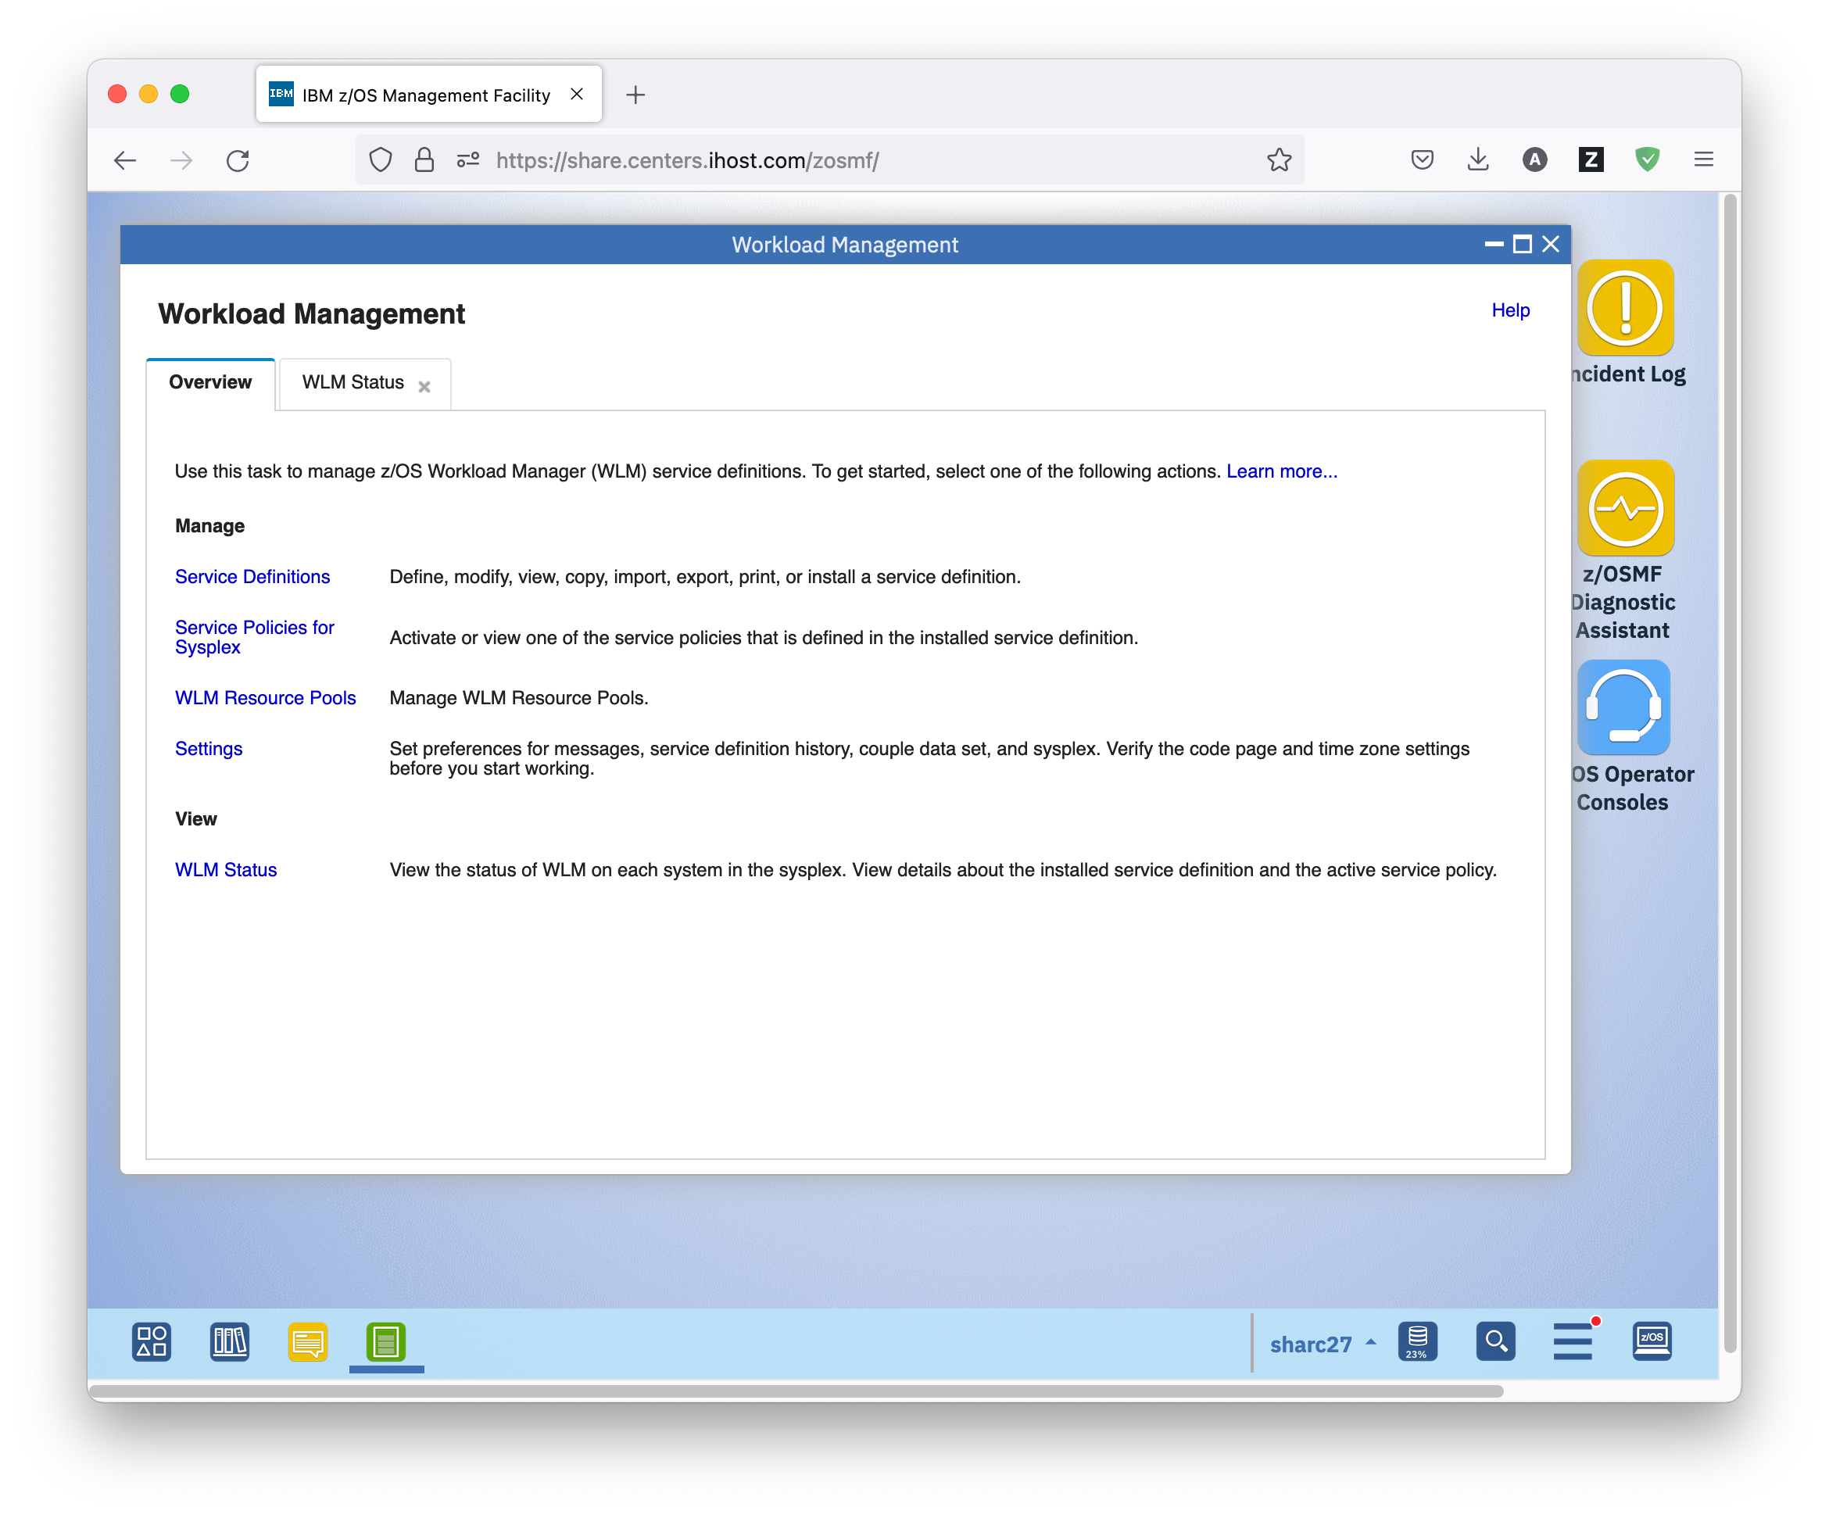

* 1. View Service Definitions

The Manage Service Definitions task allows defining, modifying, viewing, copying, importing, exporting, printing, or installing WLM service definitions. Once you select this task from the Overview tab, the Service Definitions tab is opened and shows you all service definitions in the Service Definition Repository integrated in z/OSMF.

A service definition is a definition of the workloads and classification rules in an installation. It contains all information needed for Workload Management processing.

The Service Definition Repository refers to a directory in the z/OSMF data file system in which the data for the Workload Management task is stored. The service definitions that have been defined in z/OSMF are stored in this repository, and displayed in the Service Definitions tab. There can be multiple service definitions for a sysplex; however, only one service definition can be installed and active in the WLM couple data set for the sysplex.

The repository synchronizes automatically with the WLM couple data set: When the Service Definitions panel is launched or refreshed, z/OSMF checks if the service definition currently installed in the WLM couple data set is contained in the Service Definition Repository. If it is not contained, z/OSMF extracts the service definition automatically, displays it in the Service Definitions table, and marks it with the label „Installed“. Furthermore, the service definition that is currently used by z/OS WLM to manage the sysplex is marked with the label „Active“.

## Exercise:

* On the Overview tab of the Workload Management task, click on the *Service Definitions* hyperlink
* View the service definitions present in the Service Definition Repository

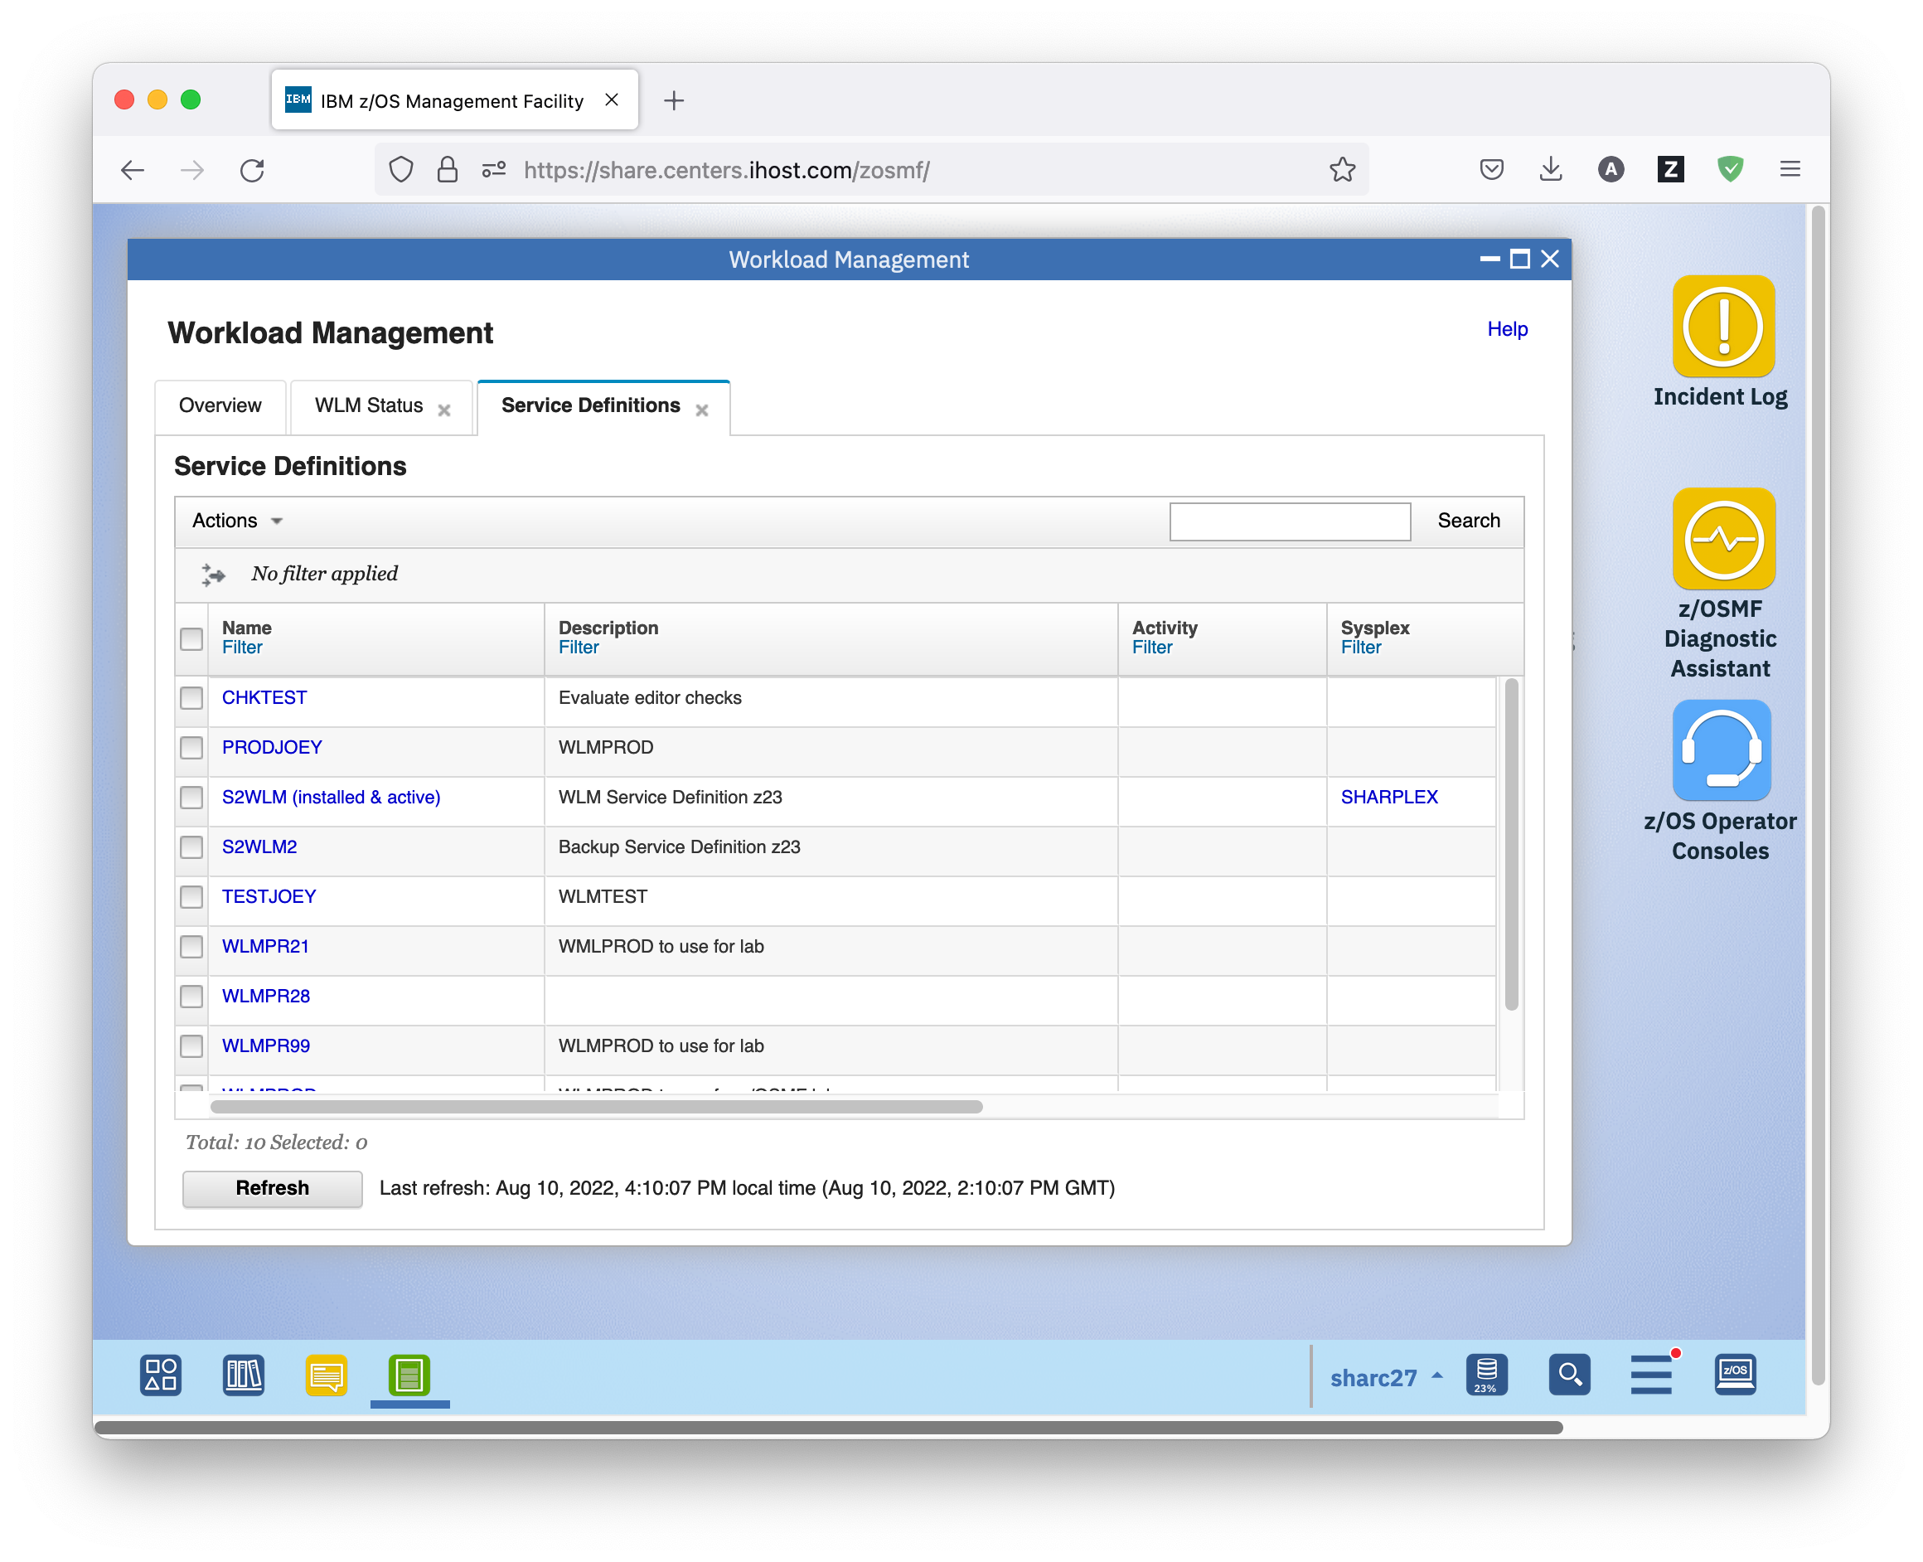

* 1. Working with z/OSMF Tables

The z/OSMF Workload Management task displays service definitions and their sections in tables. All these tables are structured similarly. There are buttons for selecting, and deselecting all elements of the table. The Actions menu consists of three sections:

* Targeted actions are actions that apply to the selected items. To use a targeted action, you must select one or more items in the table. Targeted actions are specific for the current table, here, for example, they specifically apply to service definitions.
* General actions are actions that apply to the current table, here, for example, to service definitions. No selection is required.
* Table actions are actions that apply to the entire table such as sorting and filtering. No selection is required. These actions are the same for all tables in z/OSMF Workload Management.

So let’s first concentrate on the table actions.

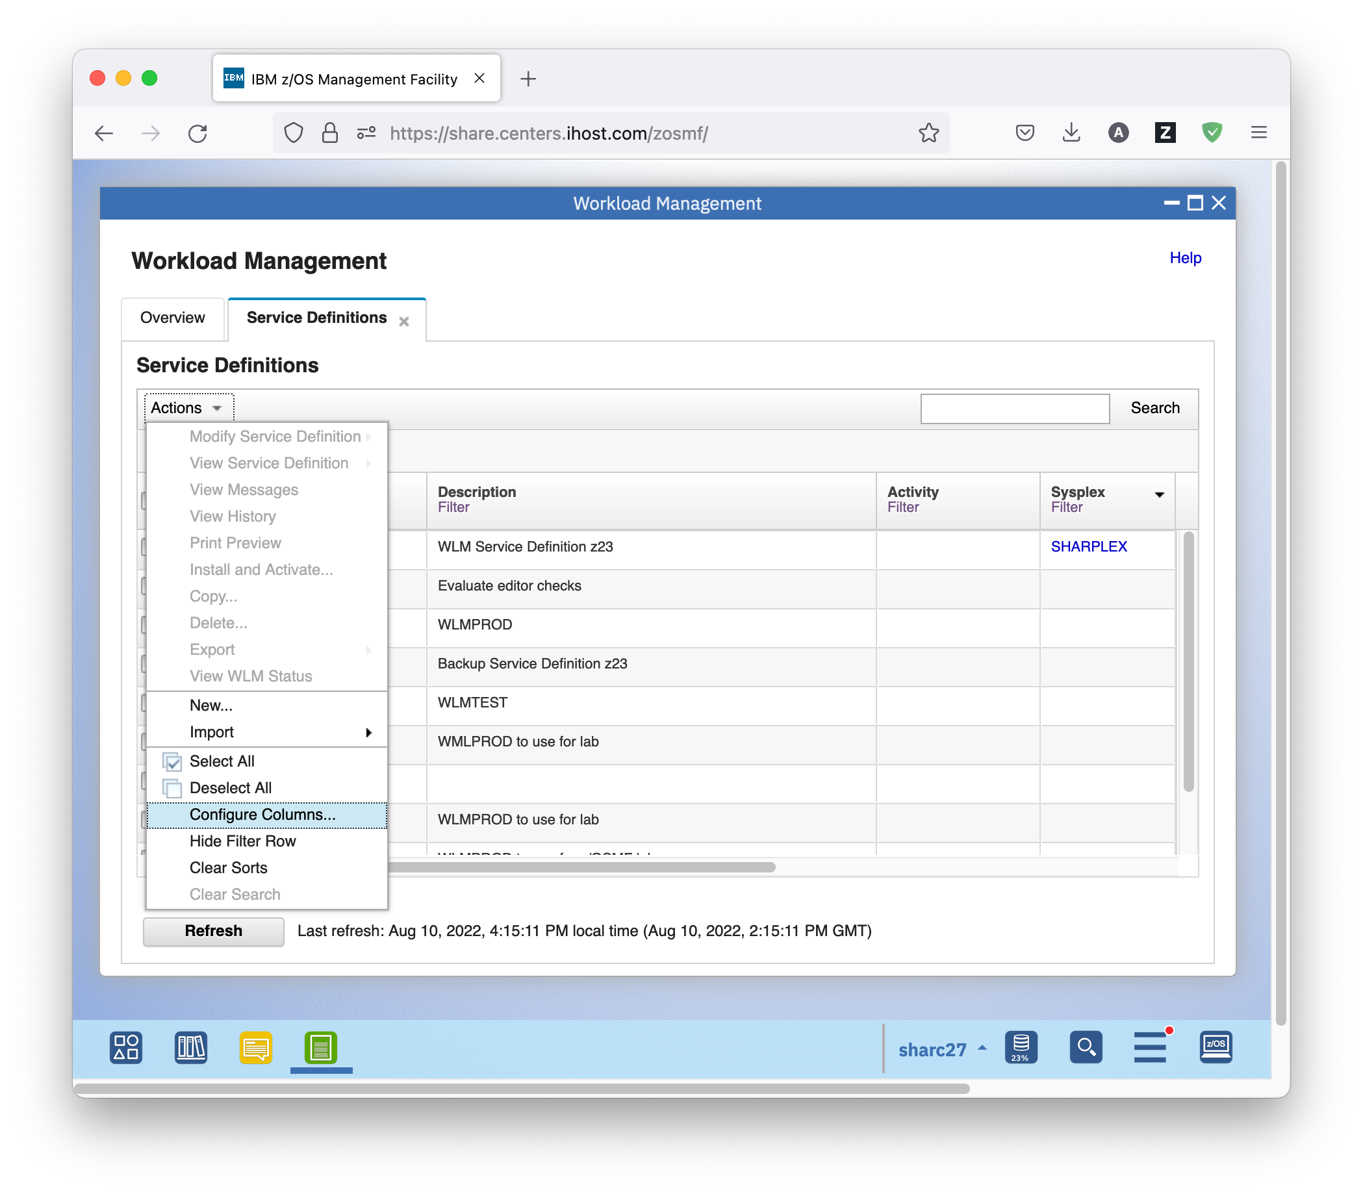

## Exercise:

* On the Service Definitions tab of the Workload Management task, click on *Actions* – *Select All*. As result, all service definitions in the table are selected. You can also click the button on the left.
* Click on *Actions* – *Deselect All* to deselect all of the selected rows in the table. You can also click the button on the left.
* Click on *Actions* – *Configure Columns* to select which columns to display in the table, to specify the order of those columns, and to designate which columns should be fixed in position when the table is scrolled horizontally. Use the *Restore Defaults* button on the *Configure Columns* window to switch back to the default setup.
* Click on the 3 arrow icon (**) under *Actions to* build or remove filter criteria for each column in a table. You can also click on the *Filter* hyperlink in each column heading of the table to access the Modify Filters window.
* Click on *Actions – Hide Filter Row* to remove the filter row from view. This action is listed only when the filter row is displayed in the table.
* Click on *Actions – Show Filter Row* to display the filter row. This action is listed only when the filter row is not displayed in the table.
* Click on the *Clear Filters* link, next to the arrow icon to clear all of the filters specified in the table.
* Click on the column heading to sort the table ascending based on the values in the column. A second click sorts the table descending based on the values in the column, a third click removes the sort criterion.
* Click on *Actions – Clear Sorts* to clear the sort from all of the columns in the table.
* To locate items of interest, use the search box displayed top right in the table toolbar. If a search box is not provided, you cannot search the table. Searching a table highlights the content that matches the search string. The search does not reduce the number of items displayed in the table, so you might need to scroll to locate the matches.
* Click on *Actions – Clear Search* to clear the search results.
* Of course, you can also modify the size of the columns to fit the size or your browser window. All these settings are persistent between sessions.
  1. Import Service Definitions from Files

Service definitions can be imported into the Service Definition Repository either from the local workstation or from a host data set.

The format for import and export is XML. This is helpful for migrating service definitions from the WLM ISPF Administrative Application.

## Exercise

* On the Service Definitions tab of the Workload Management task, click on *Actions* – *Import – From Local Workstation*.

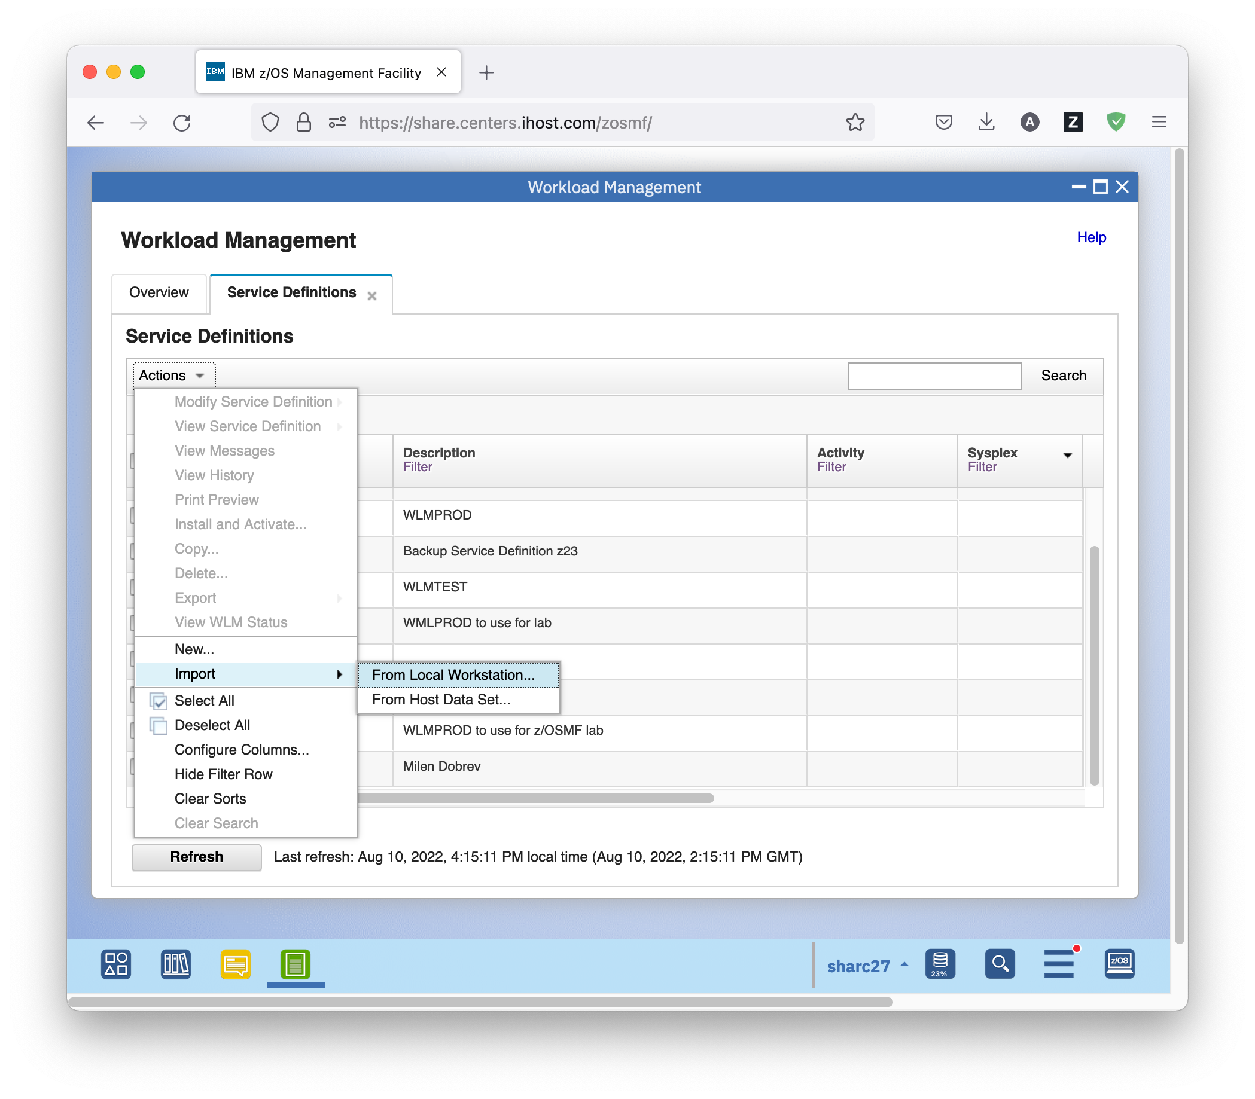

* In the dialog that opens, use the *Browse* button to select a service definition XML file on the local workstation. This file could either result from a previous export from z/OSMF WLM, or from the IBM Service Definitions Editor. For the purpose of the lab, such a file has been provided for you.   
  Choose service definition ServiceDef_WLMPROD.xml from folder zOSMF_WLM on your local workstation’s desktop. To avoid conflicts with other lab participants, select the *Save with new name and description* radio button, and provide WLMPRnn as unique name, where nn is the unique number (01 – 20) you got assigned for this lab. You also need to provide a comment. Click the OK button to import the service definition.

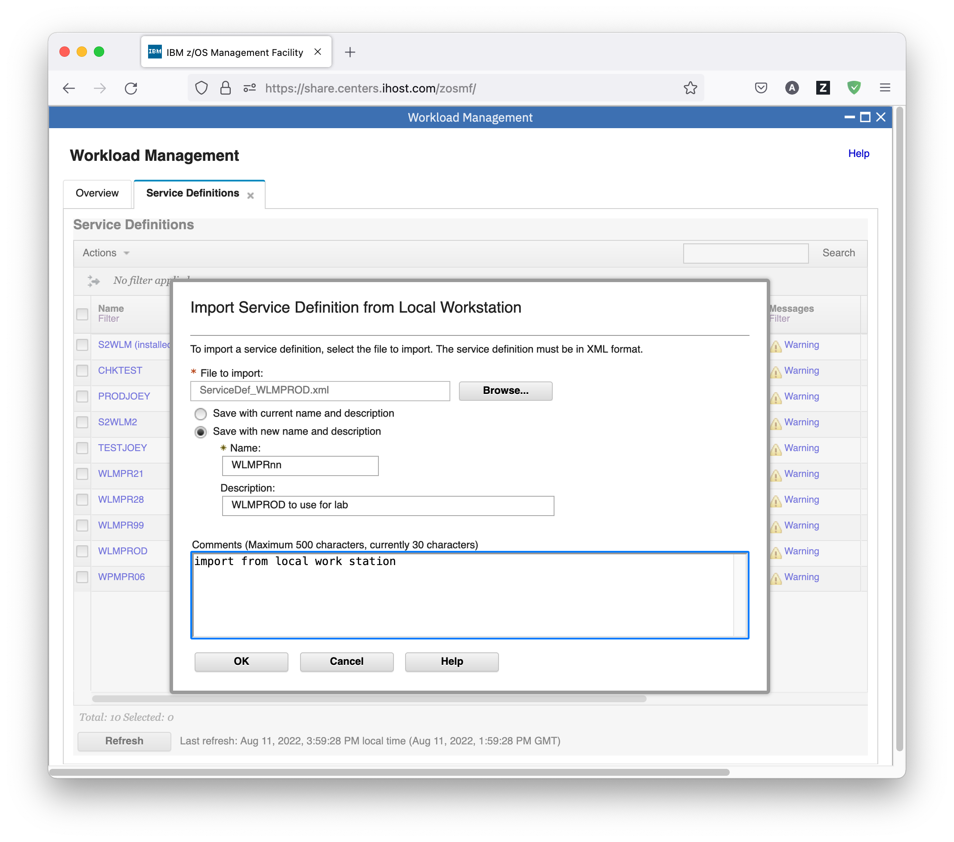

* You can ignore the messageIZUW143W As of z/OS V2R5, service coefficients are pre-set to CPU=1, IOC=0, MSO=0, and SRB=1. They cannot be specified or changed in the WLM service definition.
* The newly imported service definition then shows up in the Service Definitions table.
* 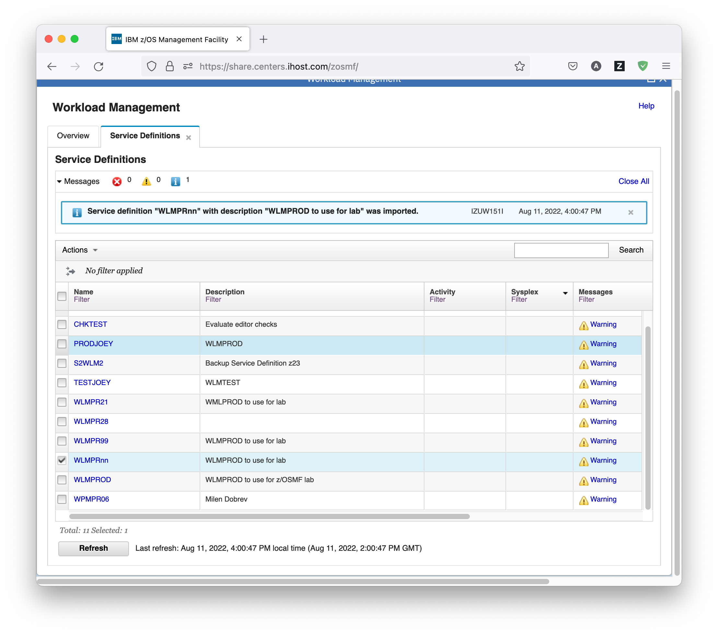Service definitions can also be imported into the Service Definition Repository from a host data set. This is helpful for migrating service definitions from the WLM ISPF Administrative Application.   
  Not part of the Lab: For example, if you have saved a service definition in ISPF table format in a host data set, you can open it with the WLM ISPF Administrative Application, and save it in XML format to a sequential data set, like we have done here for the Lab:

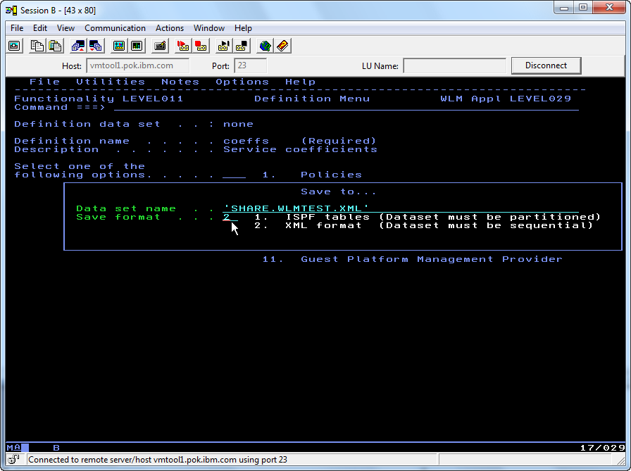

* This host data set can then be imported into the Service Definition Repository. To do so, on the Service Definitions tab of the Workload Management task, click on *Actions* – *Import – From Host Data Set*.

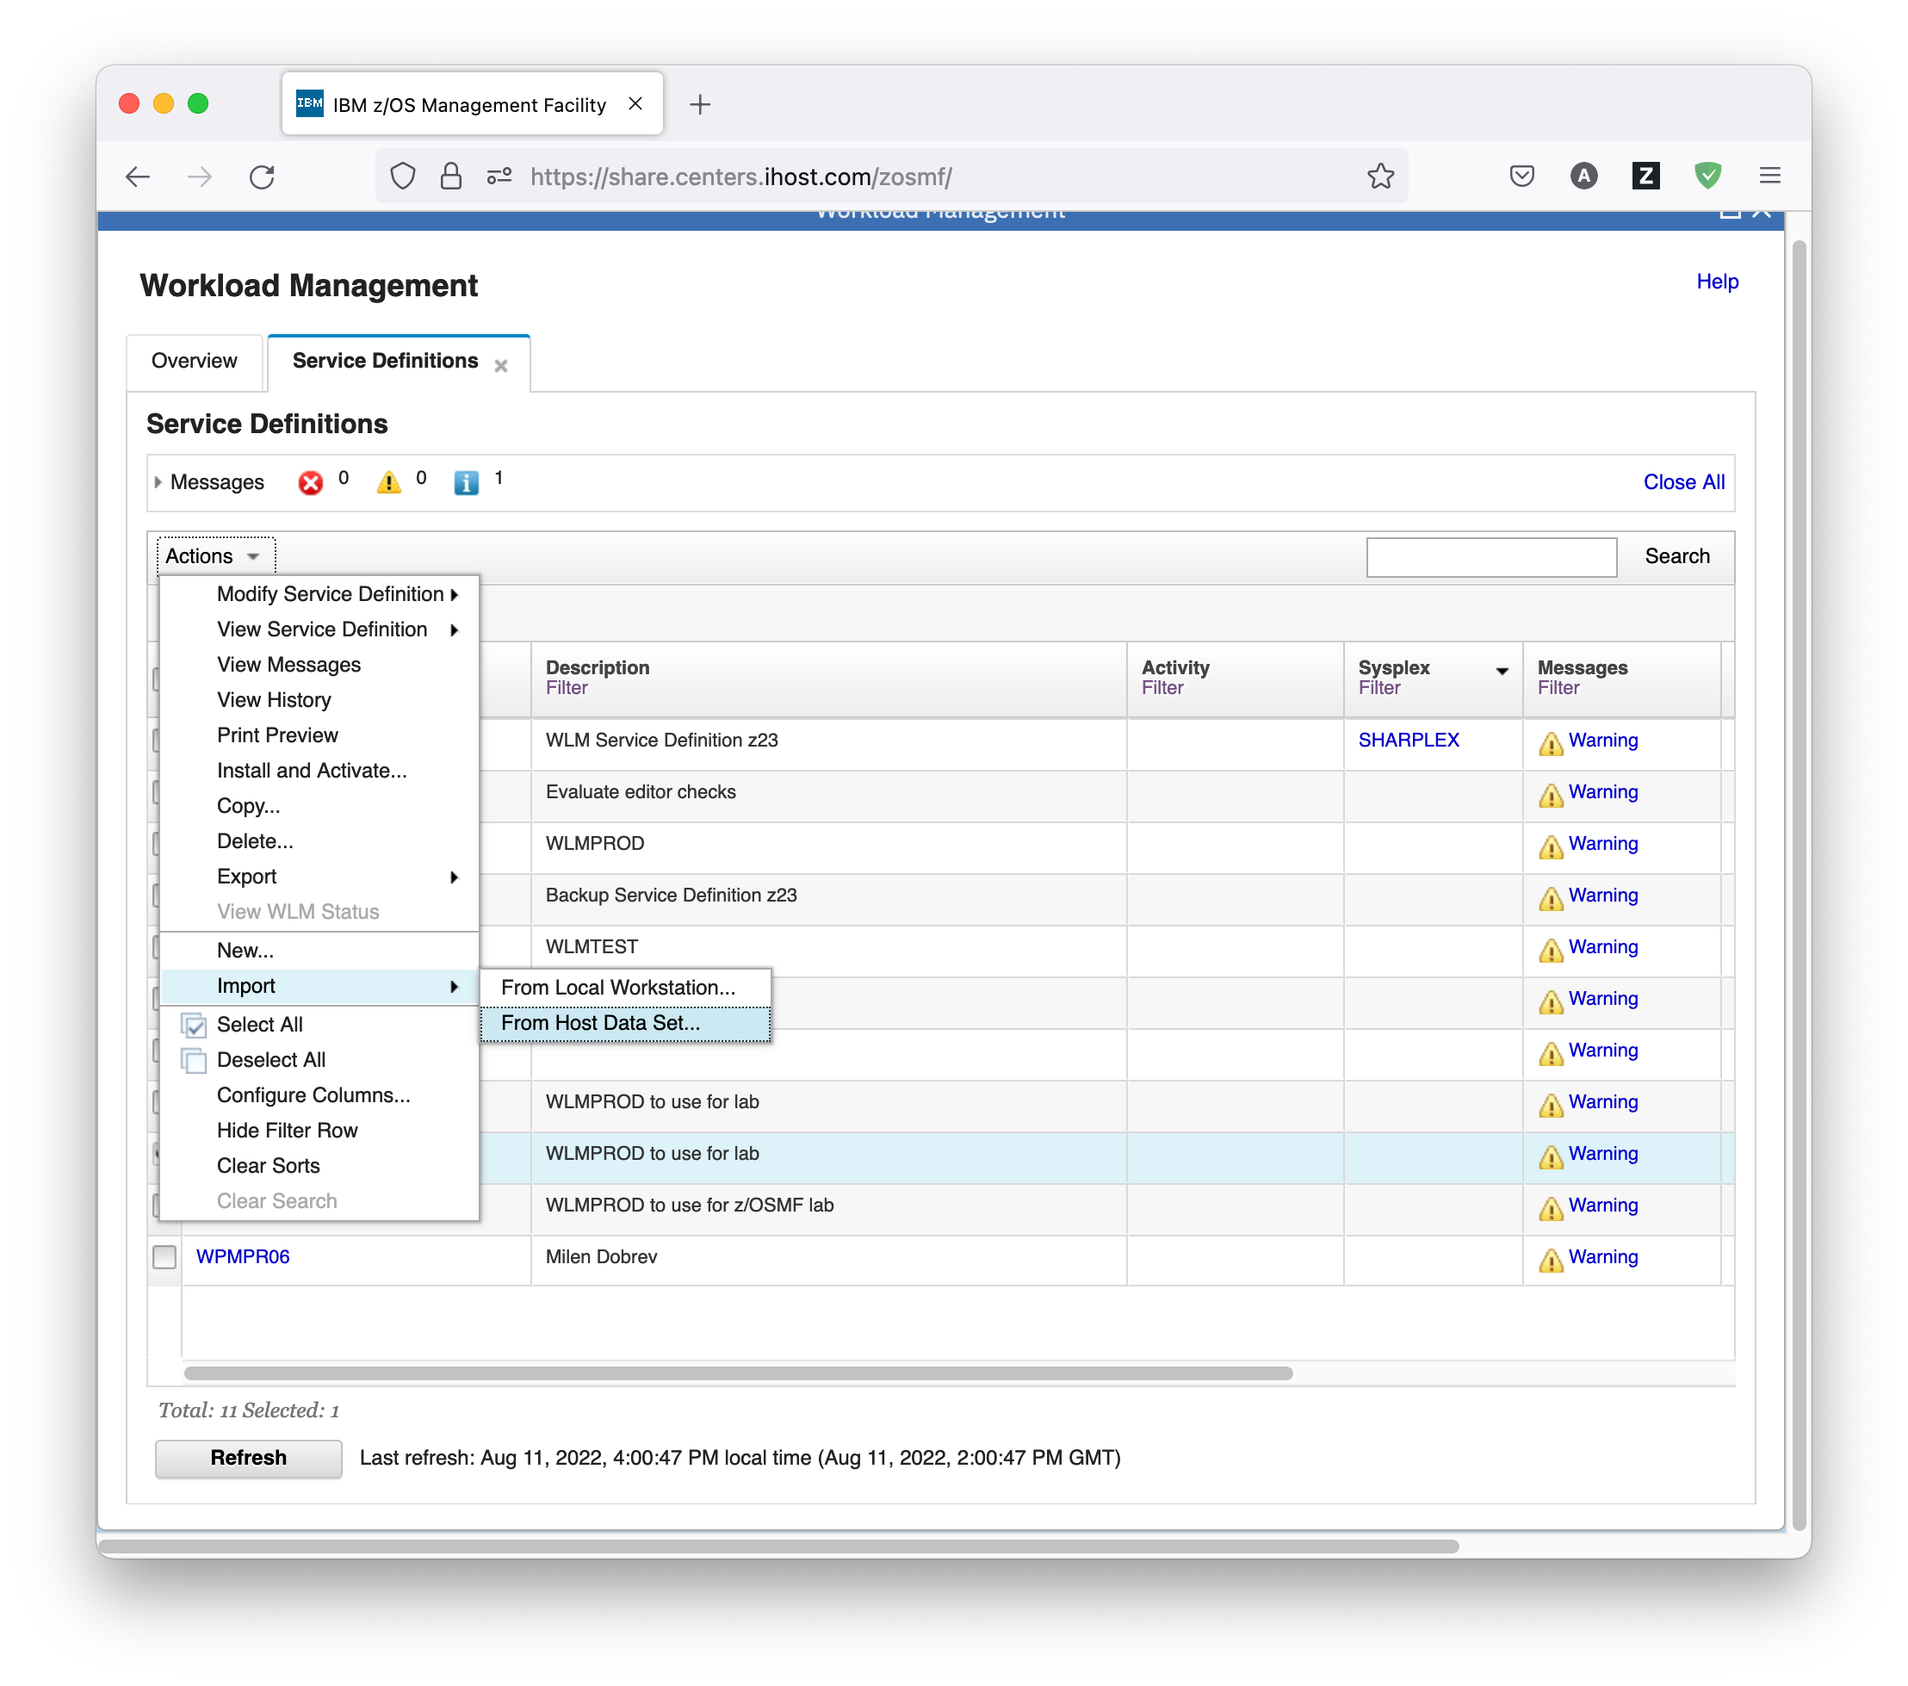

* In the dialog that opens, type in the data set name you used to save the service definition. For the purpose of the lab, such a file is already provided for you in data set SHARE.WLMTEST.XML. To avoid conflicts with other lab participants, select the *Save with new name and description* radio button, and provide WLMTSTnn as unique name, where nn is the unique number (01 – 20) you got assigned for this lab. You also need to provide a comment. Click the OK button to import the service definition.

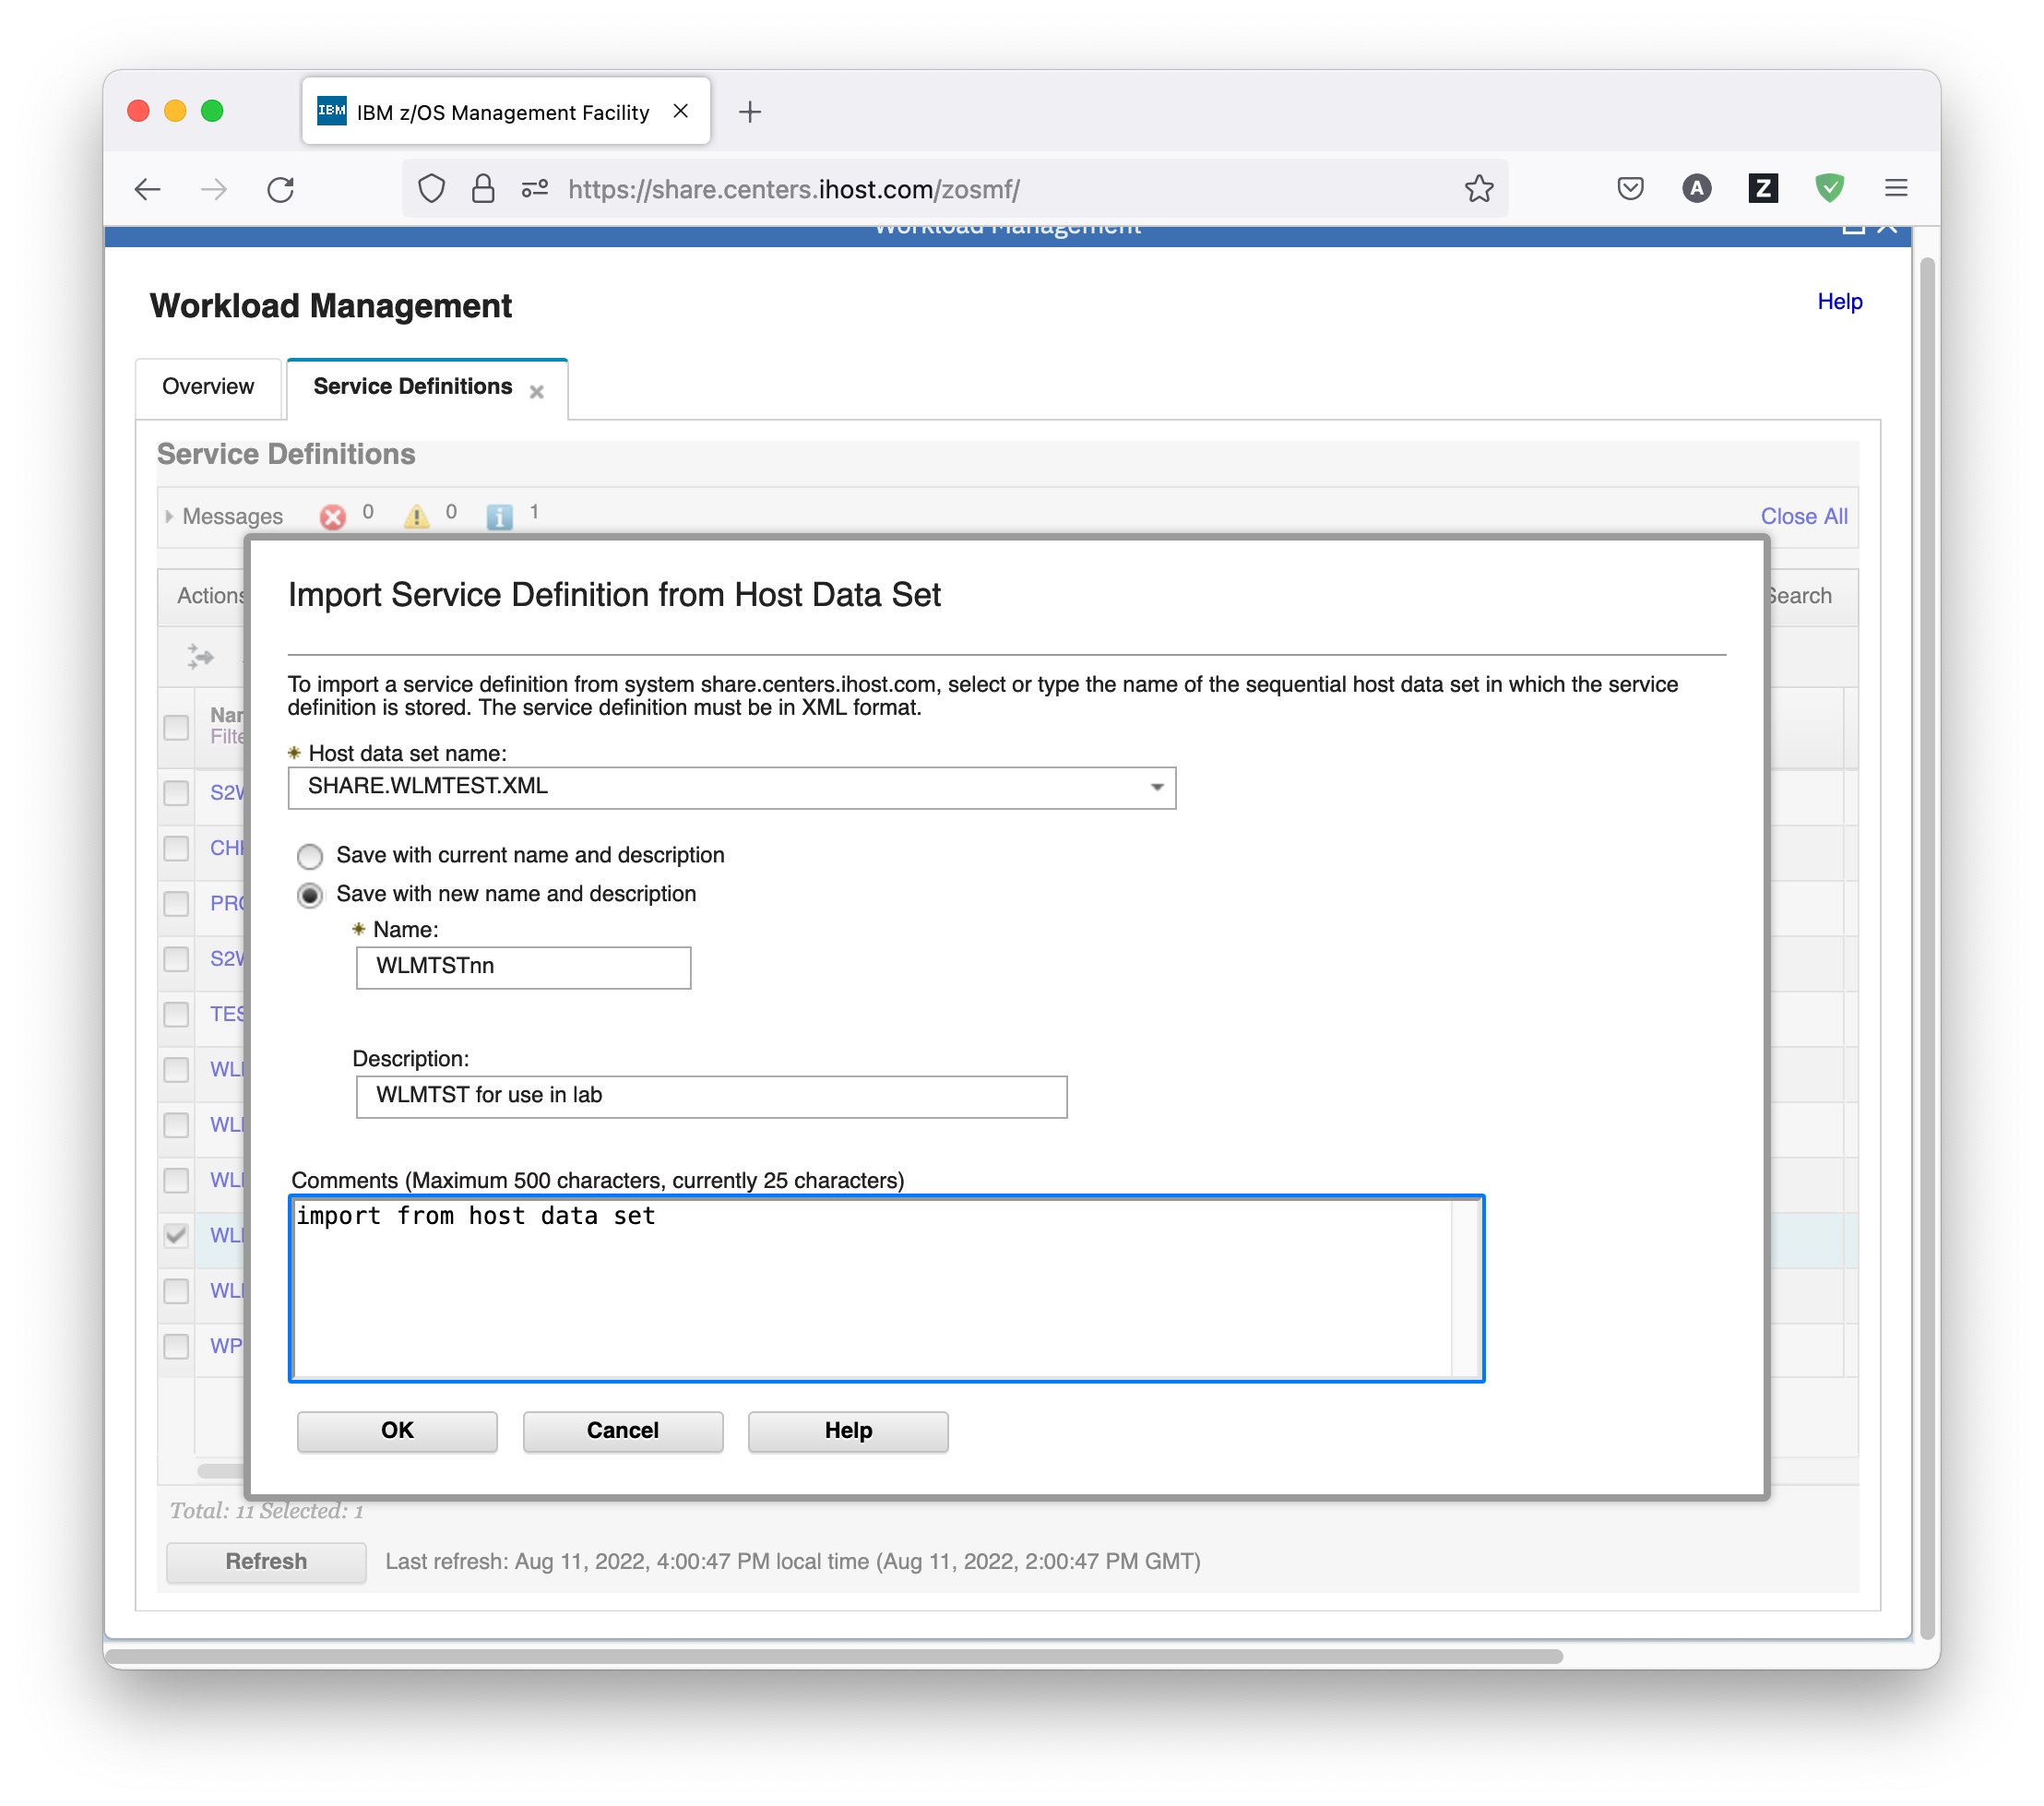

* The newly imported service definition then shows up in the Service Definitions table. Note also the Messages section in top of the Service Definitions table which informs you about the actions you have done. The Messages section can be collapsed or expanded, and you can remove single messages by clicking the *X* on the left hand side, or remove all messages by clicking the *Close All* link. 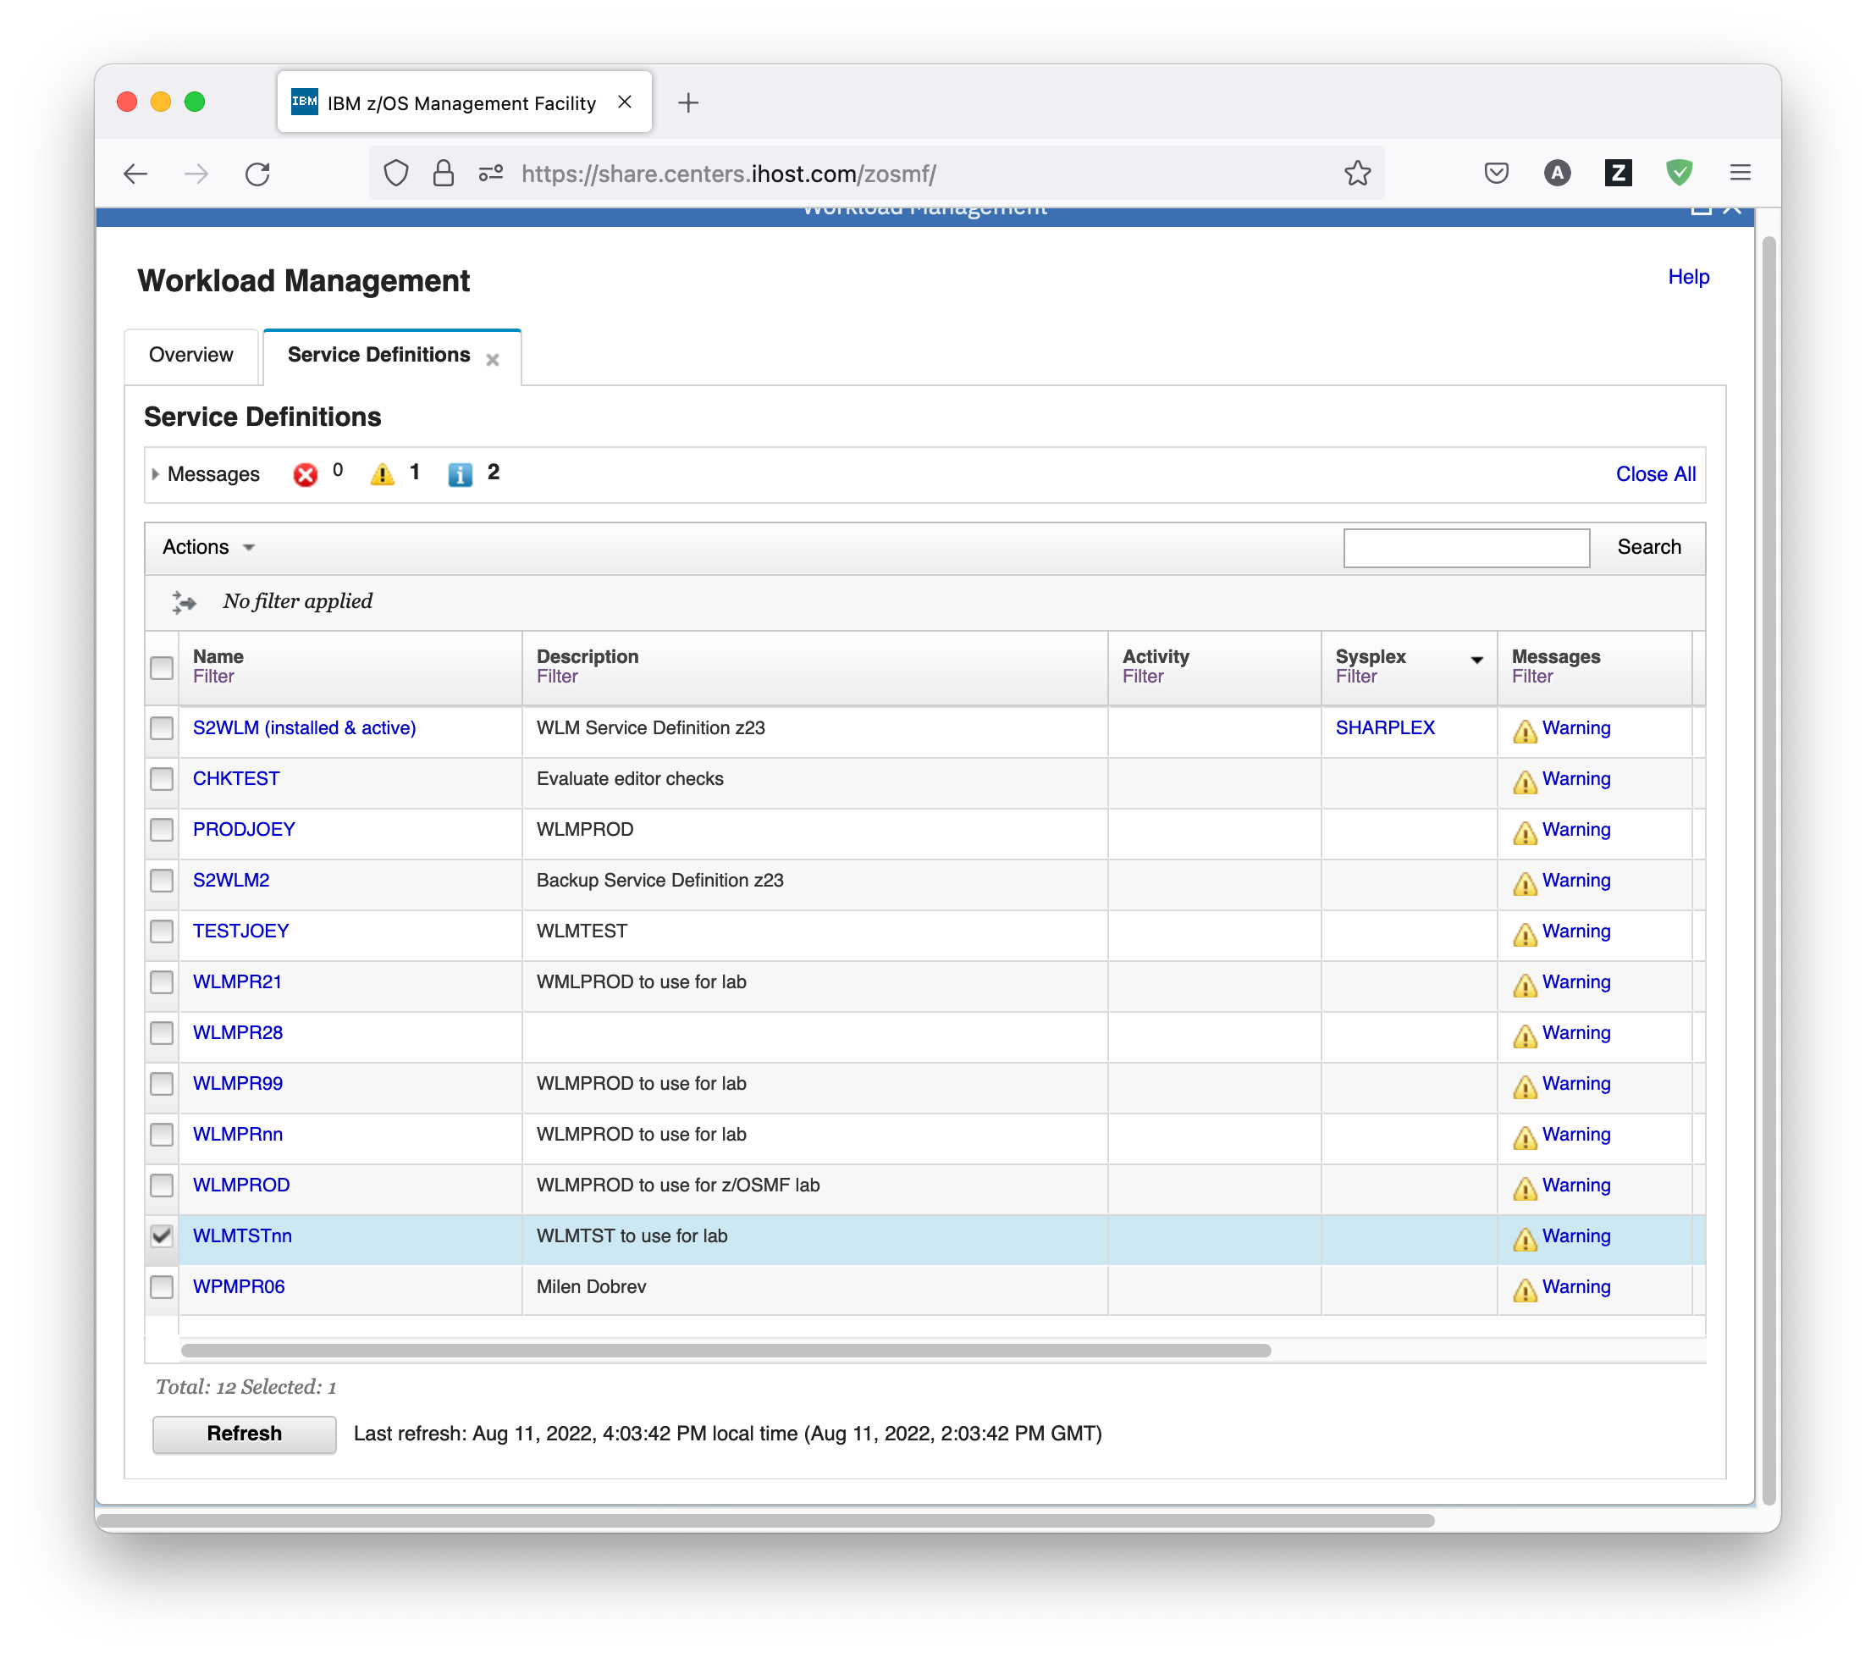
  1. Best Practice Messages for a Service Definition

Creating and editing of WLM service definitions is supported by best practice checks. So let’s have a closer look at them for our service definition.

## Exercise

* Select service definition WLMPRnn and either right-click it, or open the Actions menu, to see the targeted actions that are available for it. Under *View Service Definition*, a submenu lists the sections in the service definition. If messages exist for a section, a status icon is displayed to the left of its label. The status icon can indicate information, warning or error. So there is for example an information message for the *Service Definition Details*.

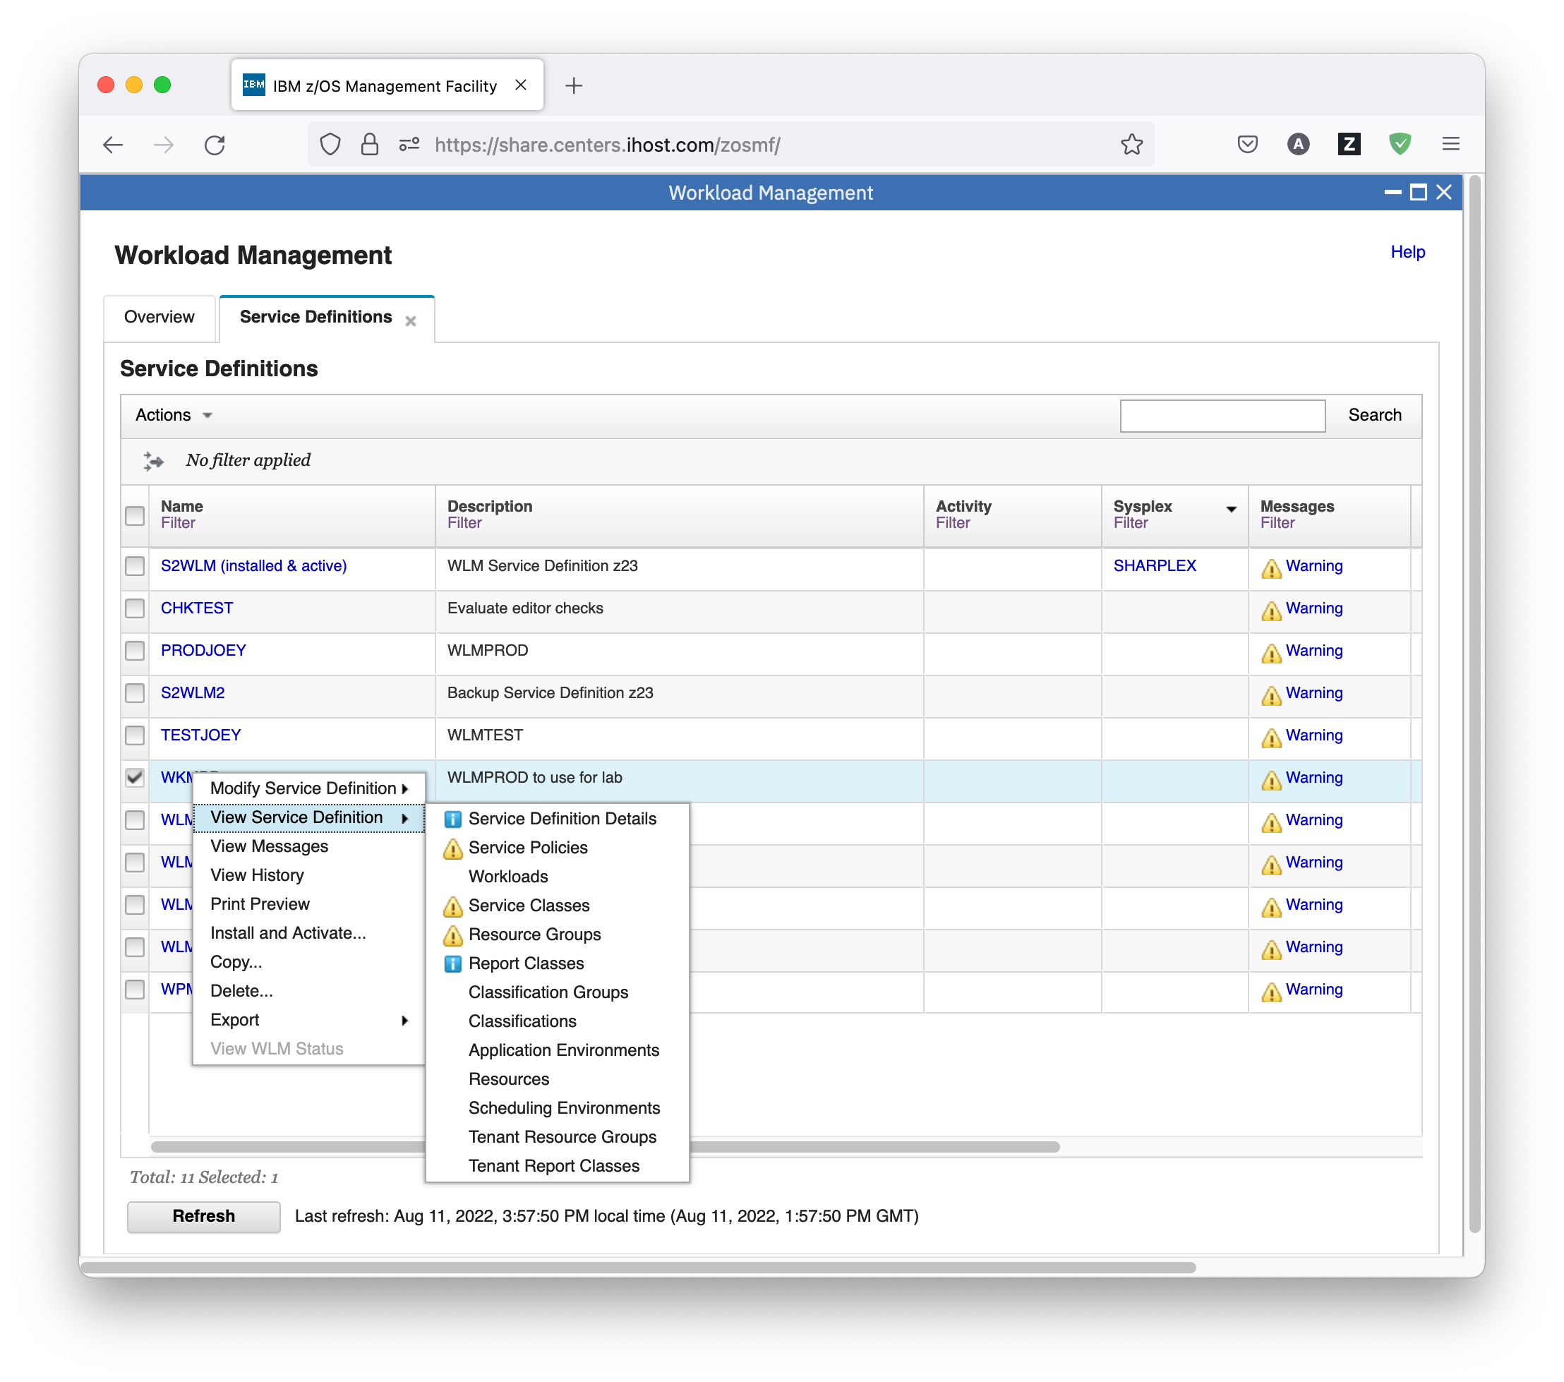

* If you select *Service Definition Details* in the submenu, a new panel opens, and you can see which item requires attention: Service Option Enable dynamic alias management. You can either mouse over the information status icon to view the information message, or control-click on it to get a message window.

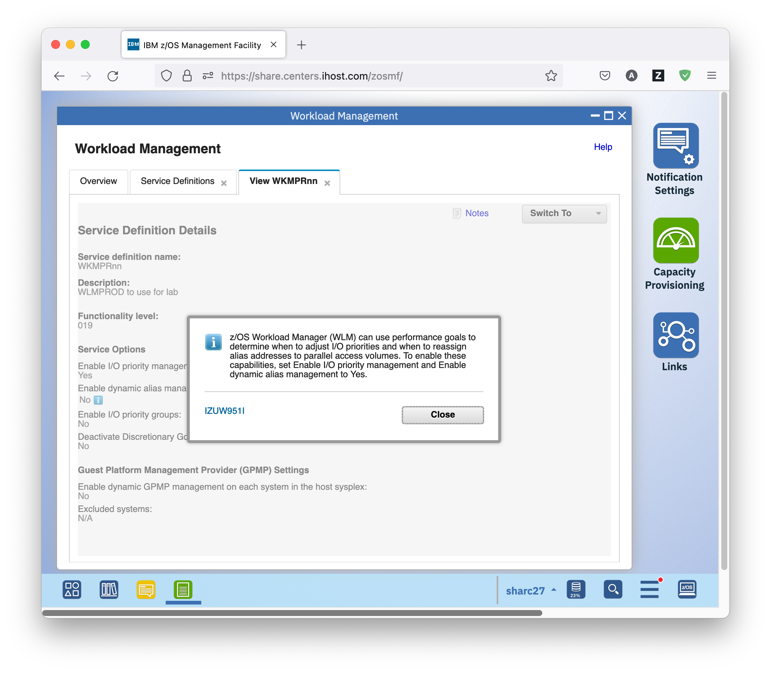

* In this message window, you can click on the message ID to get further help and information on the message.

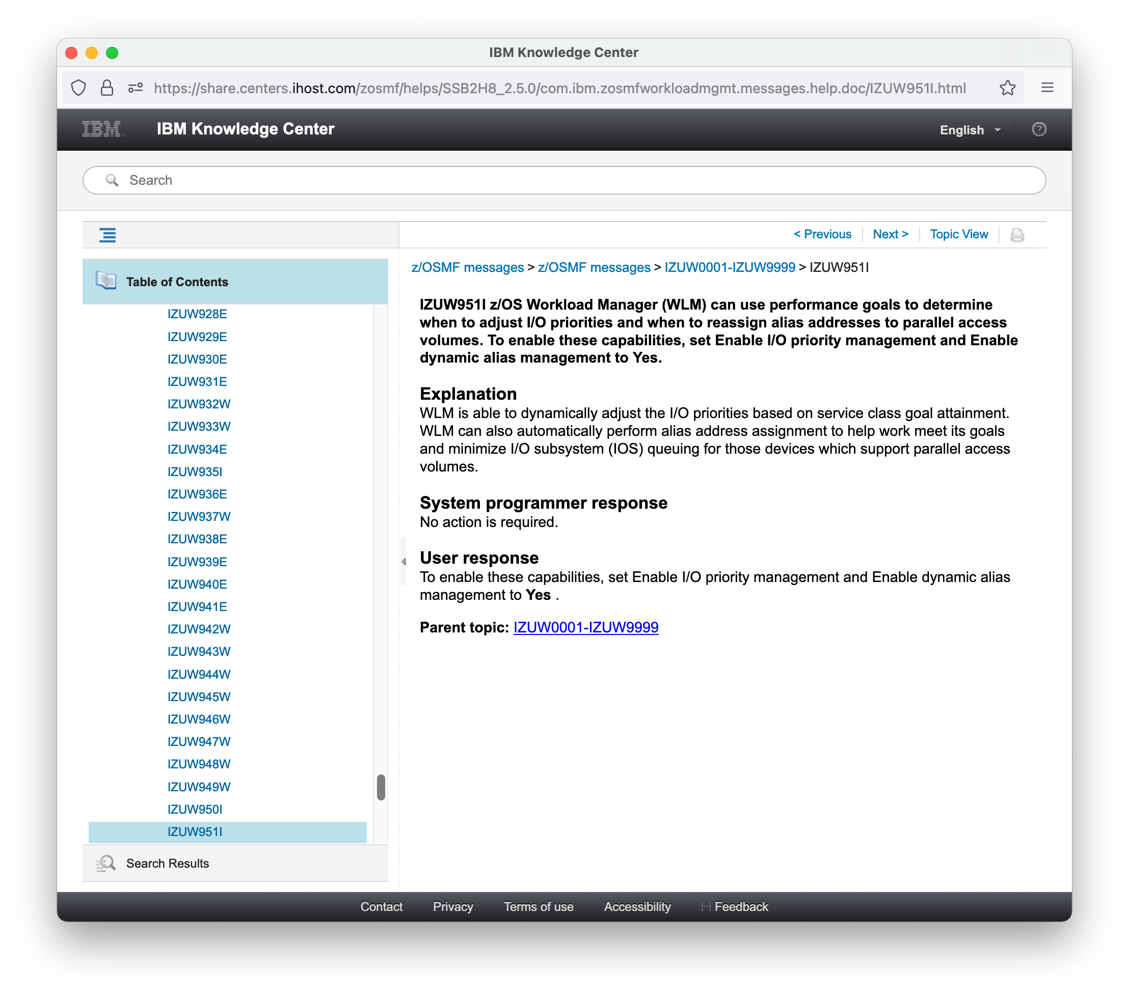

* 1. Removal of Best Practices Warning Messages from a Service Definition

There are more messages for the service definition. We will now check them and try to fix one of the more severe issues.

## Exercise

* On the Service Definitions tab, select service definition WLMPRnn and either right-click it, or open the Actions menu, and choose *View Messages*. Alternatively, you can scroll to the right and click on the *Warning* hyperlink in the Messages column.

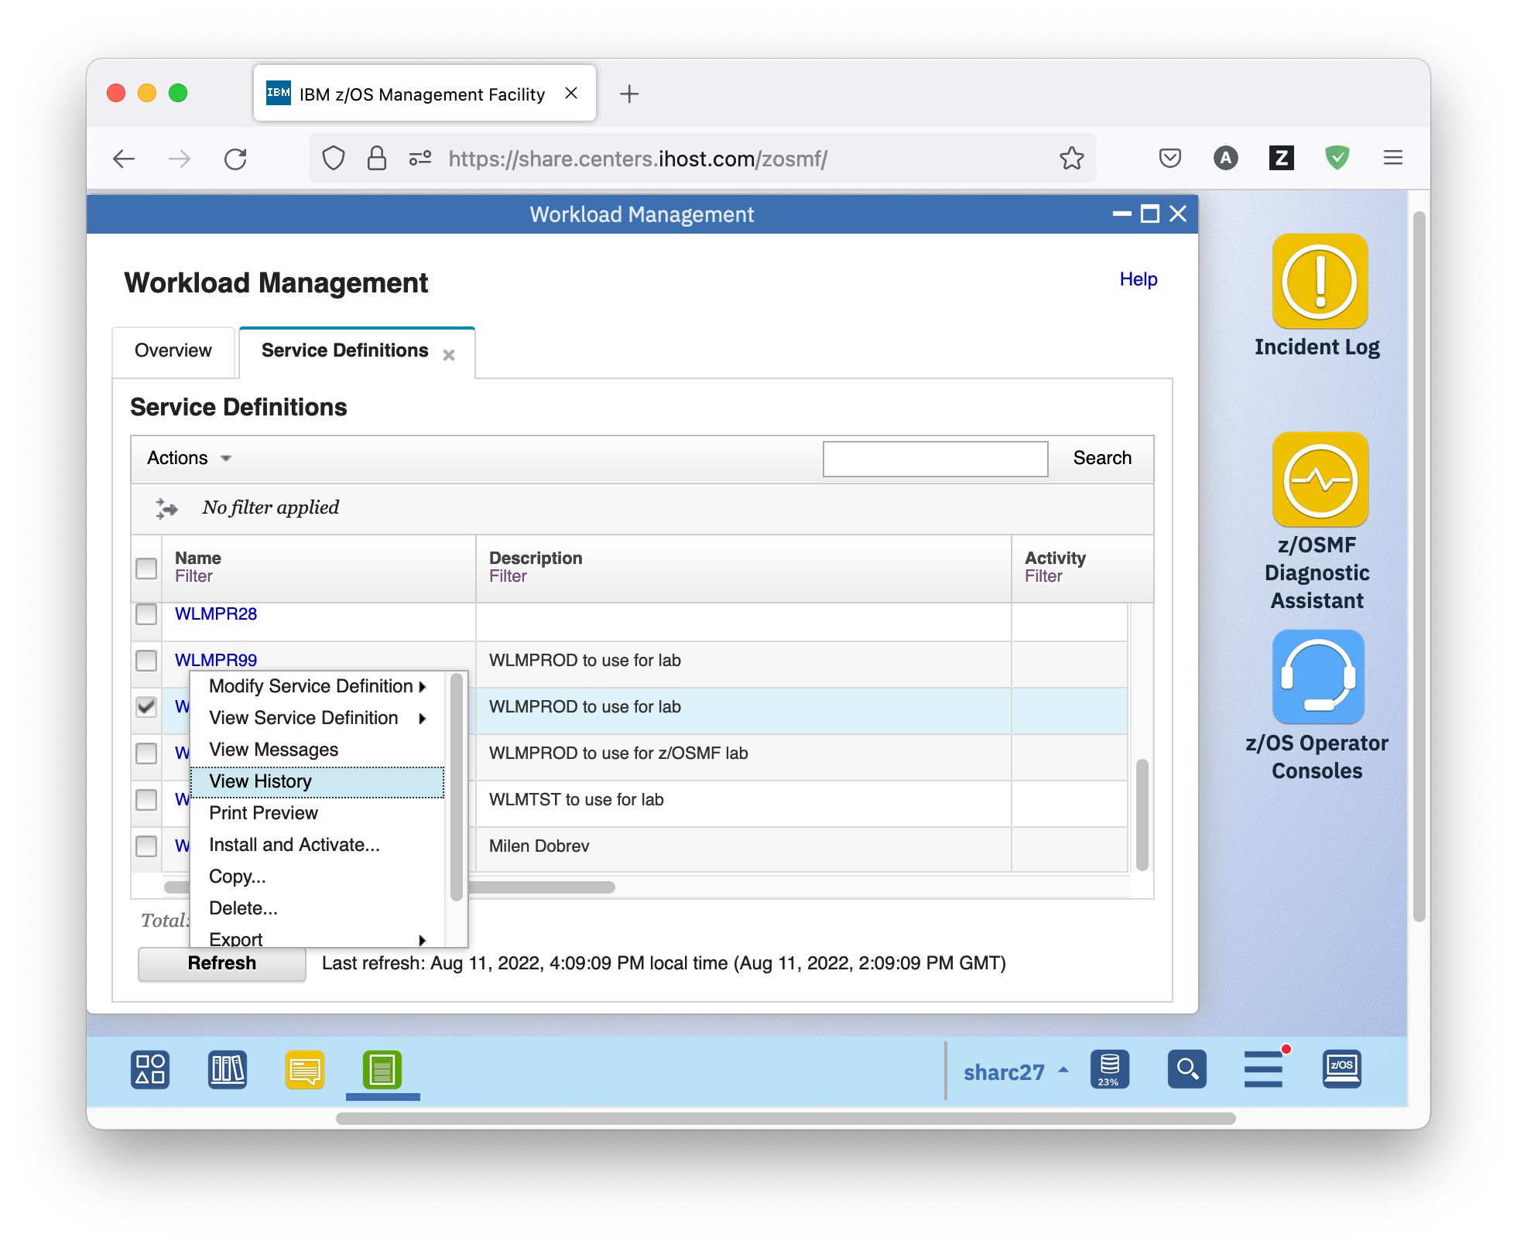

* The View WLMPRnn panel is brought to the front and displays all messages for the service definition. You see that there are quite some of them.

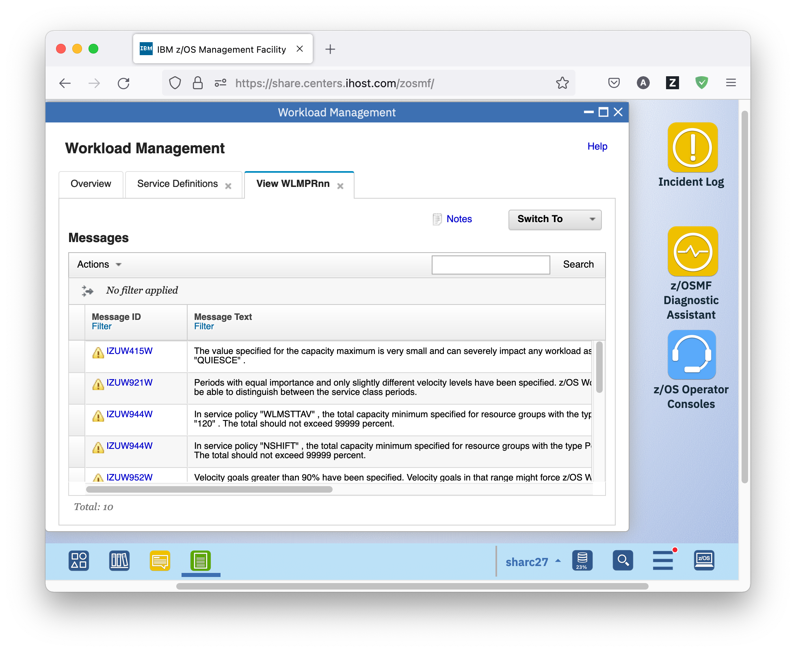

* As before, you can click on the message ID to get further help and information on the message.

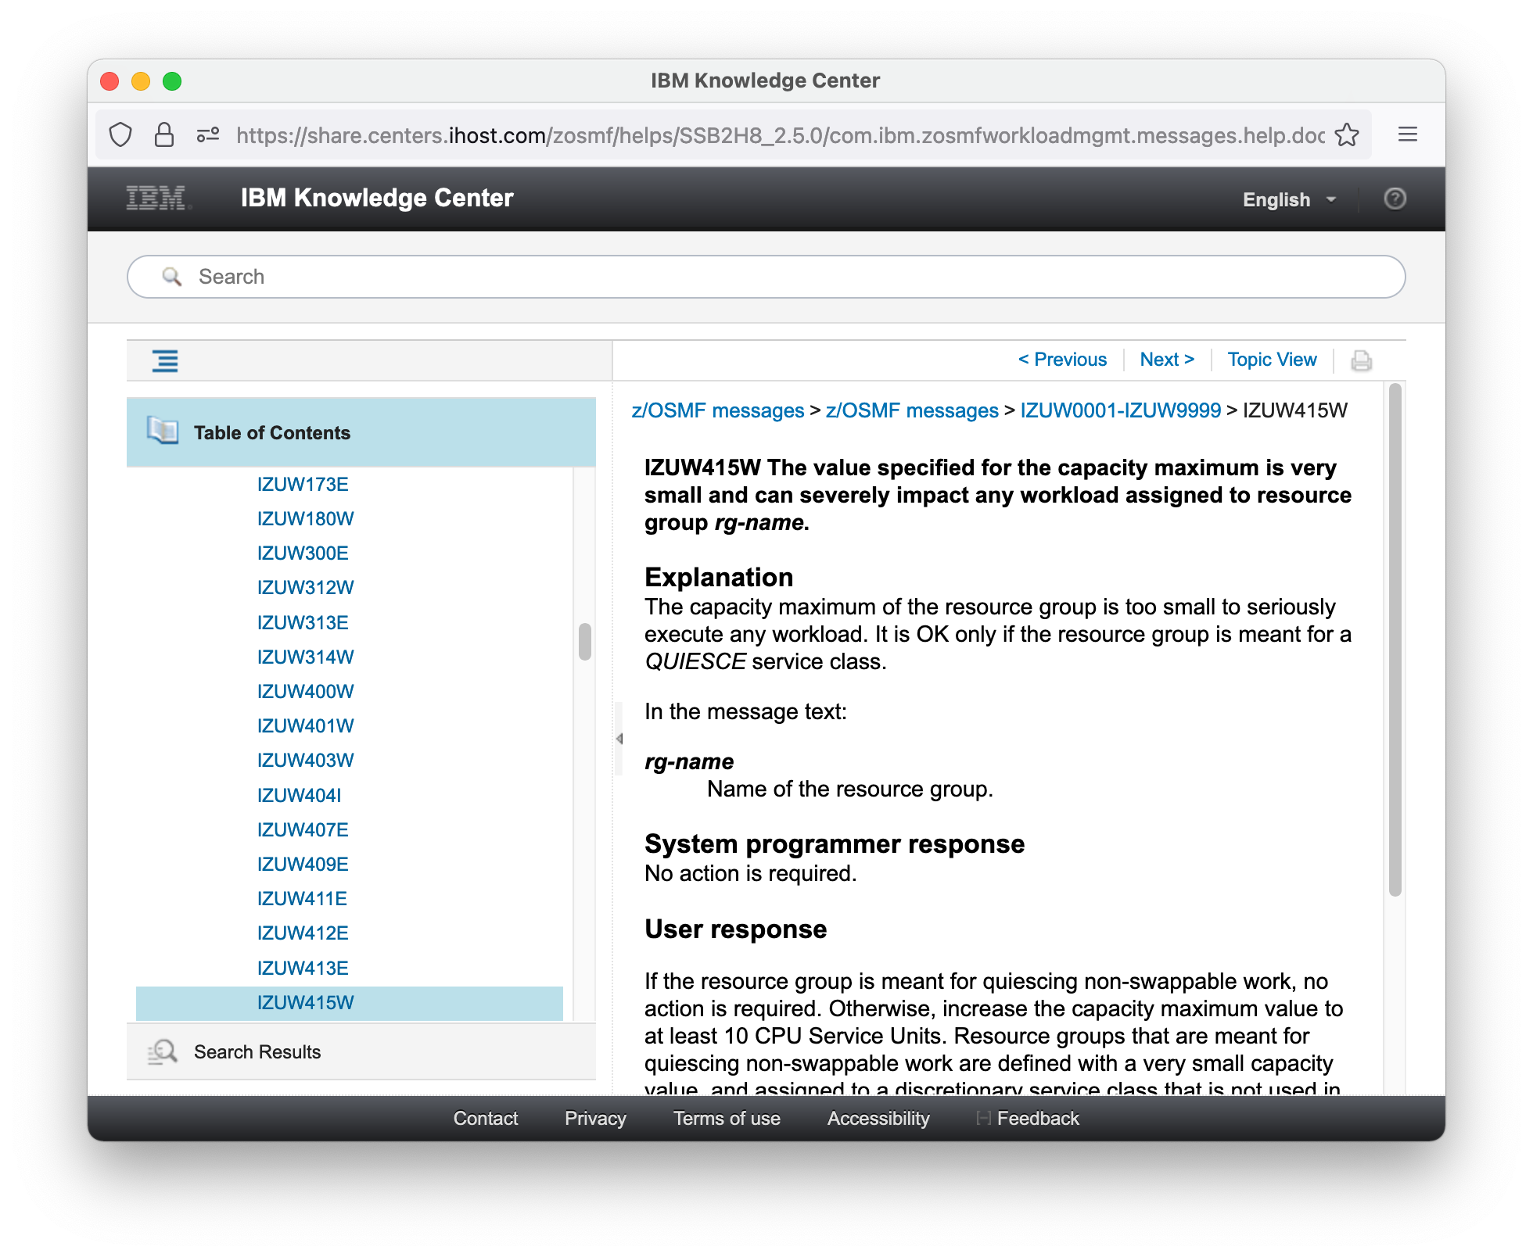

* But there is more information in the Messages table. If you scroll to the right, you see a link to the service definition item that is in error. For the second message, you will find a Service definition item called *Velocity of Service Class "SOAKI1"*, this is a service class period. In order to navigate to the service class period referenced by the second message click on the hyperlink. The following panel is displayed.

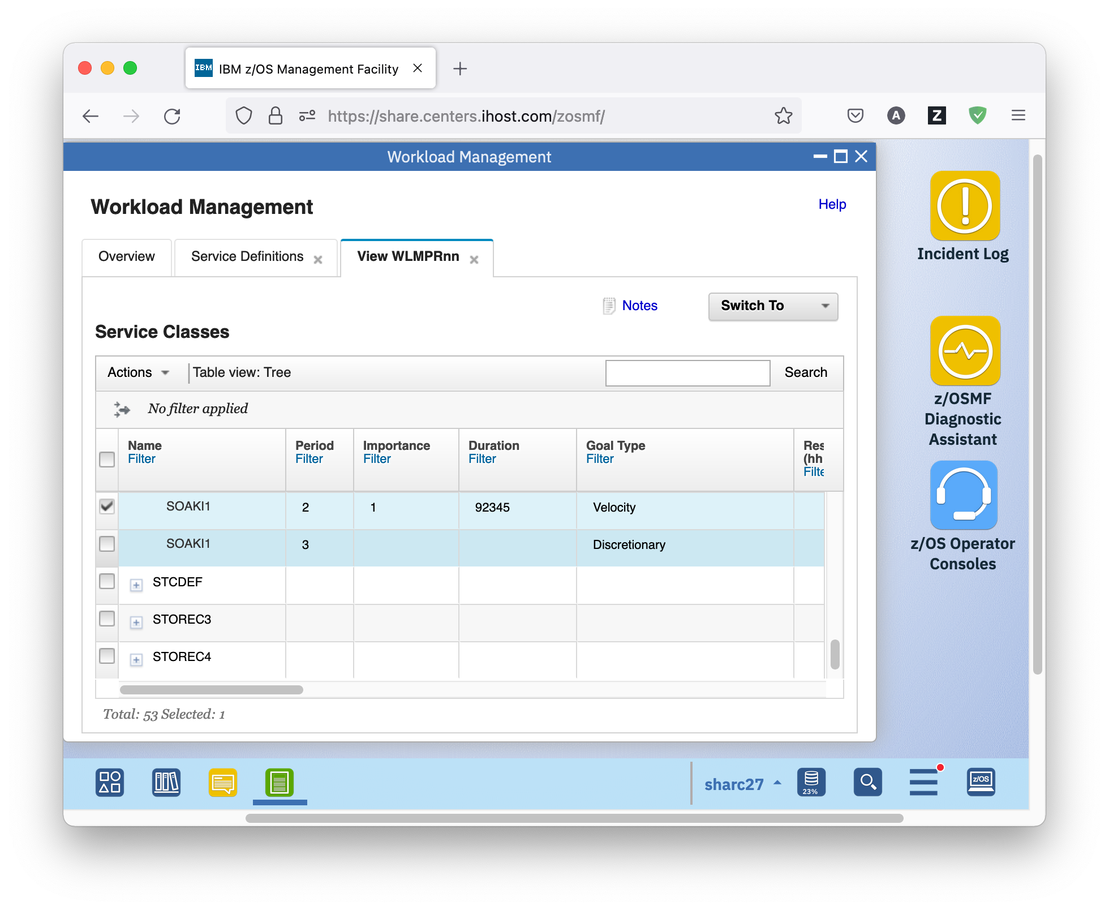

* The Service Class table displays all service classes in the service definition. A service class is a named group of work within a workload with similar performance goals, resource requirements, or business importance. Each service class contains at least one and at most eight performance periods. You use performance periods to assign service goals and importance levels to a service class for a specific duration.
* If you scroll to the right, you see that for the first and second period equal importance (1) and only slightly different velocity levels (60 and 59) have been specified. z/OS Workload Management (WLM) might not be able to distinguish between the service class periods, which is the reason for the warning message. This message is also displayed in the Messages column of the Service Classes table, if you scroll further to the right. 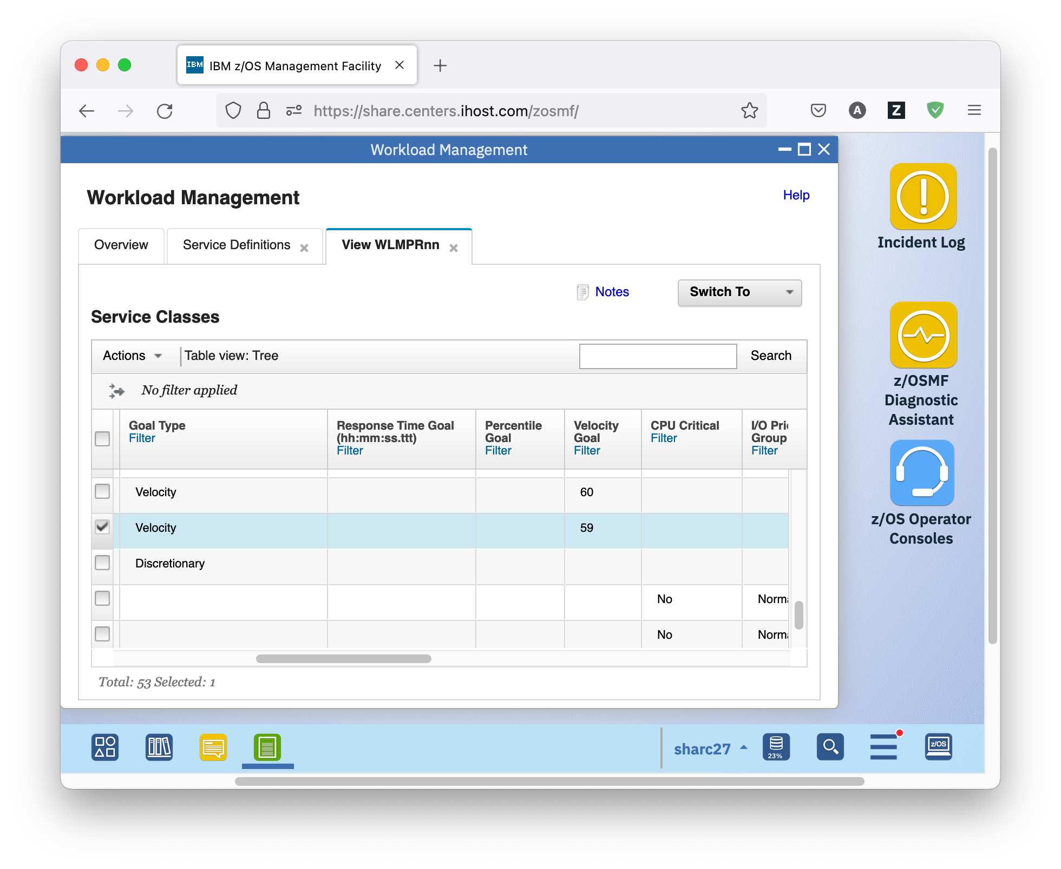
* To fix the issue correlated with the warning message you need to change the Velocity Goal of the second service class period to a lower value. First, you have to switch from view mode to modify mode via action *Editable Version of Service Definition* in the *Switch To* menu.

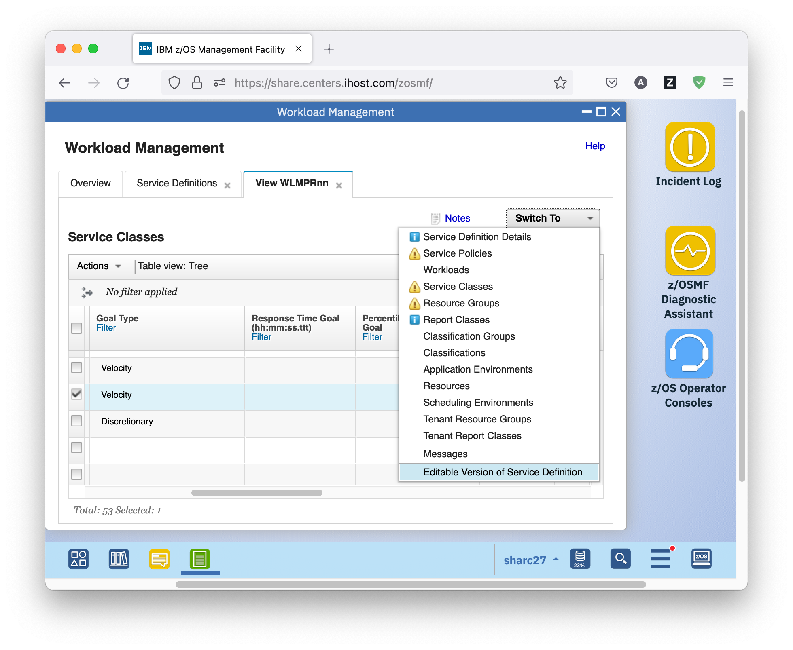

* The service definition is now editable. Editable table cells have a border around the value.

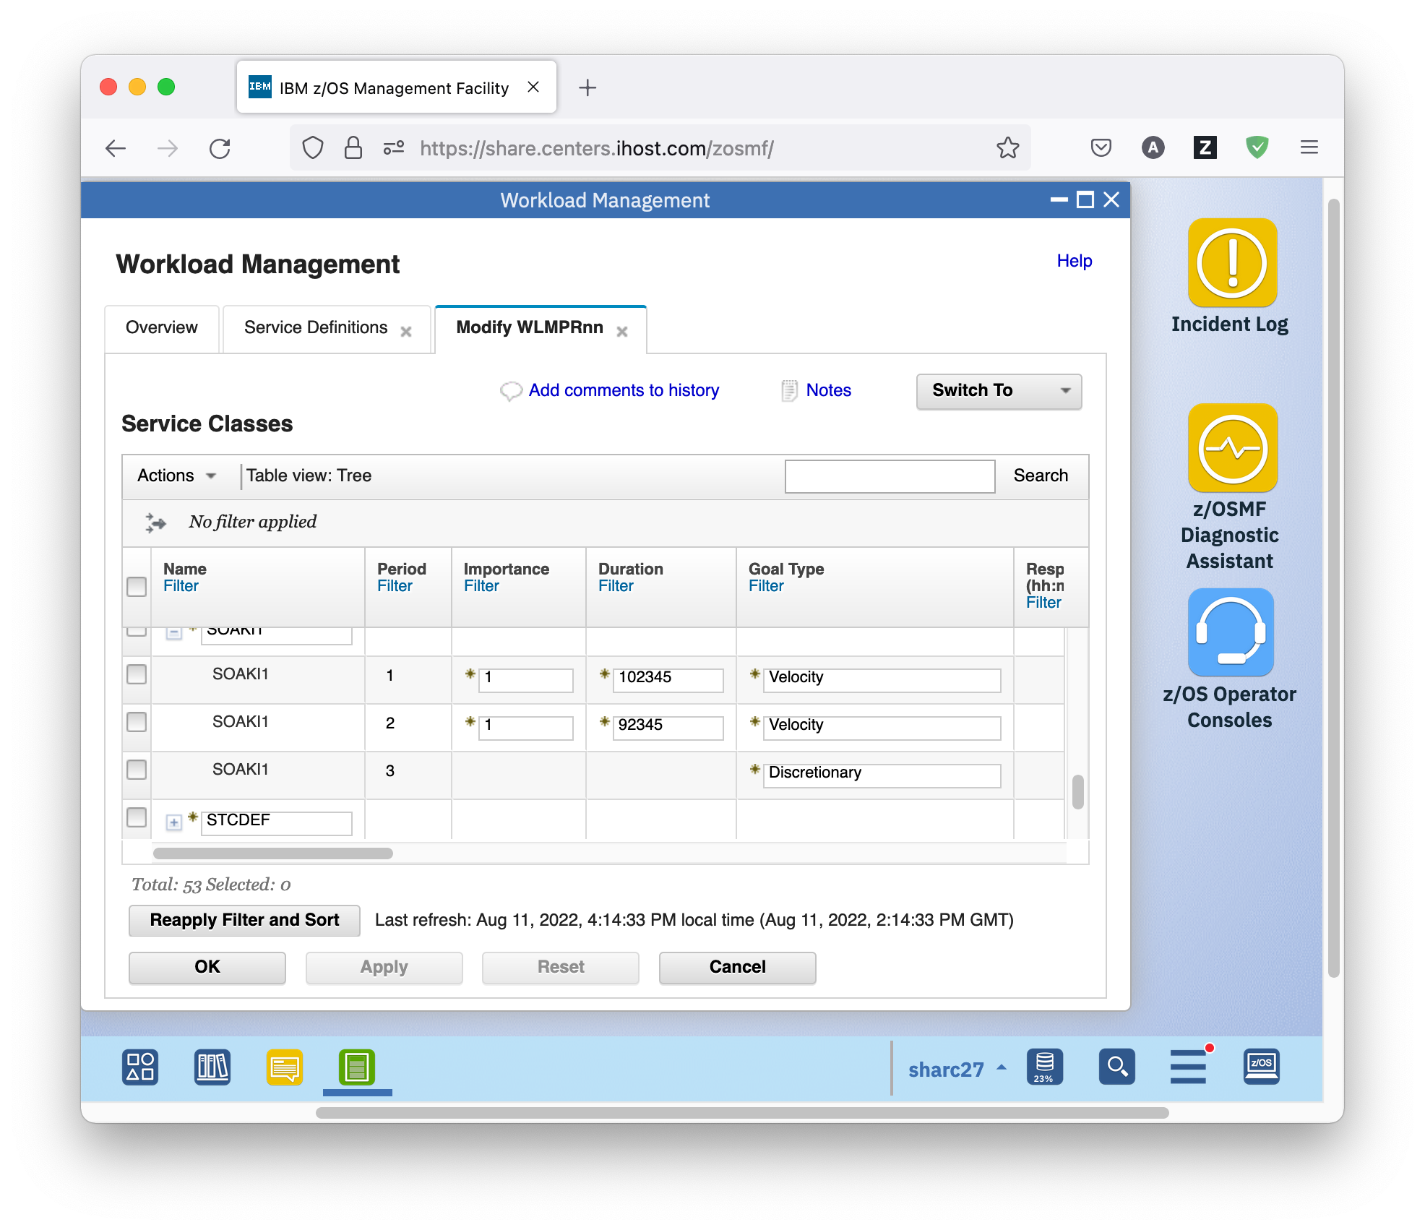

* In order to change the Velocity Goal of the second service class period, double click on the table cell, then type in value 30 and press the Enter key (to undo changes, press the ESC key). The warning icon disappears in the Messages column of the Service Classes table, if you scroll further to the right.

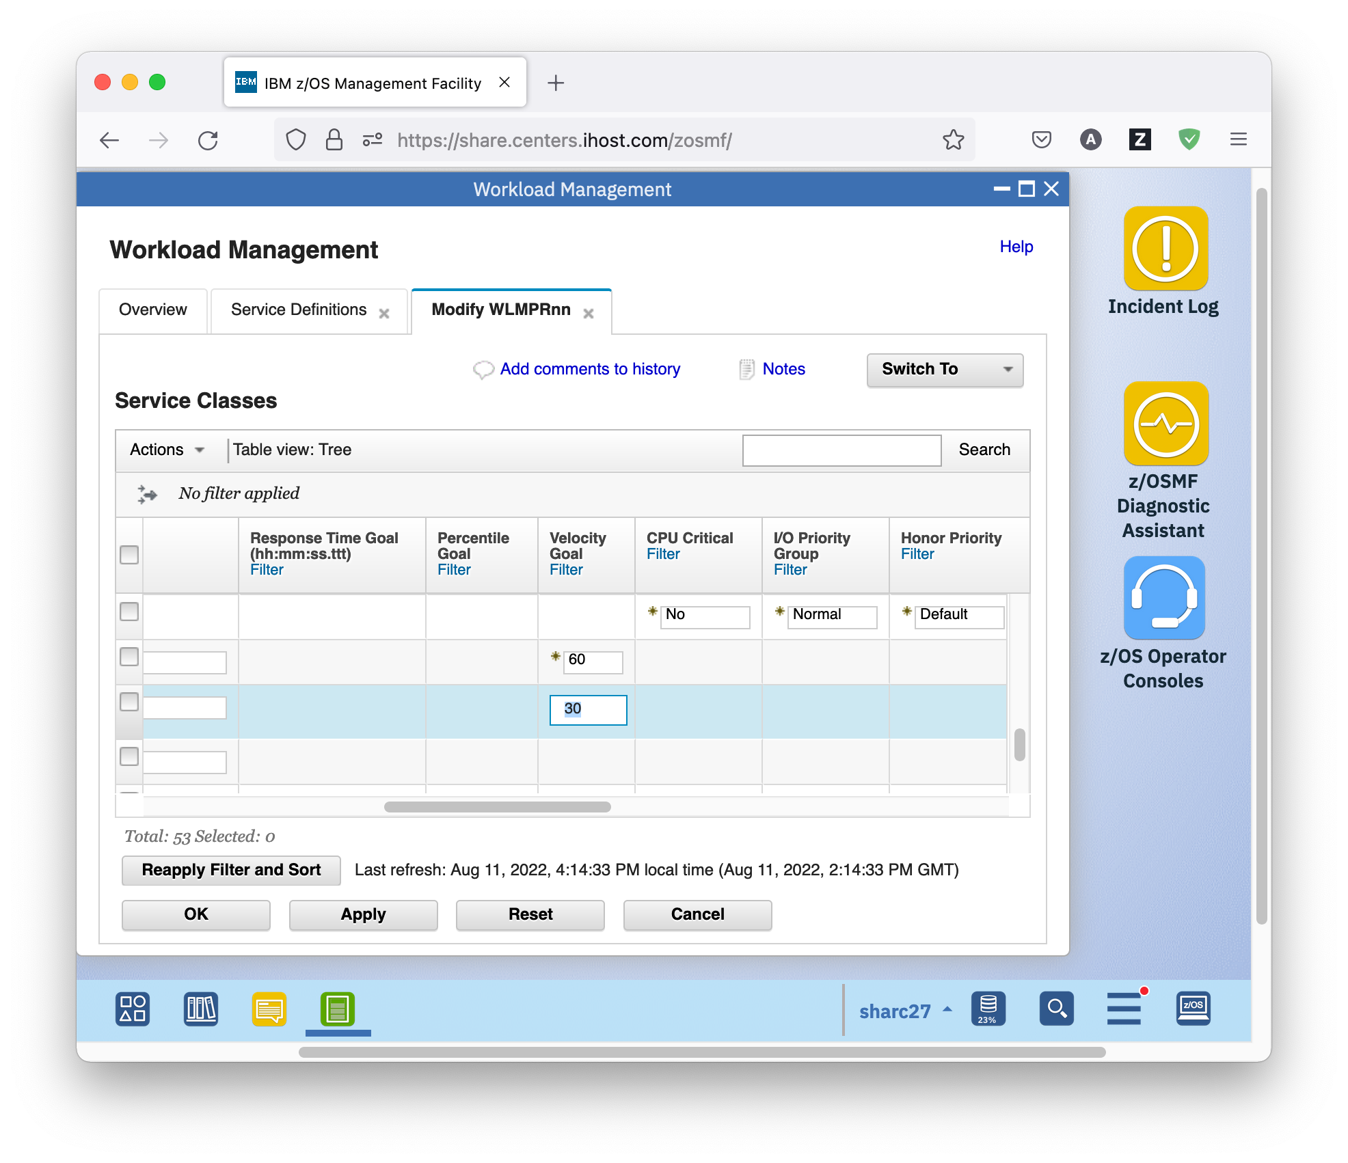

* Now that you have modified the service definition, there are different buttons at the bottom for proceeding.
* The *OK* button saves your modifications and closes the Modify WLMPRnn tab.
* The *Apply* button saves a temporary copy of your modifications to the server, and leaves the Modify WLMPRnn tab open.
* The *Cancel* button discards your modifications and closes the Modify WLMPRnn tab.
* And the *Reset* button discards your modifications, and leaves the Modify WLMPRnn tab open.
* This time, press the *OK* button to save the modified service definition and close the Modify WLMPRnn tab.
* Optionally, you can provide a comment for your modifications. 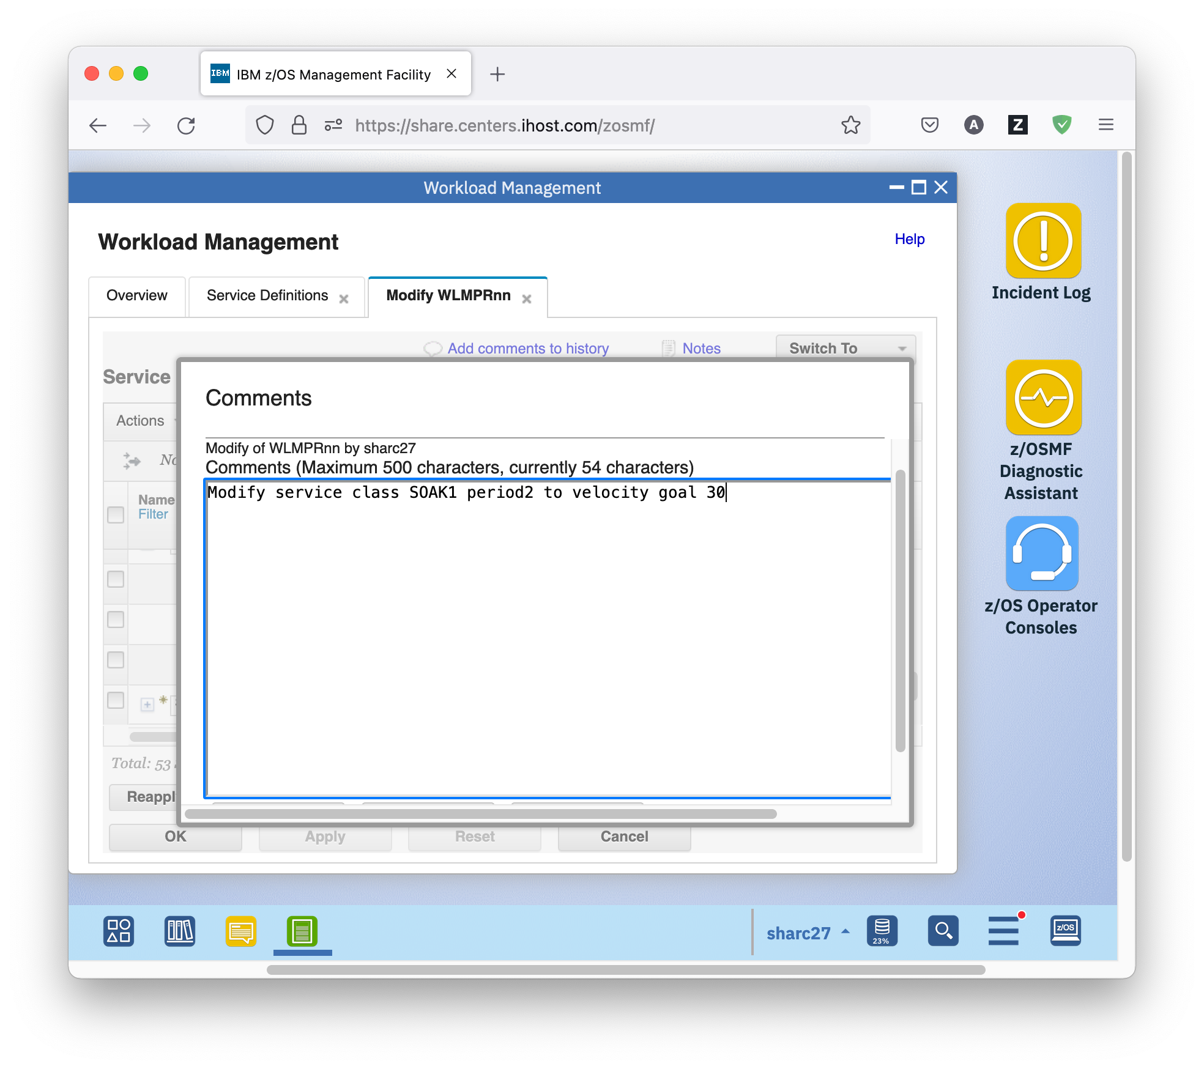
  1. More on z/OSMF Tabs and Tables

A word about the tabs z/OSMF WLM opens for viewing and modifying service definition. A service definition consists of different sections. Each of the sections is displayed in one panel. You can watch one panel at a time in the opened tab and you can switch between the panels using the *Switch To* menu, or by clicking links (as you already did for the service definition item that was in error), or by following cross references (as you might do later).

## Exercise

* As before, on the Service Definitions tab, select service definition WLMPRnn and either right-click it, or open the Actions menu, and choose *View Messages*. The View WLMPRnn tab opens, displaying all messages for the service definition. Note that one of them is gone because of your modification. If you want to view the service classes, you have to use the *Switch To* menu. Never use the browser back button; it is not going to work.

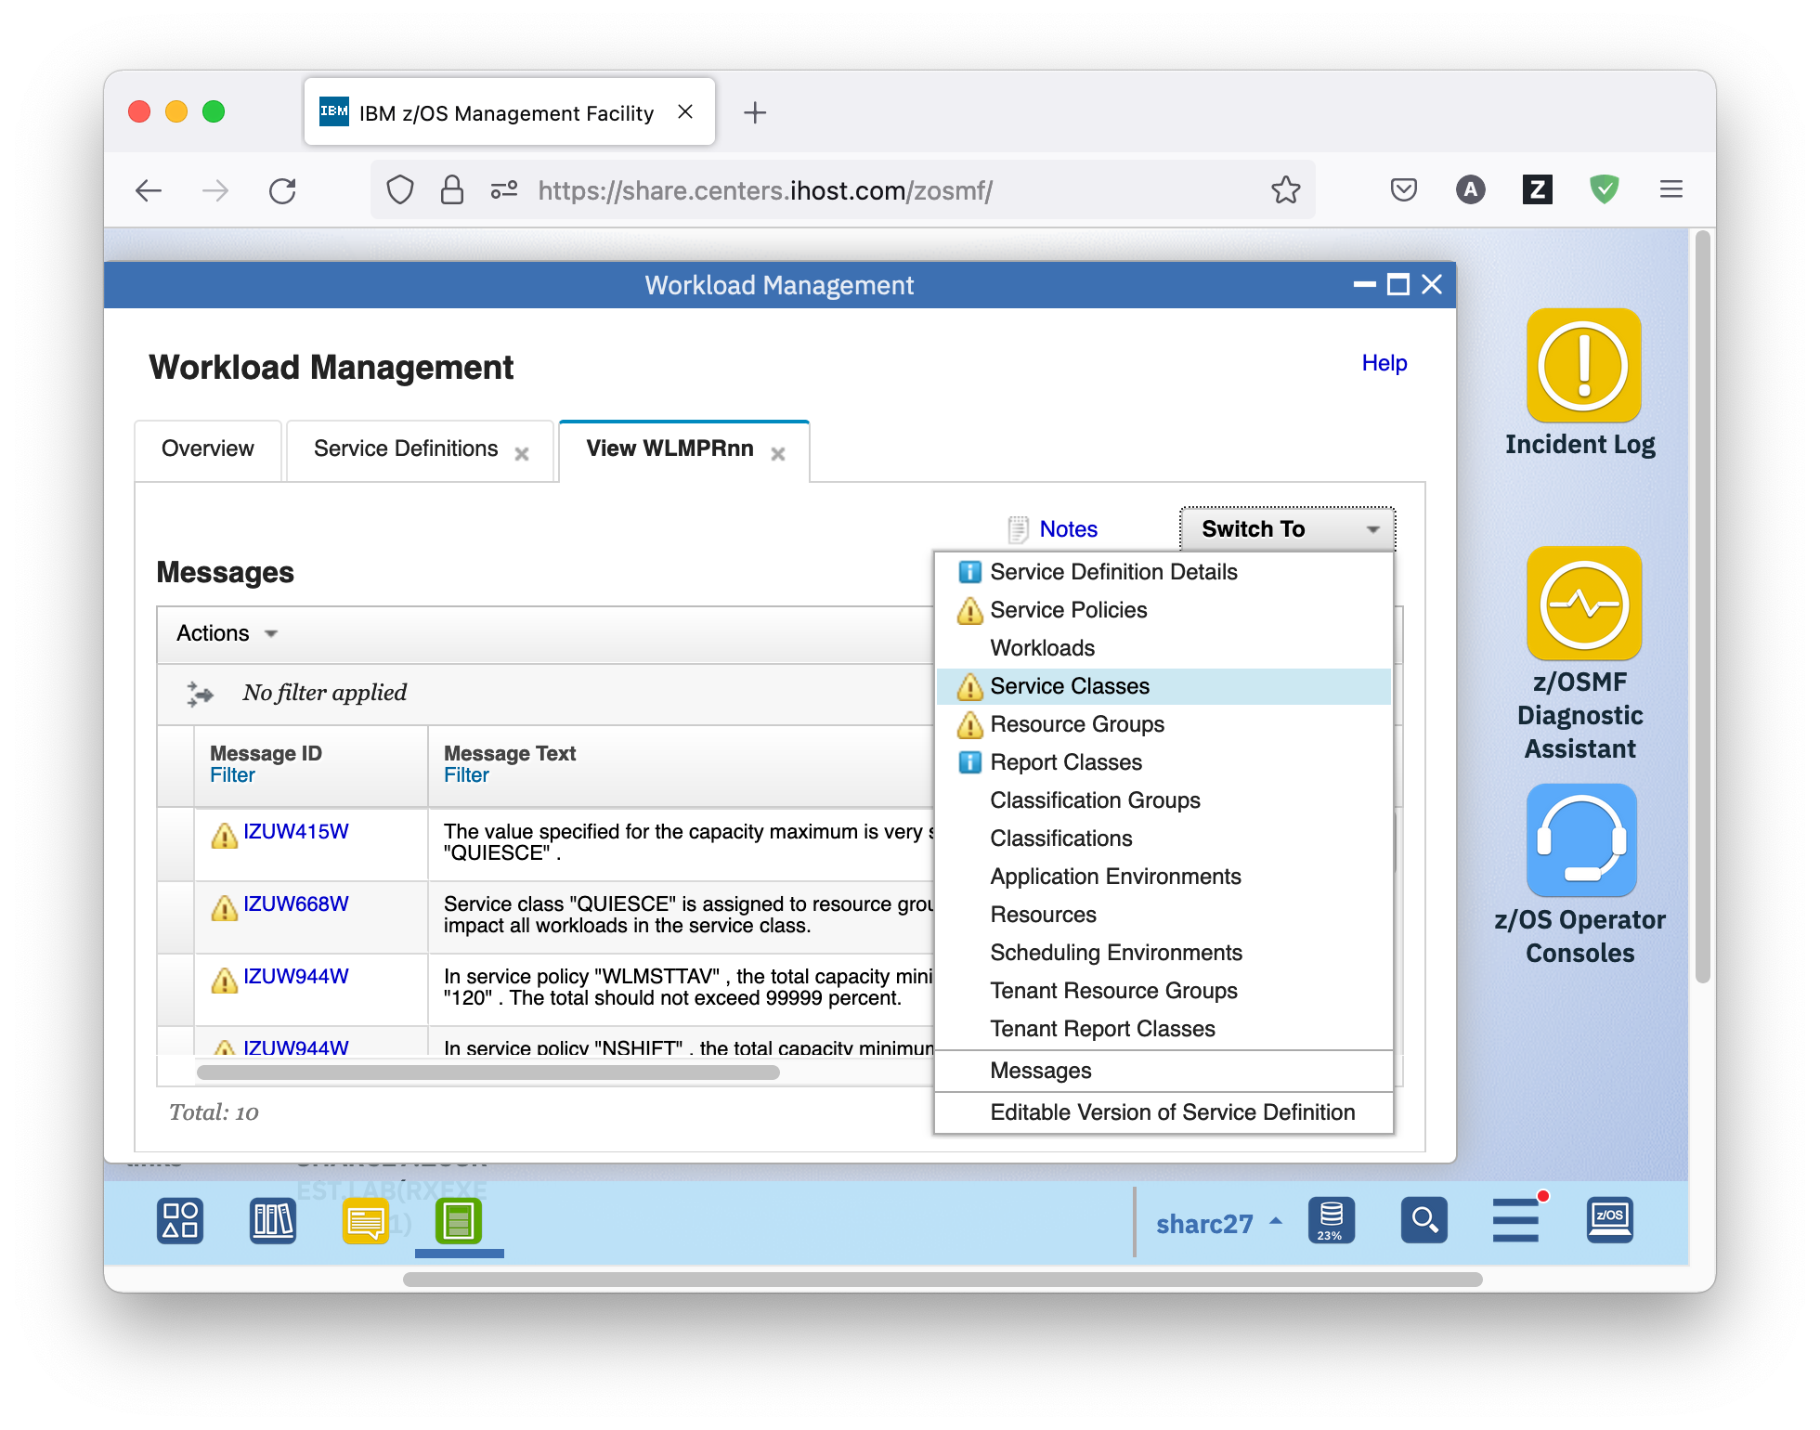

* You can simultaneously have a service definition open in View and Modify mode in two tabs. To do so, on the Service Definitions tab, select service definition WLMPRnn and either right-click it, or open the Actions menu, and choose *Modify Service Definition – Service Classes*. The Modify WLMPRnn tab opens, displaying all service classes for the service definition.

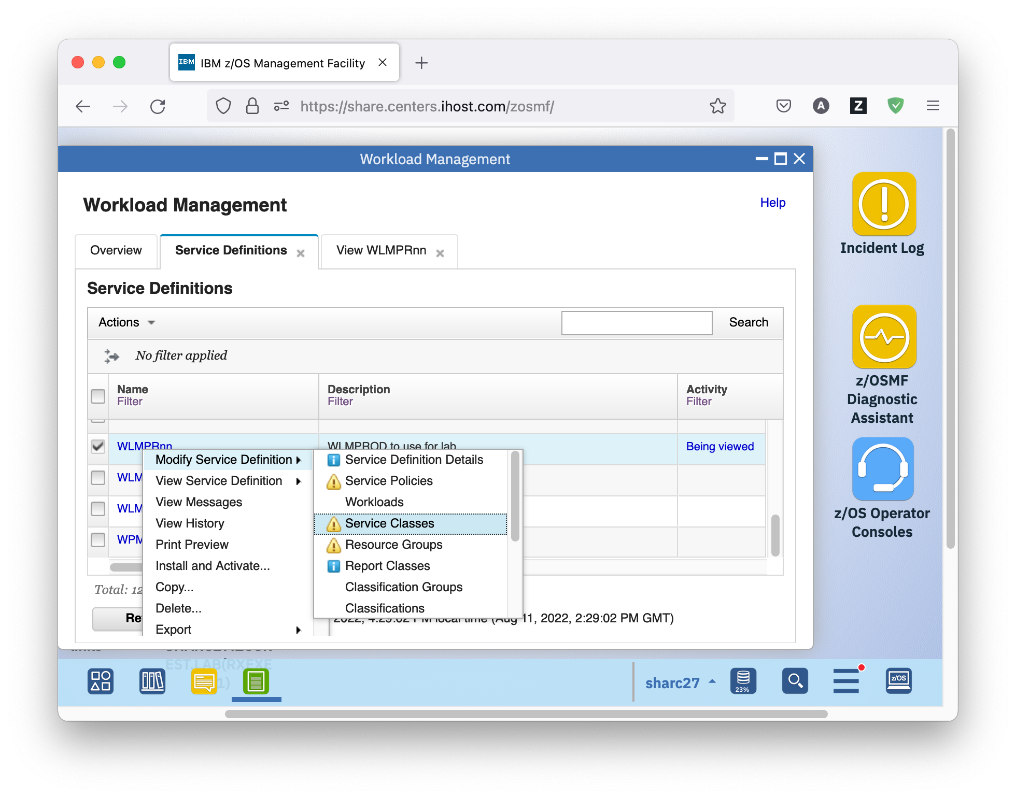

* You can also have several service definitions open in View or Modify mode. z/OSMF WLM supports up to 20 tabs at the same time. To do so, on the Service Definitions tab, select service definition WLMTSTnn and either right-click it, or open the Actions menu, and choose *View Service Definition – Service Policies*. The View WLMTSTnn tab opens, displaying all service policies for the service definition. A service policy is a named collection of service class and resource group-specific overrides. If your installation has performance goals or processing requirements that change at certain times, you can define multiple policies to address those changes and activate the service policy required during each time period. Doing so changes the performance goals and processing capacity boundaries specified in the service definition without requiring you to modify or re-install the service definition.

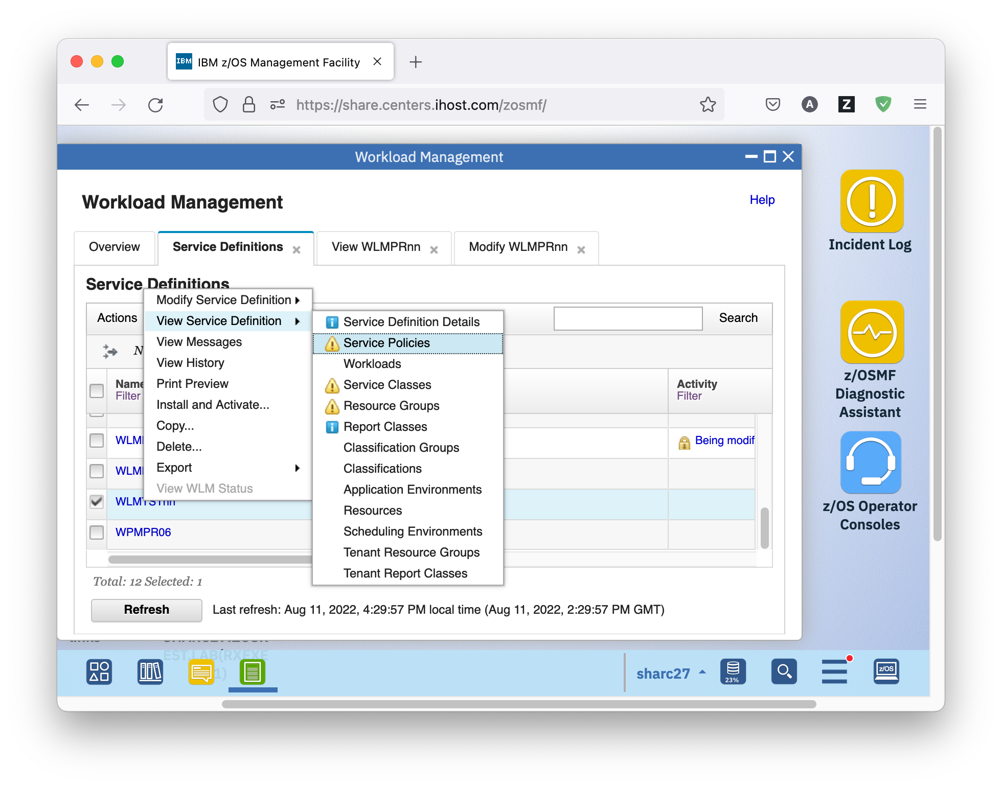Another word about the Service Class panel you opened above. The table in the panel is different from the Service Definitions table. It is a tree table with all service classes in the service definition. The rows on level zero represent service class items. The nested rows represent the periods of the service classes. You can switch between tree view and non-tree view. The non-tree view is accessible, and provides additional sort capabilities, like sorting or filtering for period columns.

## Exercise

* Switch to the View WLMPRnn tab you opened above which displays all service classes of the service definition. Only the service class items at level zero are displayed. To expand the service class periods of a service class, click the + sign left to the service class name, to collapse them again, click the – sign left to the service class name. You expand and collapse all by choosing *Actions – Expand All* or *Actions – Collapse All*.

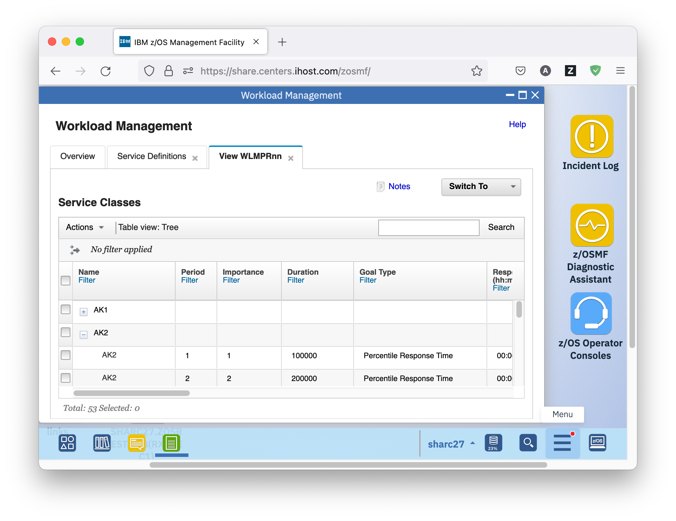

* You can also switch between Tree View and Non-Tree View by using *Actions – Switch to Non-Tree View* and *Actions – Switch to Tree View*.

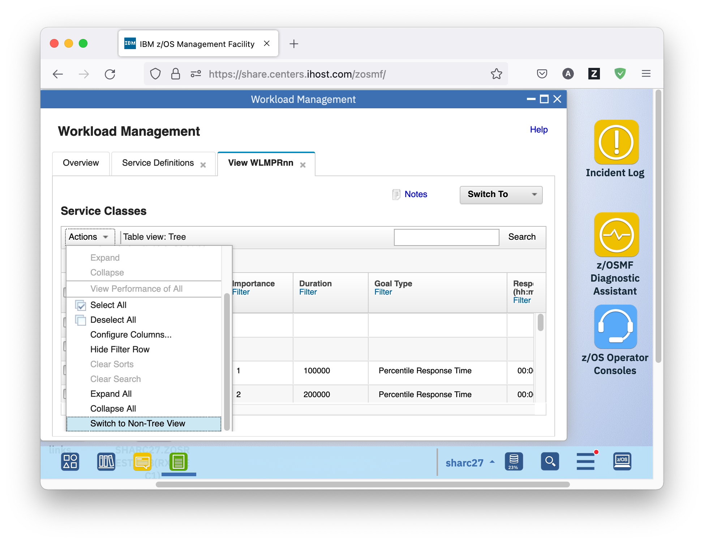

* The Non-Tree View provides additional sort capabilities, like sorting or filtering for period columns. For example, if you are interested in how many importance 1 periods exist in your policy, you switch to Non-Tree View, and click on the column heading of the Importance column to sort the table ascending based on the values in the column.

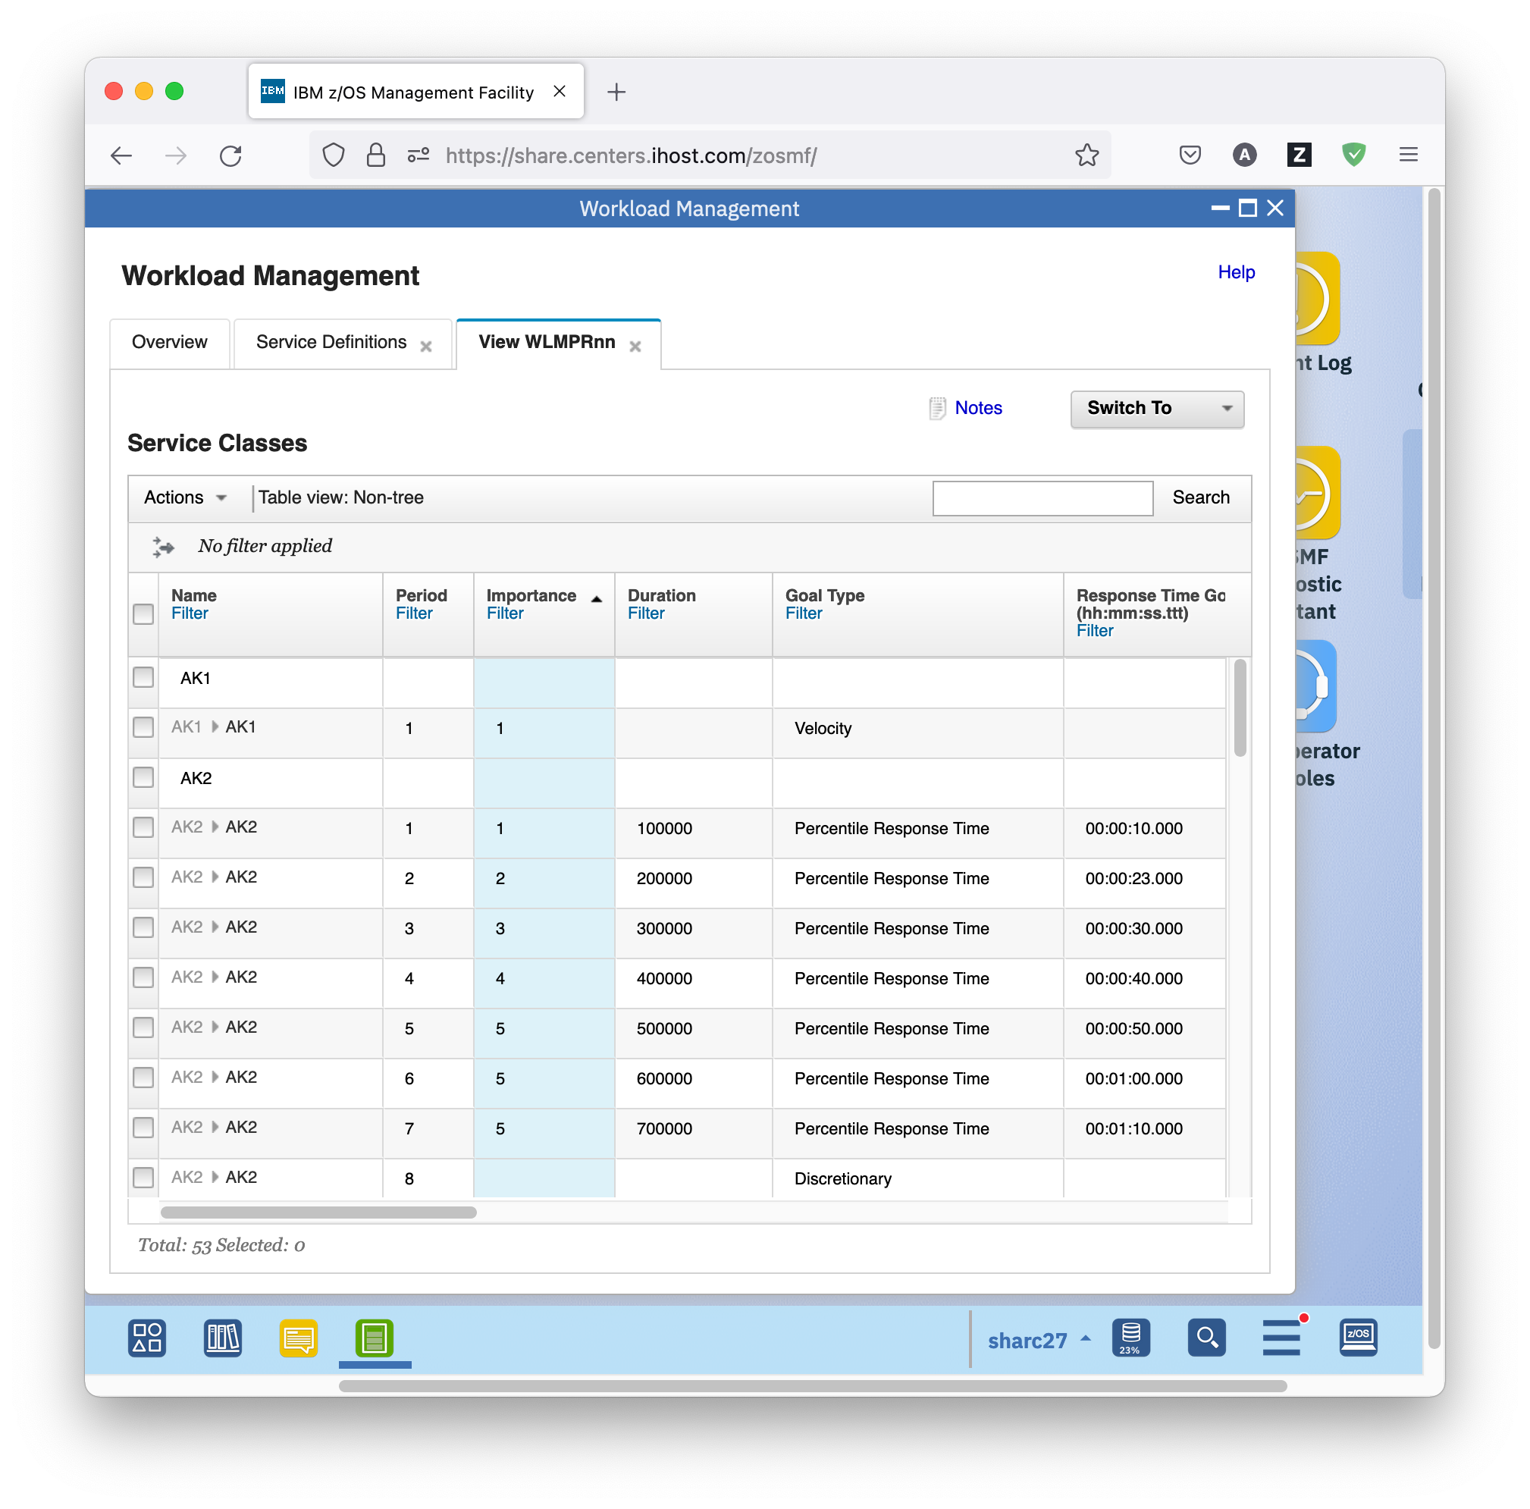

* Now switch back to Tree View.
  1. Removal of Best Practice Warning Messages from a Service Definition Continued

Now let’s fix a second warning message related to service classes.

## Exercise

* On the Modify WLMPRnn tab, switch to the messages for the service definition.

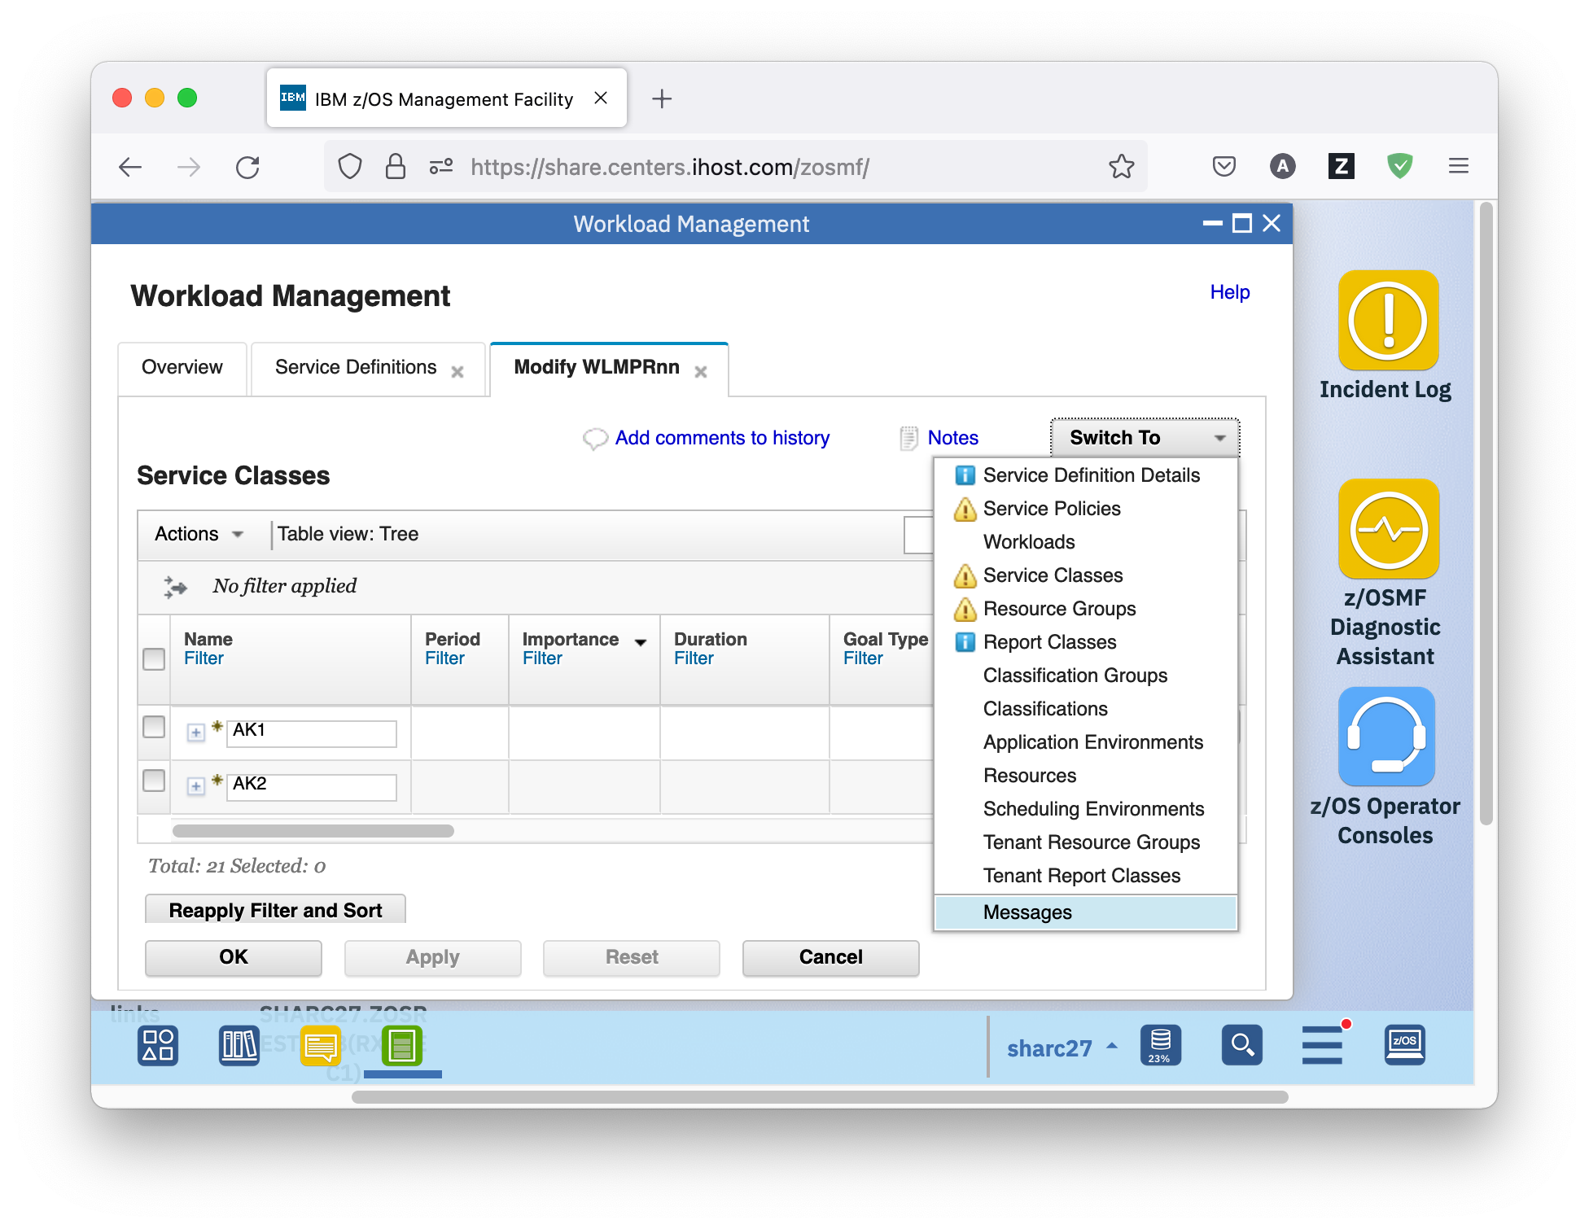

* This time you are going to fix the IZUW952W warning message. Scroll to the right to see a link to the service class period that is in error. In order to navigate to the service class period referenced by the error message click on hyperlink *Velocity of Service Class AK1* in the Messages table. The following panel is displayed.

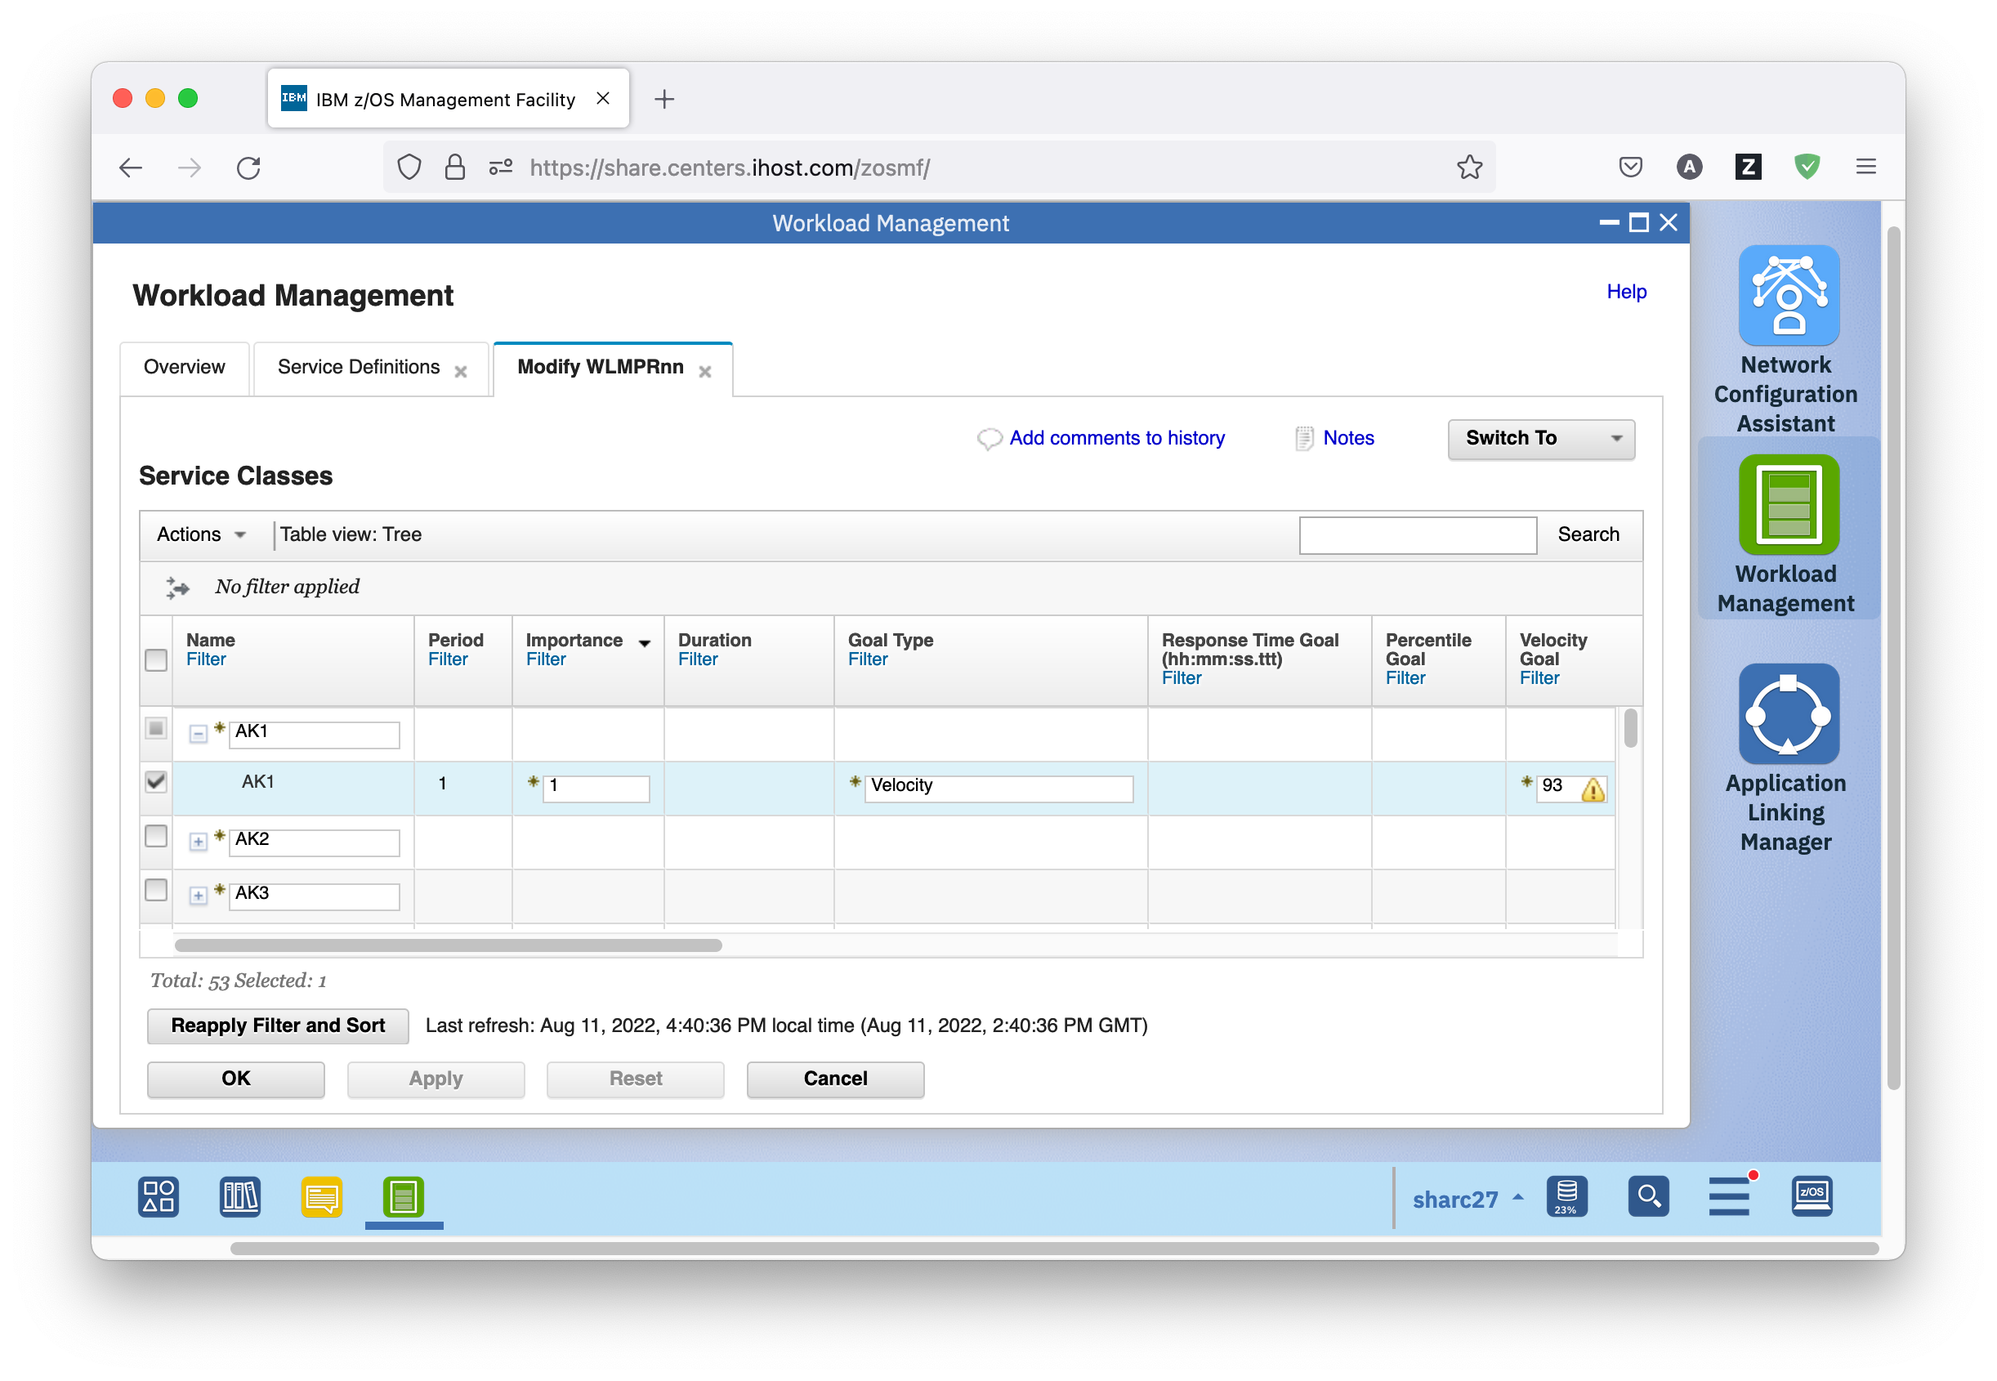

* You can see there is a warning icon for the velocity goal of the service class. You can either mouse over the warning status icon to view the information message, or control-click on it to get a message window.

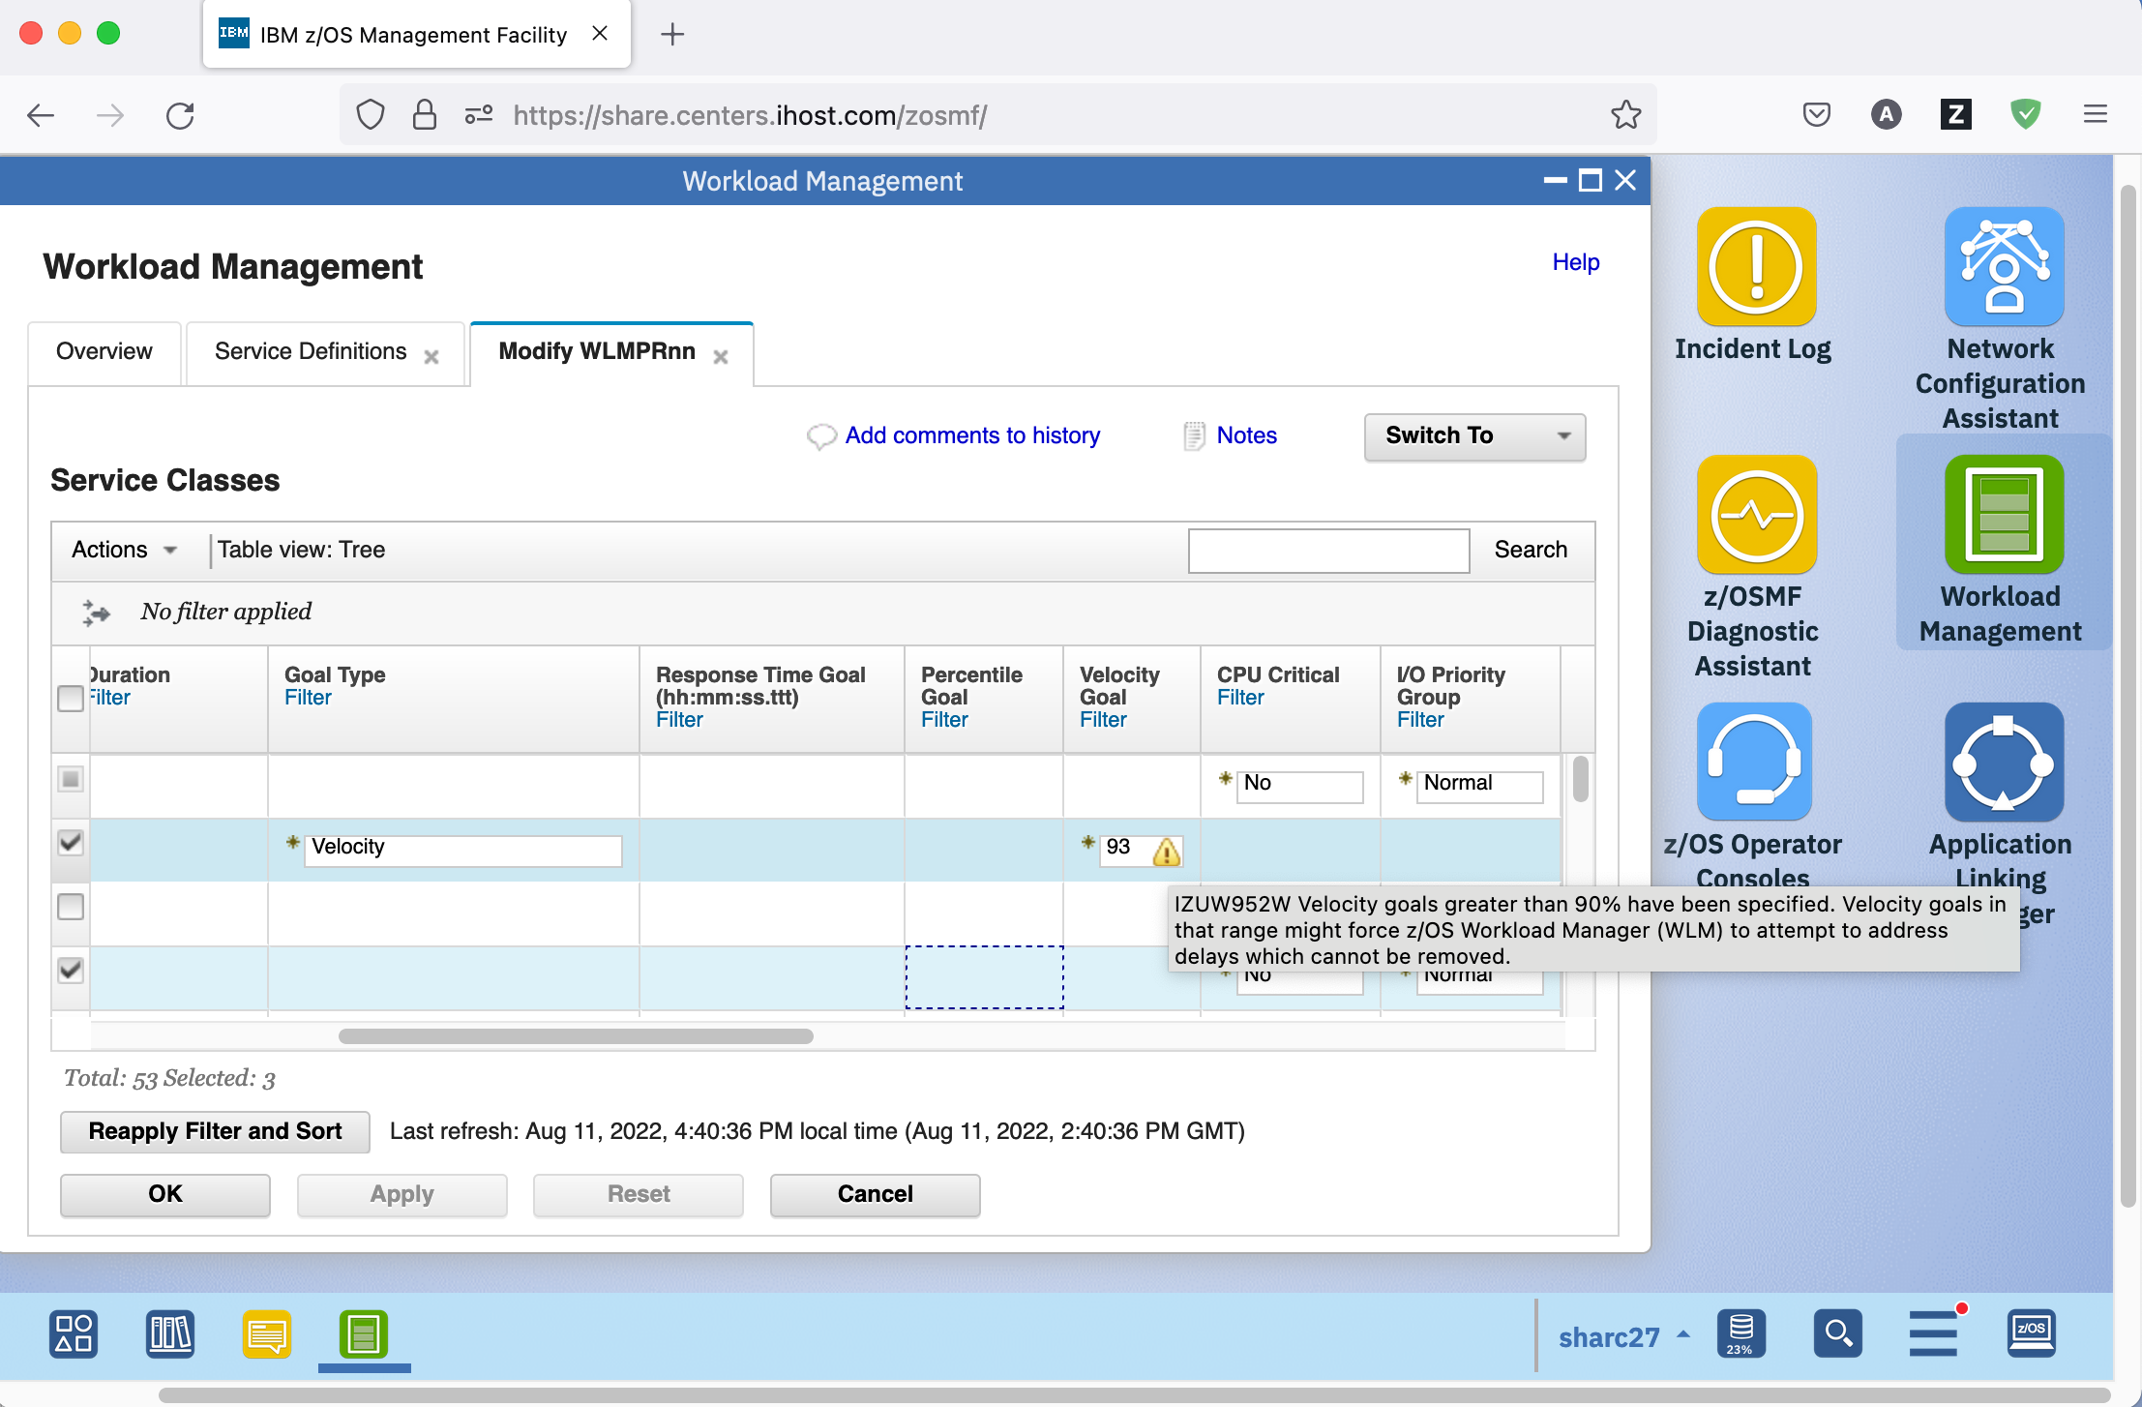

* As before, to fix the issue correlated with the warning message you need to change the Velocity Goal of the service class period to a lower value. Because you already are on the Modify WLMPRnn tab, you can just double click the Velocity Goal table cell for the service class, then type in value 85, and press the Enter key. The warning icon disappears in the Messages column of the Service Classes table.

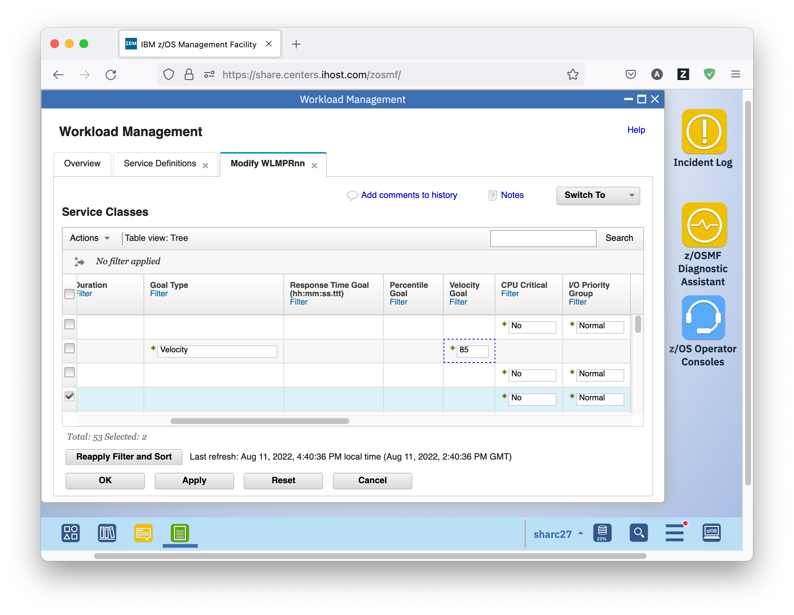

* Click the Apply button to save a temporary copy of your changes to the server.
  1. Multi-User Synchronisation

While you are working with several service definitions, a word about synchronization:  
The Service Definition Repository provides Multi-User Synchronisation through locking. This ensures that a service definition is only modified by one user at a time.

* When a service definition is viewed, it is locked in shared mode. This means that others can view or modify the same service definition, but cannot delete it.
* When a service definition is modified, it is locked in exclusive mode. This means that others can view the same service definition, but cannot modify or delete it.

## Exercise

* On the Service Definitions tab, view the current locking status in the Activity column of the Service Definitions panel. WLMPRnn is displayed as being modified, while WLMTSTnn is displayed as being viewed.

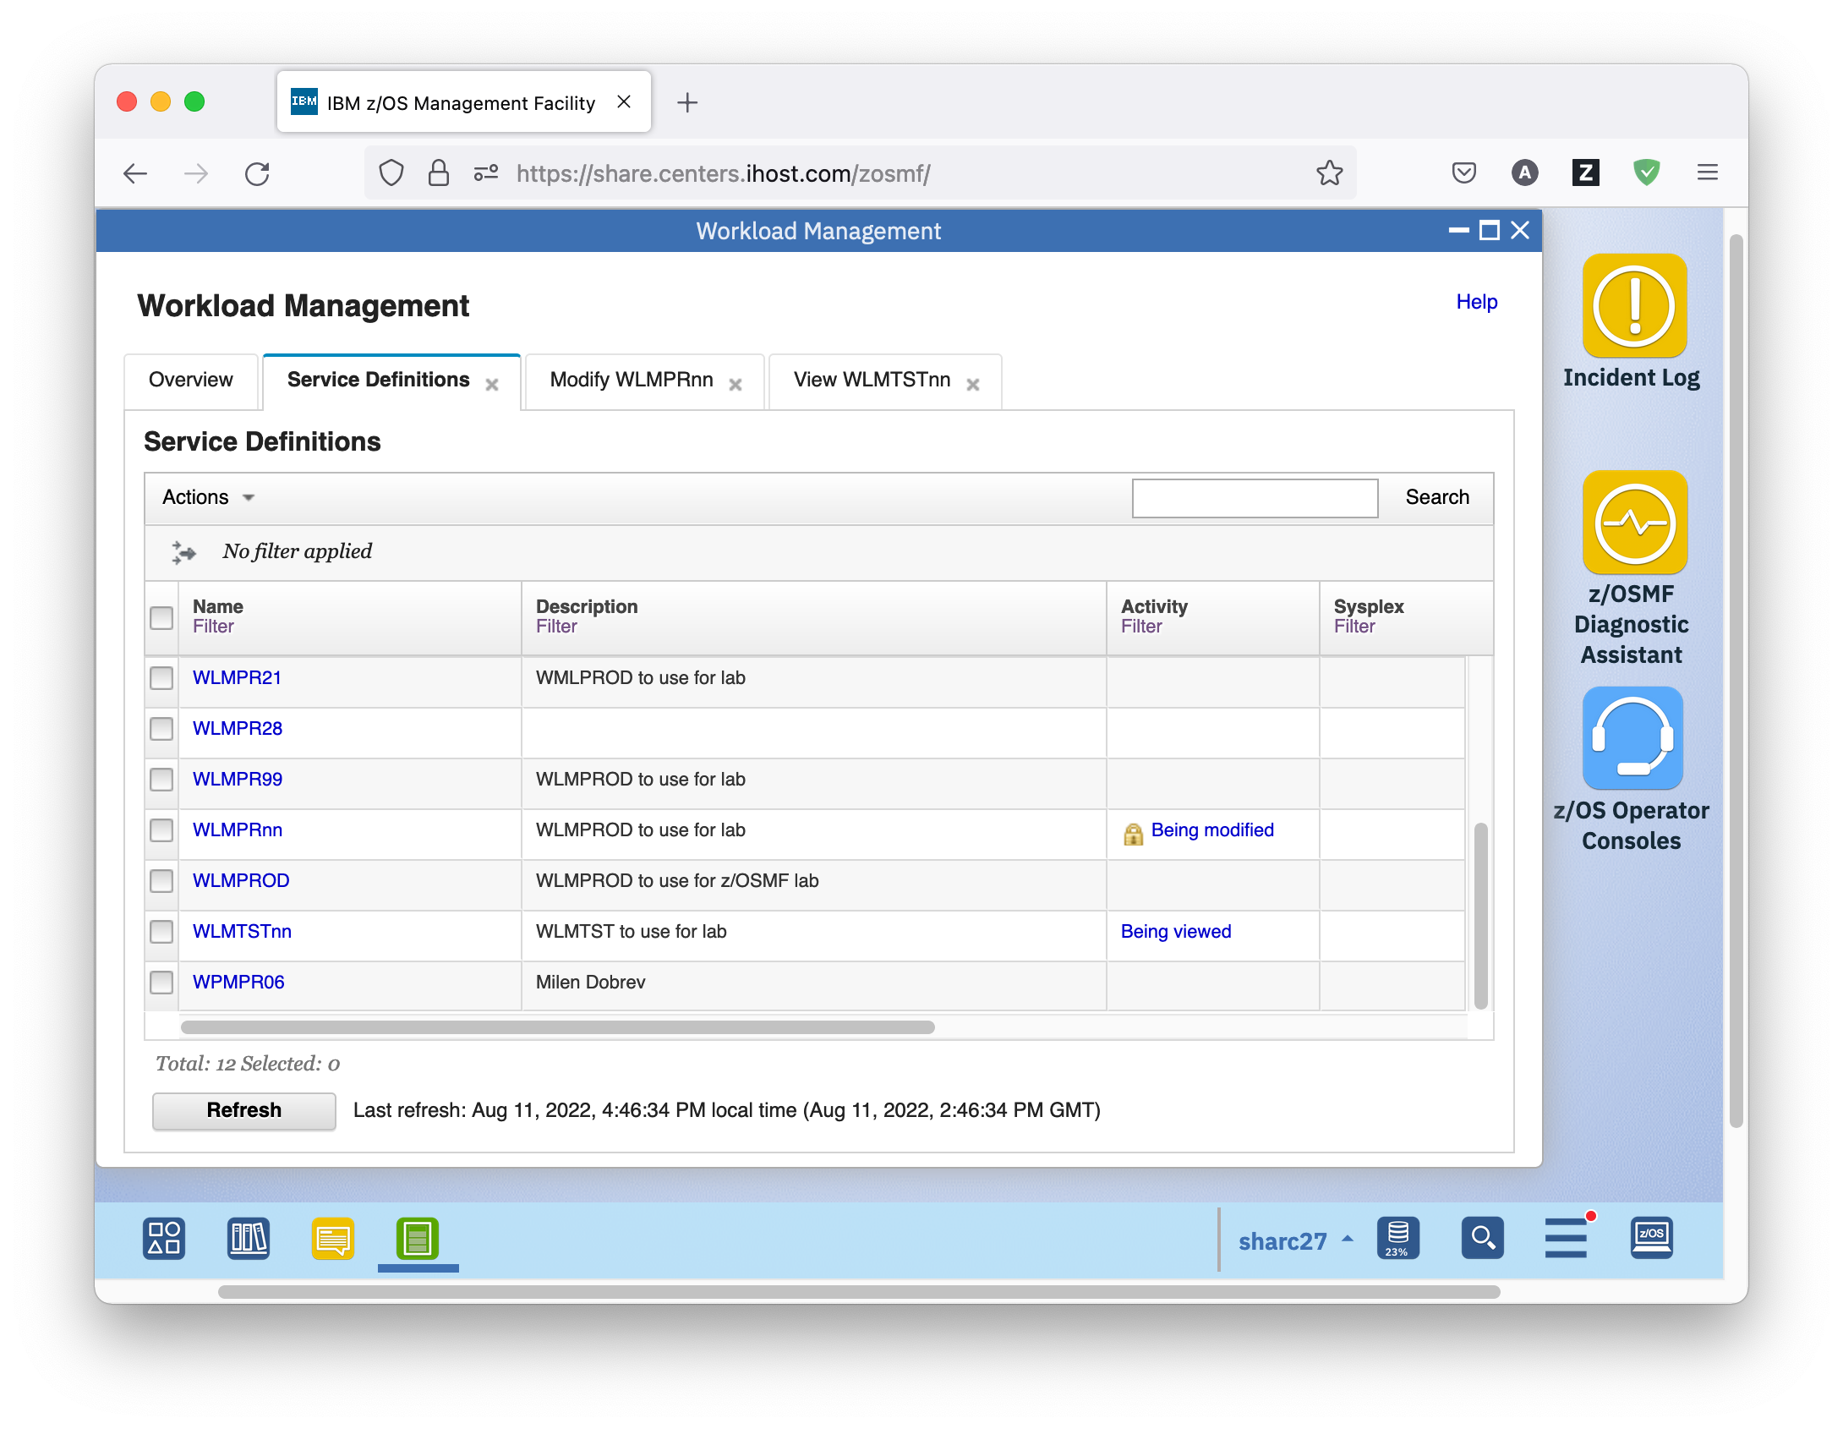

* 1. Built-In Prevention against Data Loss

The z/OSMF Workload Management task provides built-in prevention against data loss. While you are editing a service definition in a *New/Copy/Modify* tab, the browser sends temporary copies of the service definition to the server when you

* Press the *Apply* button
* Switch to another service definition component using the *Switch To* menu

If you accidentally close the *Workload Management* task before saving your changes, you can open the last saved temporary copy of the service definition in a *Modify* tab and continue with editing.

In the *Service Definitions* table service definitions for which a temporary copy exist have in the Activity column the label

* *Changes pending* if a *Modify* tab was aborted
* *Temporary* if a *New* or *Copy* tab was aborted

## Exercise

* Log off from z/OSMF by clicking the *Log out* hyperlink top right
* Log in again with your SHARE userid/pw
* Start the Workload Management task. To do so, in the navigation tree on the left hand side, under heading performance, click on Workload Management
* On the Overview tab of the Workload Management task, click on the *Service Definitions* hyperlink

View the service definitions present in the Service Definition Repository, and note that WLMPRnn is marked as *Changes pending* in the Activity column of the Service Definitions panel

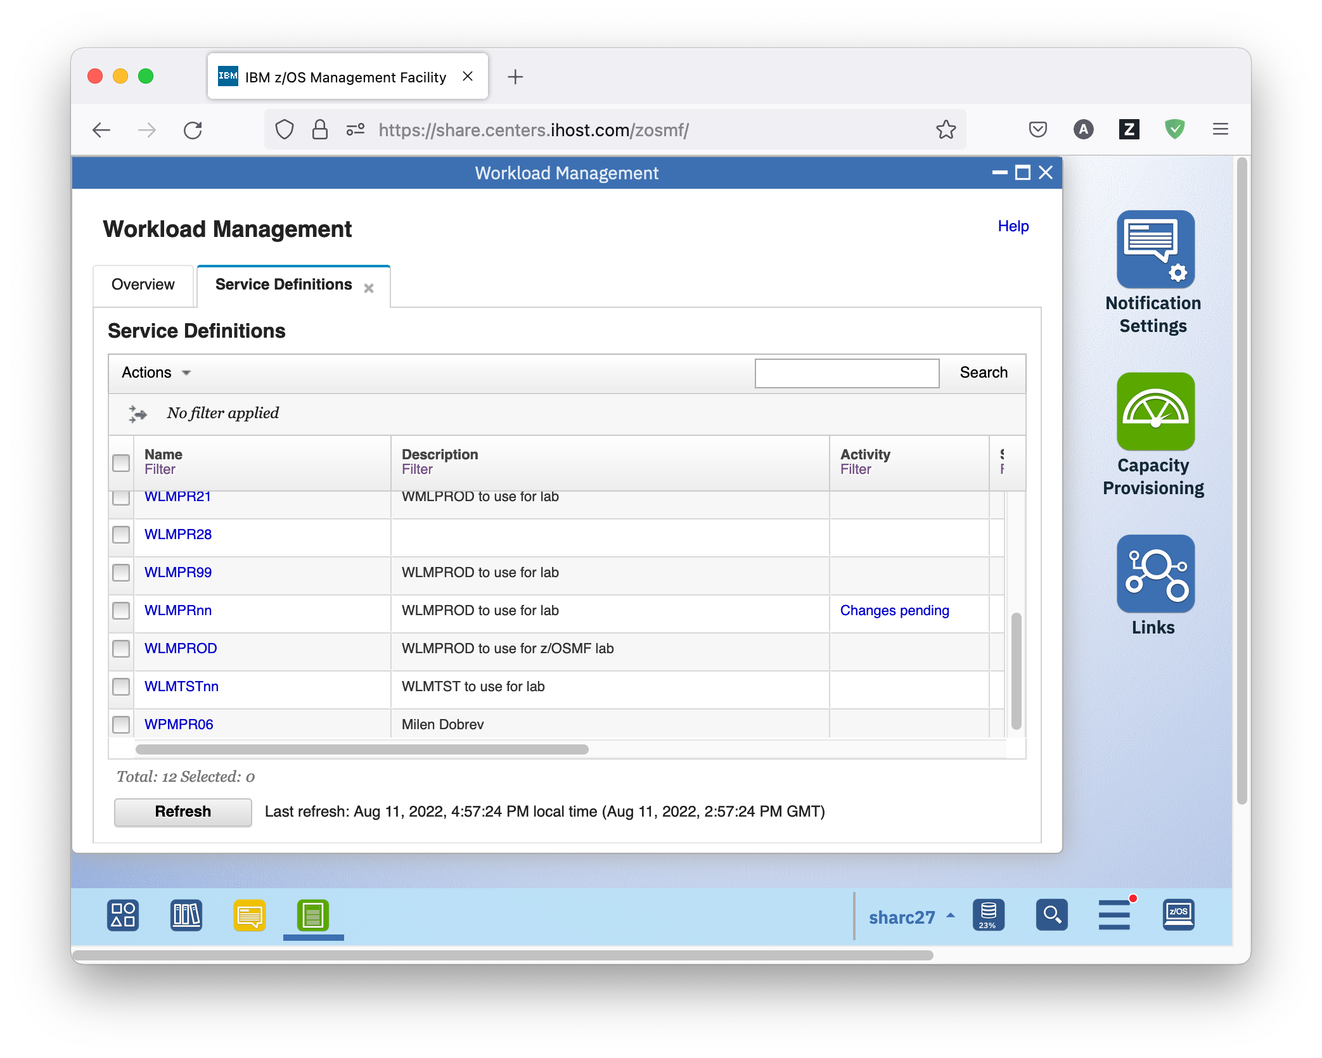

* To continue modifying the service definition, on the Service Definitions tab, select service definition WLMPRnn and either right-click it, or open the Actions menu, and choose *Modify Service Definition – Service Classes*. A warning box opens that offers you to either continue working with the temporary copy, or the original service definition. If you select the original service definition, the temporary service definition will be deleted, and all your changes will be lost.

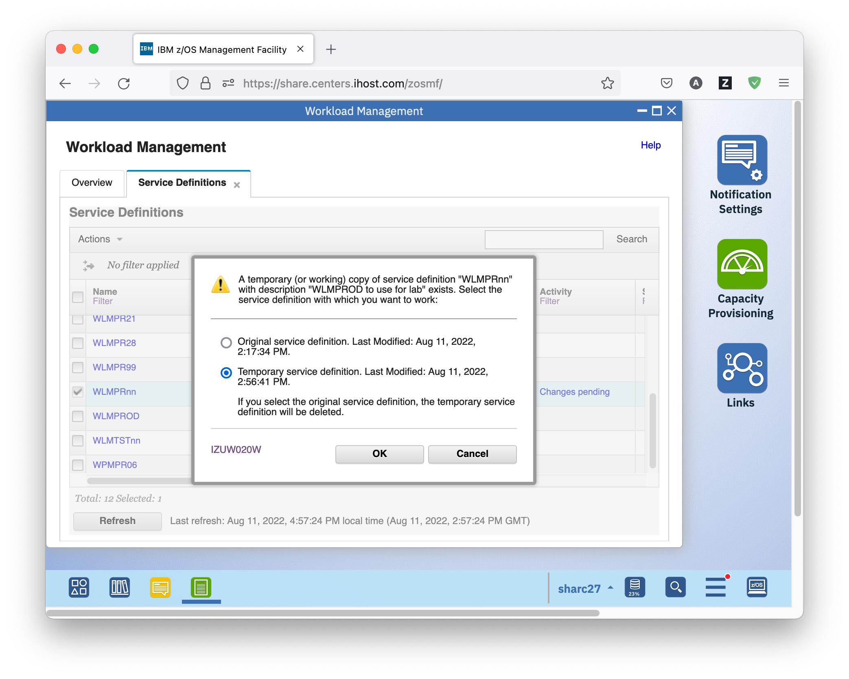

* Choose the temporary service definition to continue your work. Verify that the change you have done to the Velocity goal of the first period of service class AK1 is still there.
* Press the OK button to permanently save the modified service definition and close the Modify WLMPRnn tab. You can optionally enter a comment for your modifications.
  1. View the History of a Service Definition

Now that you have worked so much with service definition WLMPRnn, you might want to check what actually happened. For that, the z/OSMF Workload Management task offers a history for the service definitions.

The service definition history is a log of the actions that have been taken against the service definition during a specified period of time. Logged actions can include details about when the service definition was modified, installed, activated, or when a backup copy was created.

## Exercise

* On the Service Definitions tab, select service definition WLMPRnn and either right-click it, or open the Actions menu, and choose *View History*. The History WLMPRnn tab opens, displaying the history for the service definition. Note that the comments you entered for each step show up in the Comments column.

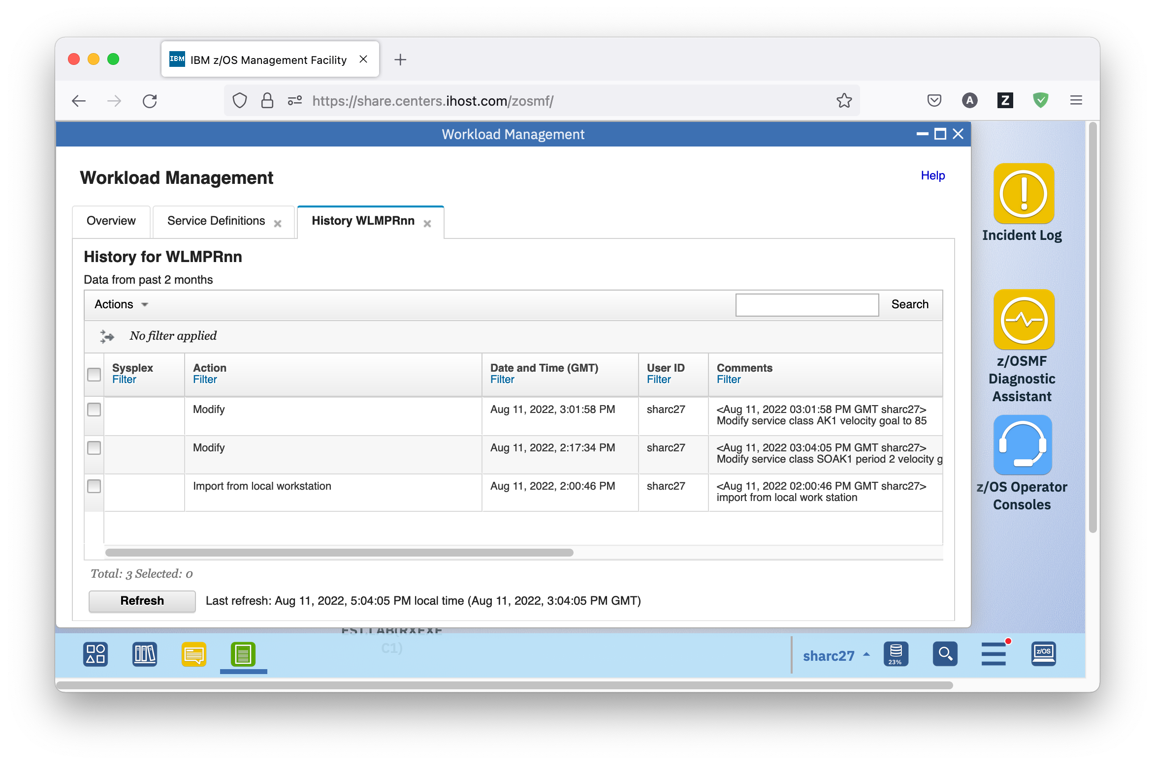

* By default, the history information is captured for the last two months. In the Settings tab, you can specify how long to keep the service definition history. To view the Settings tab, switch to the Overview tab of the Workload Management task and click on the *Settings* hyperlink.

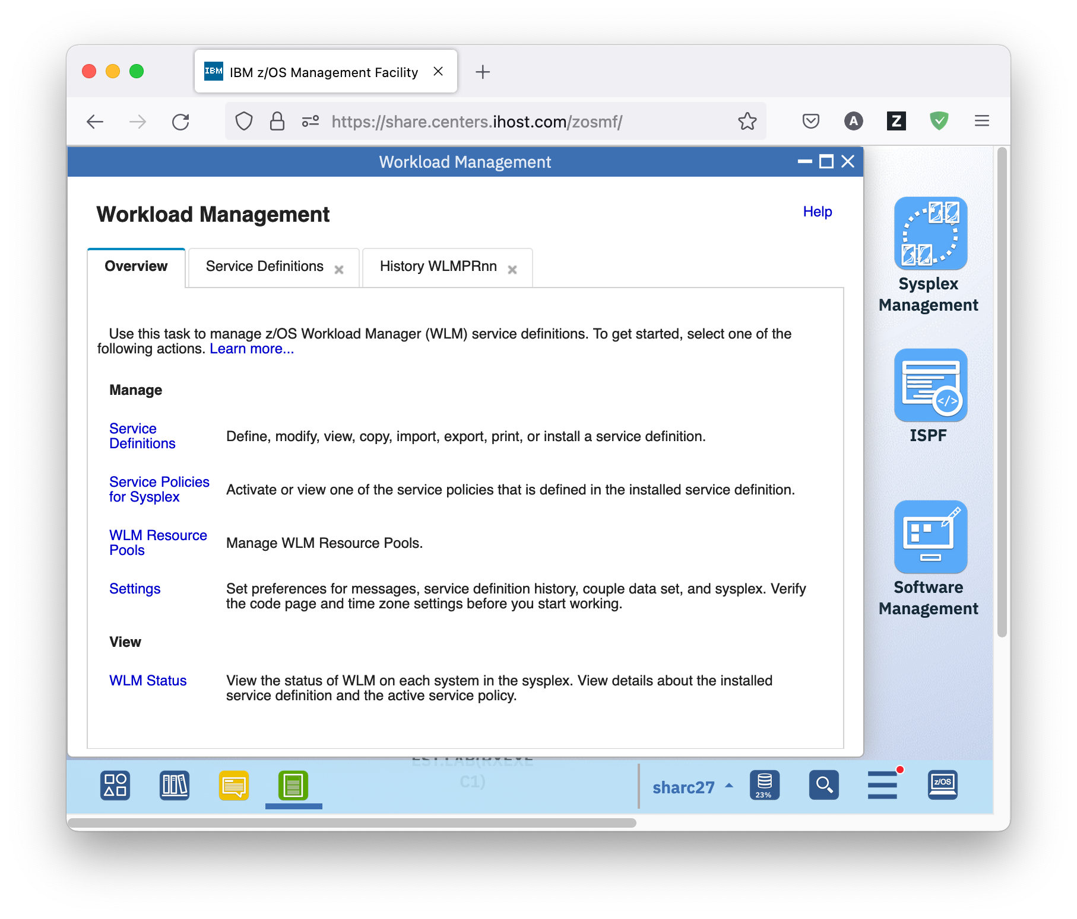

* The Settings tab allows you to specify how long to keep the service definition history, whether comments are required for service definition actions, what types of consistence checking is done, and other settings. Review the help available for the Settings tab by clicking the *Help* hyperlink top right.

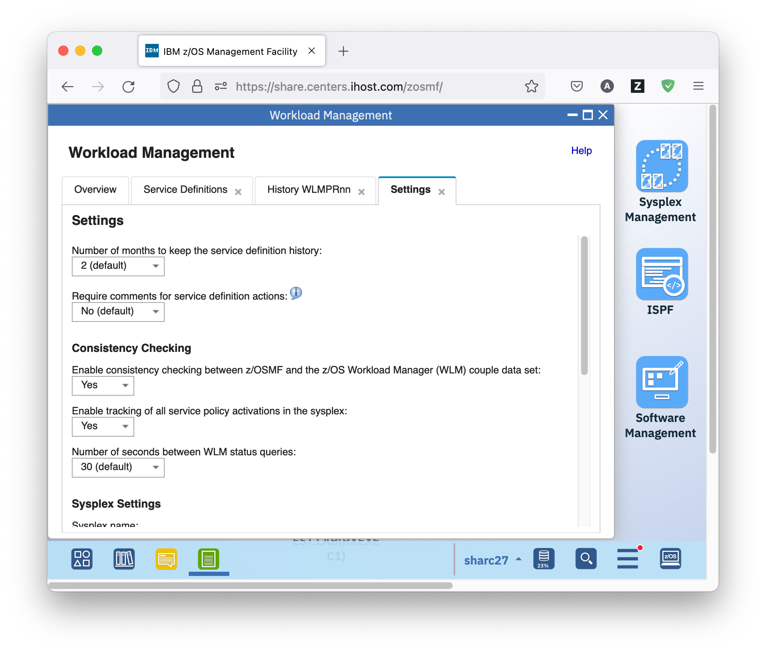

* 1. Print Preview of a Service Definition

Another thing you might want to do after having modified service definition WLMPRnn is printing it, to review your changes. For that, the z/OSMF Workload Management task offers a print preview for service definitions in HTML format.

## Exercise

* On the Service Definitions tab, select service definition WLMPRnn and either right-click it, or open the Actions menu, and choose *Print Preview*. The Print Preview WLMPRnn tab opens, displaying the service definition in HTML format. You can see the same sections as in the View or Modify submenu of the Service Definitions panel, however, with a bit more structure. For example, information about a service class is displayed within the corresponding workload in the Workloads section.

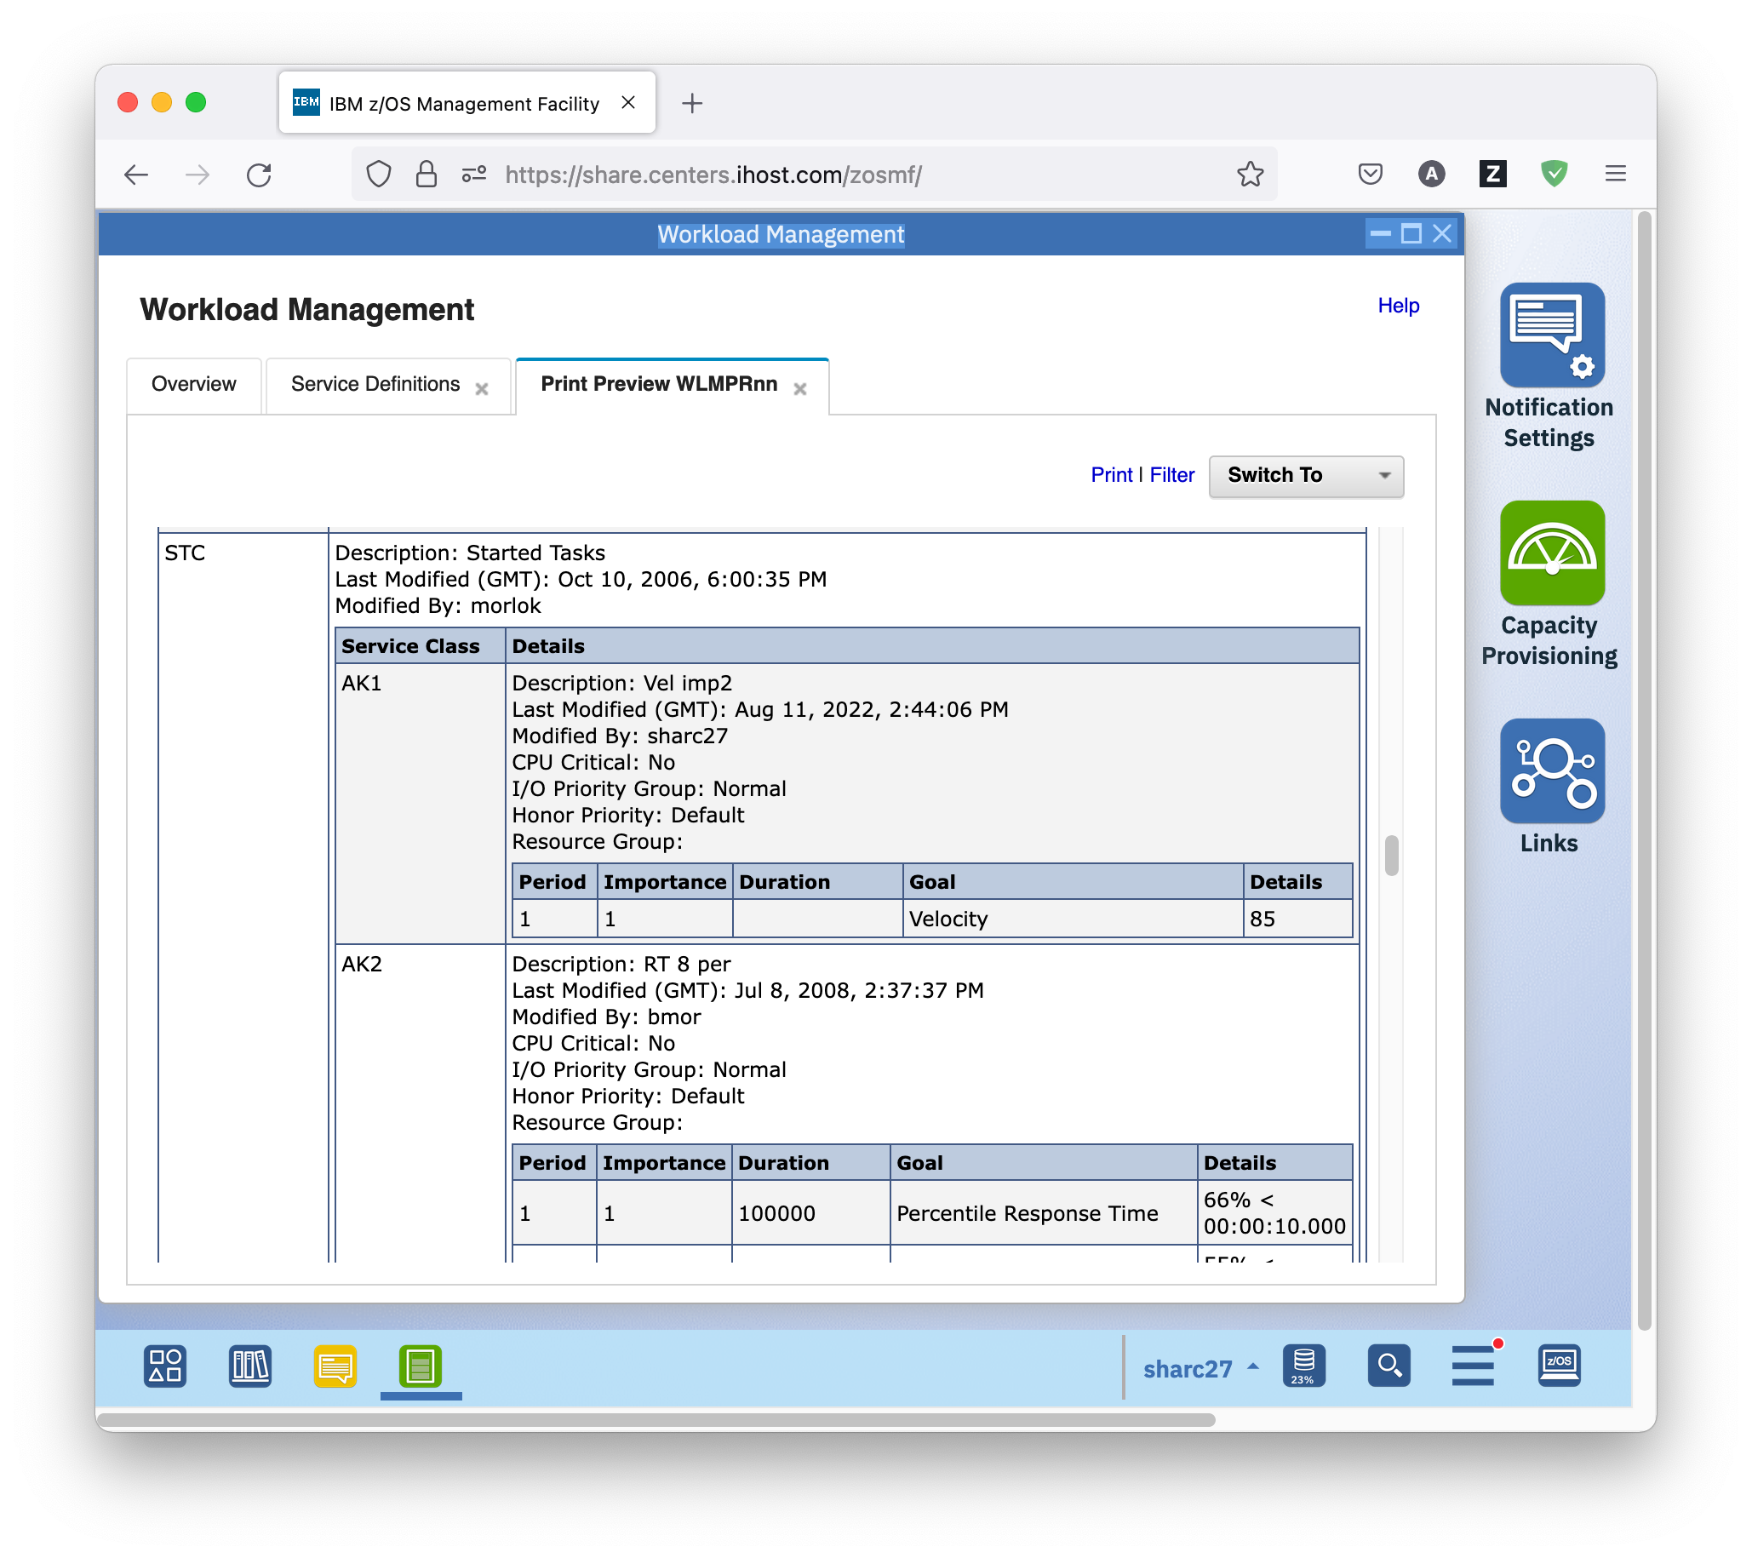

* You can also filter which pieces of the service definition are displayed in the print preview. To do so, click on the *Filter* hyperlink top right of the panel. A dialog opens that allows you to select which pieces are displayed.

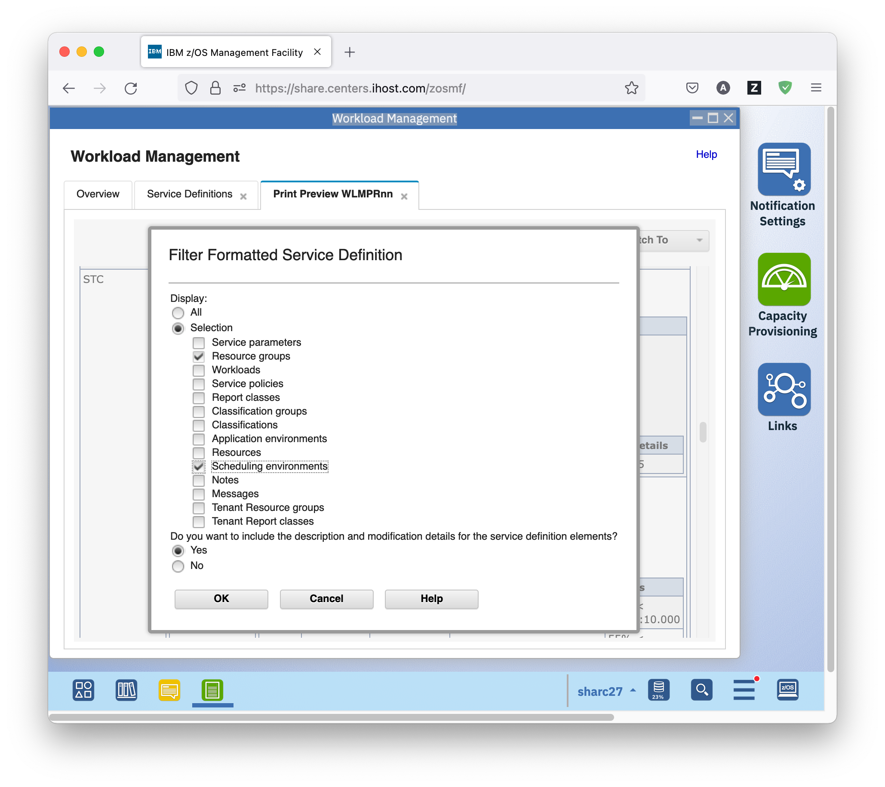

* The Switch To menu top right allows you to choose between previewing the formatted service definition and its formatted service policies. The main difference between the two is that in the latter, the Service Policies section is omitted and the overrides are directly reflected in the corresponding service classes and resource groups.

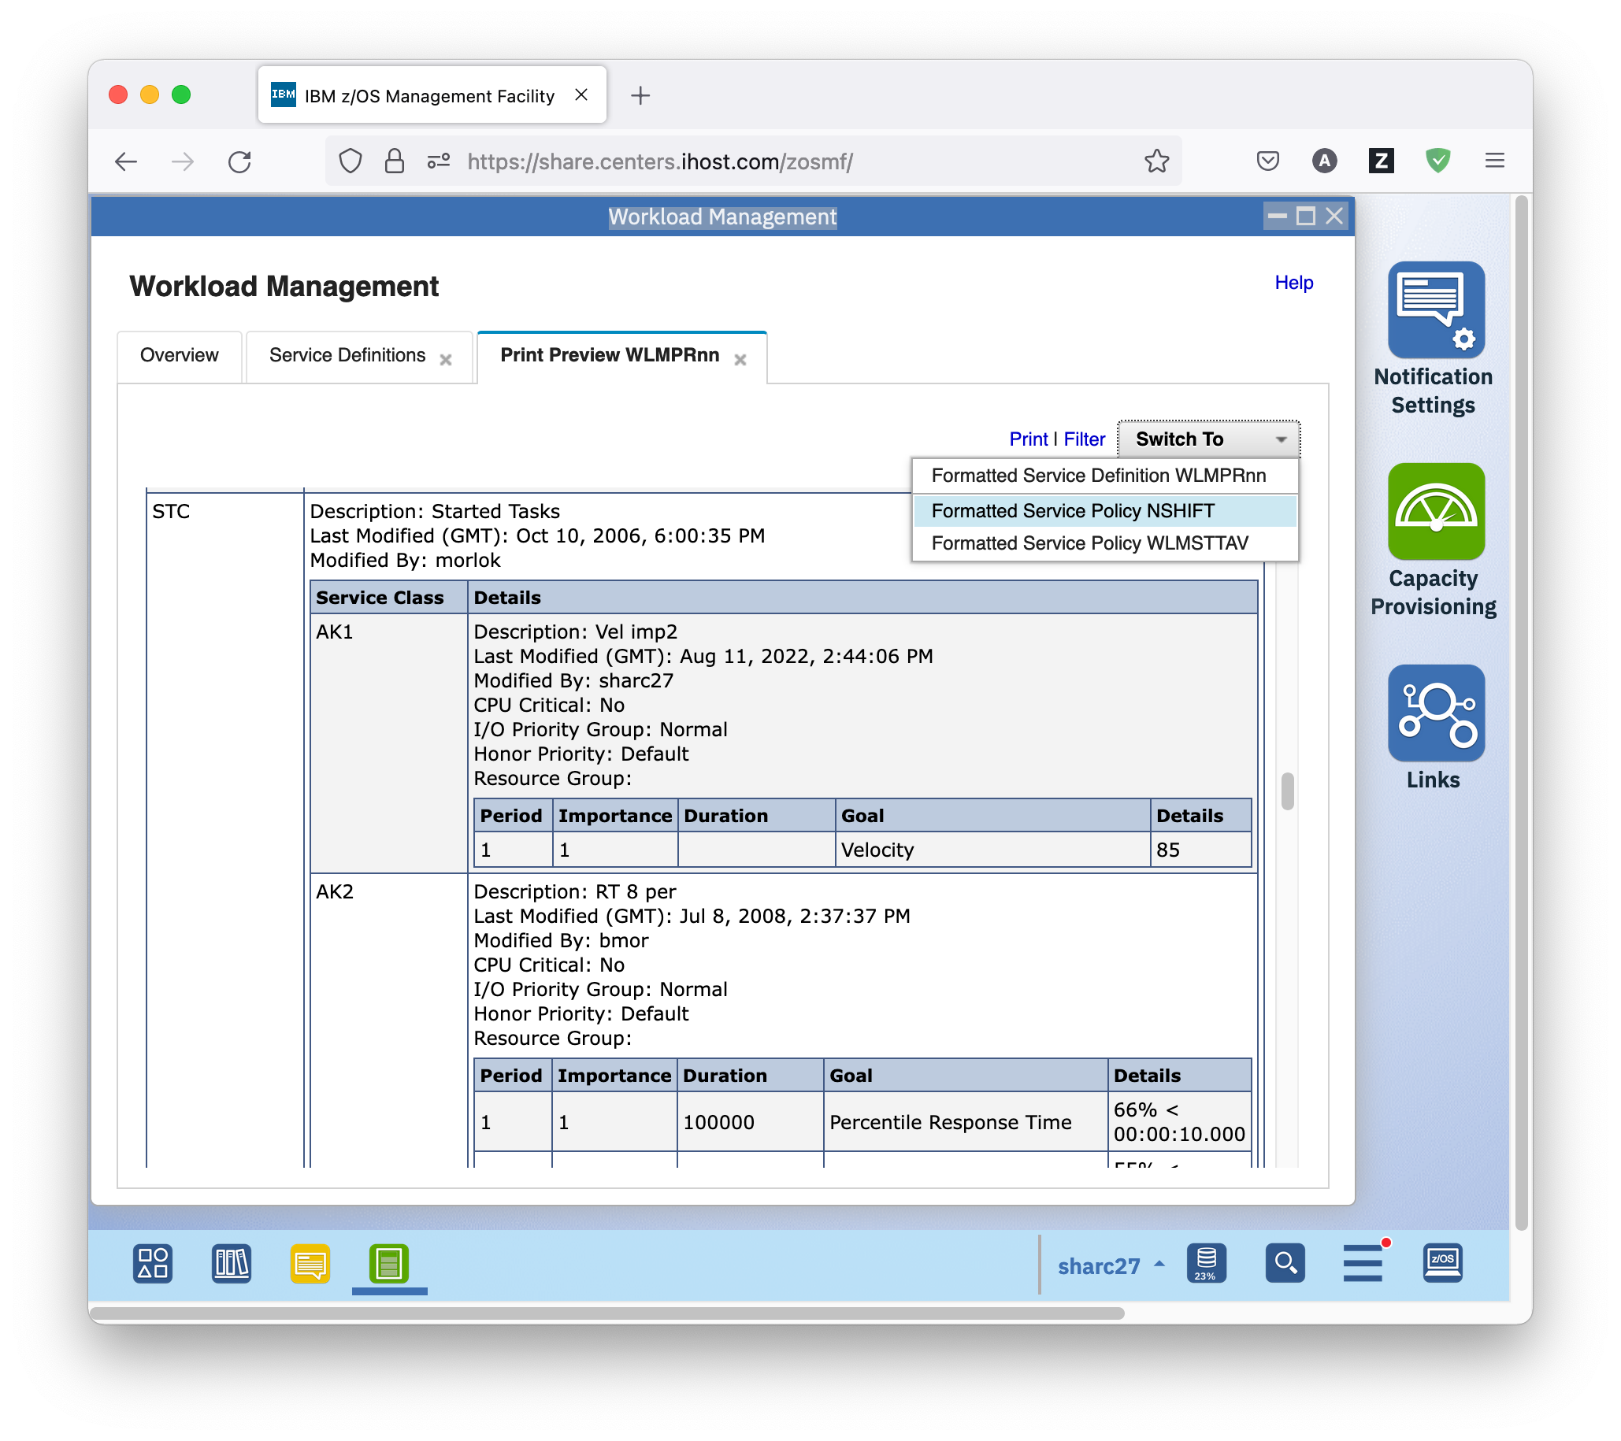

* To actually print the service definition, press the *Print* hyperlink top right. A new web browser tab or window opens with the same content. From there you can print the service definition by pressing the *Send to Printer* hyperlink top right.
  1. Exporting Service Definitions to Files

Another thing you might want to do after having modified service definition WLMPRnn is saving it to a file. For that, the z/OSMF Workload Management task offers action *Export*, either *To Local Workstation*, or *To Host Data Set*.

With that action, you can save the file to your local workstation, or to a host data set, from where you can import it, for example, into the Service Definitions table of a z/OSMF instance running on another Sysplex using the *Import From Local Workstation* action of the Service Definitions table.

## Exercise

* On the Service Definitions tab, select service definition WLMPRnn and either right-click it, or open the Actions menu, and choose *Export – To Local Workstation*. A dialog opens where you can choose format and scope of the export.

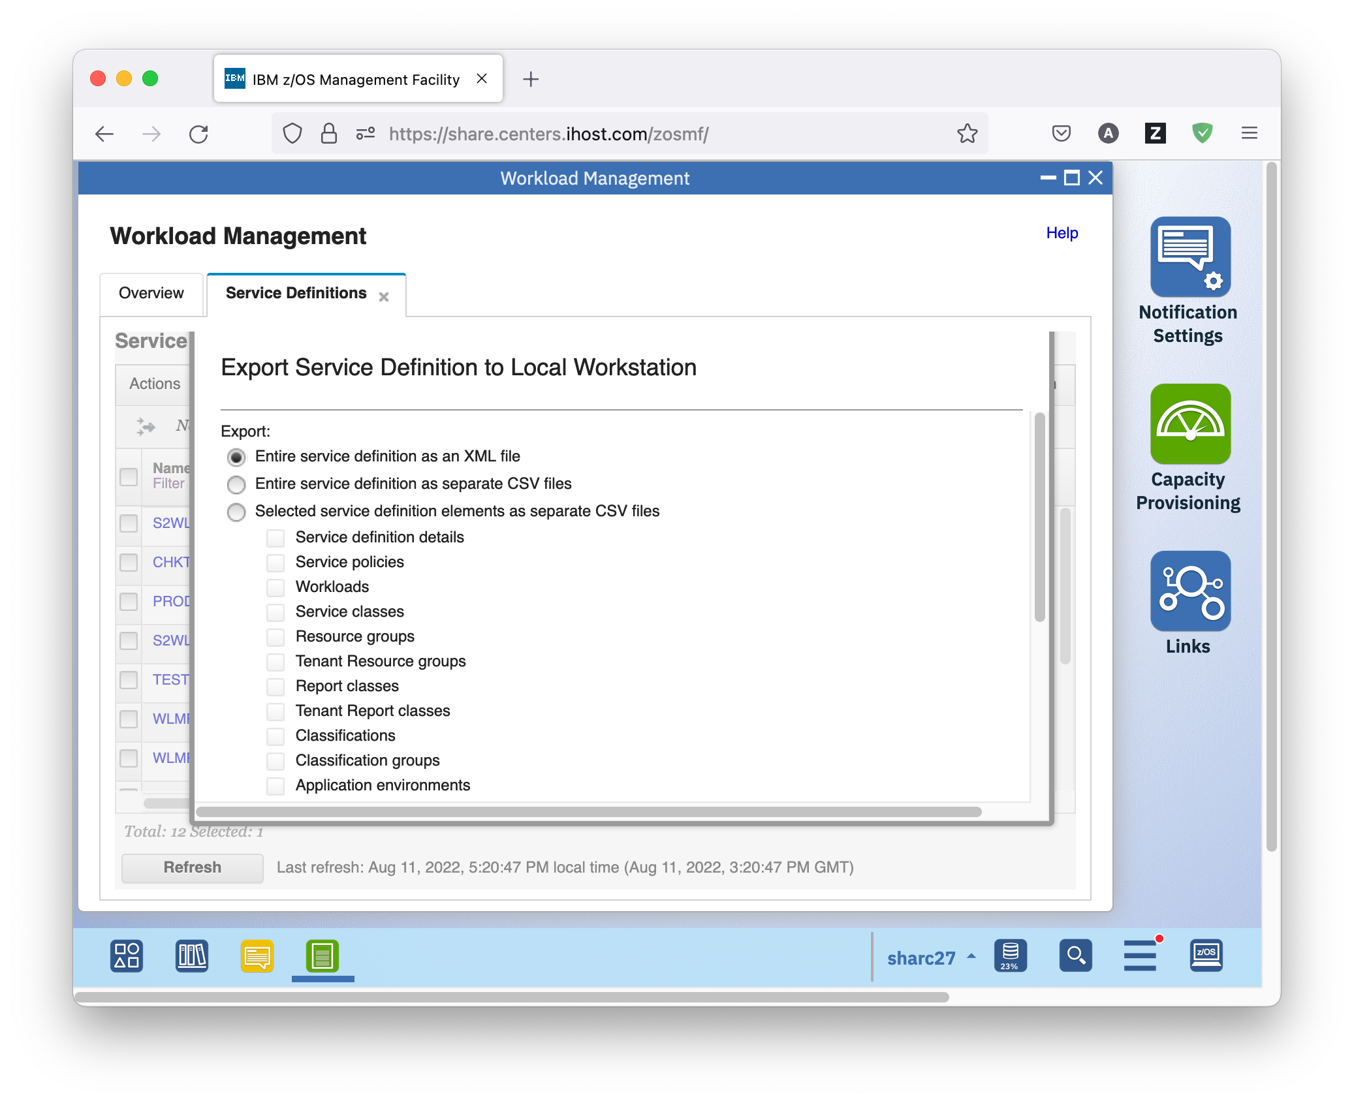

* A browser dialog opens το saving the file to the local disk.

**If you still have the time and feel like it, proceed with the optional exercises.**

However, just make sure that you have 2 minutes left in the end for doing the cleanup described in the last section☺!

* 1. Optional: Editing a Service Definition

Suppose you want to modify your service definition by adding new service classes, new service class overrides, or new service policies. The z/OSMF Workload Management task provides much guidance for required fields and valid values – you get immediate feedback of what is going wrong. Furthermore, it allows copying and pasting various service definition elements within a service definition, or even between different service definitions.

## Exercise

* On the Service Definitions tab, select service definition WLMPRnn and either right-click it, or open the Actions menu, and choose *Modify Service Definition – Service Classes*. On the Modify WLMPRnn tab that opens, select *Actions – New Service Class*.
* A new service class with empty name and a default discretionary period is created. Double click the name field, and enter a name, for example, NEWSC.
* If you scroll to the right, you see an error icon in the Workload column of the new service class. Mouse over it to view the detailed error message

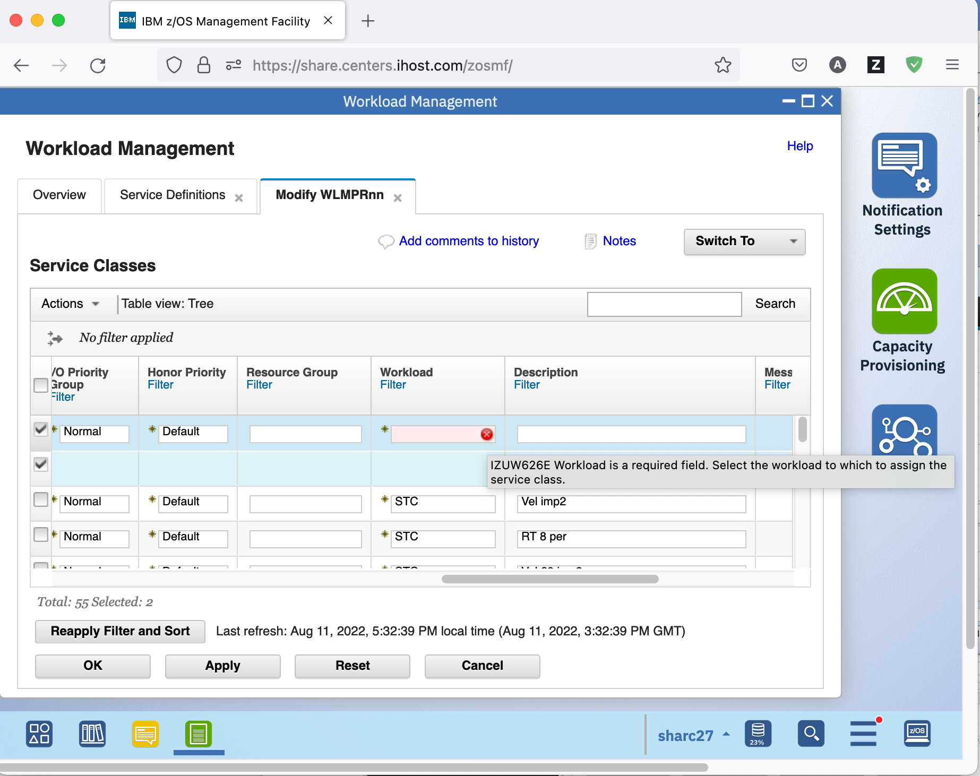

* Double click the Workload field, and select a workload for the new service class, for example, TSO. The error icon disappears.
* Now double click the Goal Type field of the service class period, and select *Percentile Response Time*. If you scroll to the right, you see that the Response Time Goal and Percentile Goal columns are in error. To view the detailed error messages, click on the *Error* hyperlink in the Messages column of the new service class. A Messages window opens that displays detailed information about the errors.

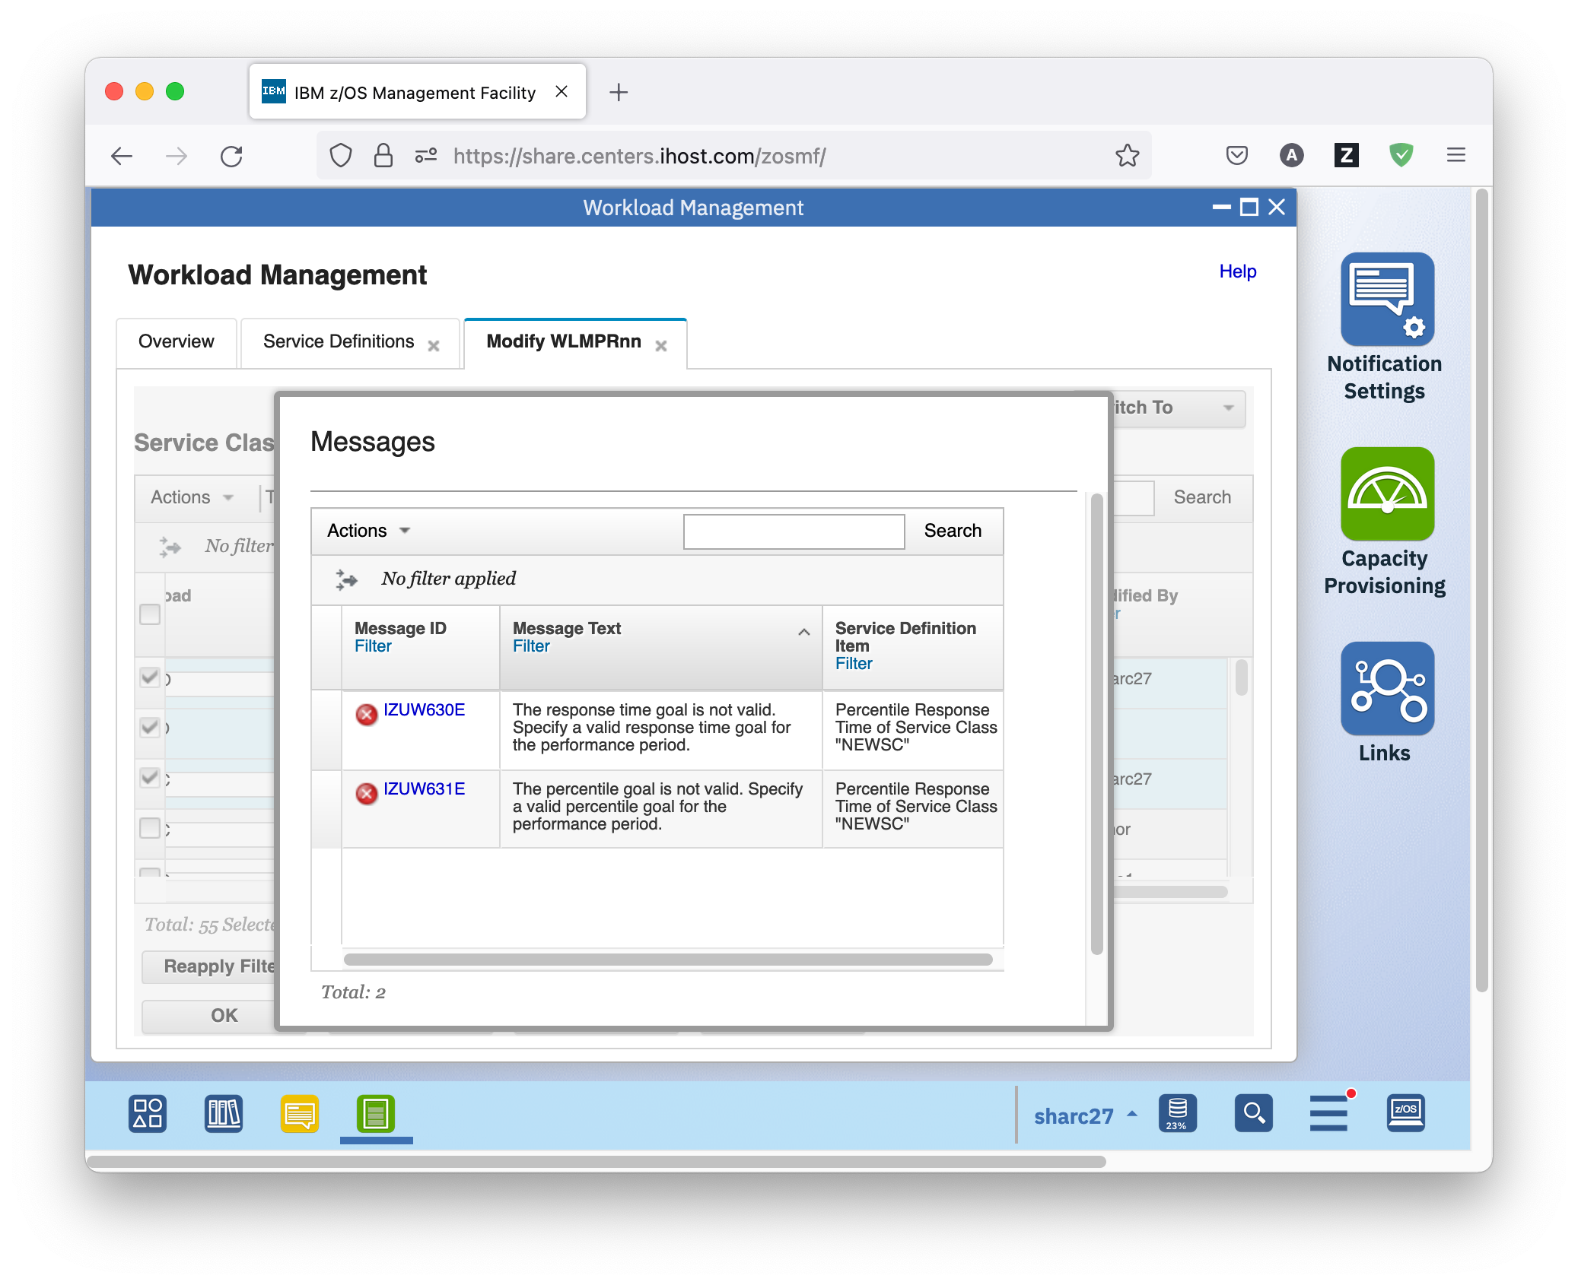

* To fix the errors, double click the Response Time Goal, and specify 00:00:01.000. Double click the Percentile Goal, and specify 90. This means that 90% of the transactions should complete in at most 1 second.
* You can also copy and paste service classes or service class periods. To do so, click the Deselect all action.

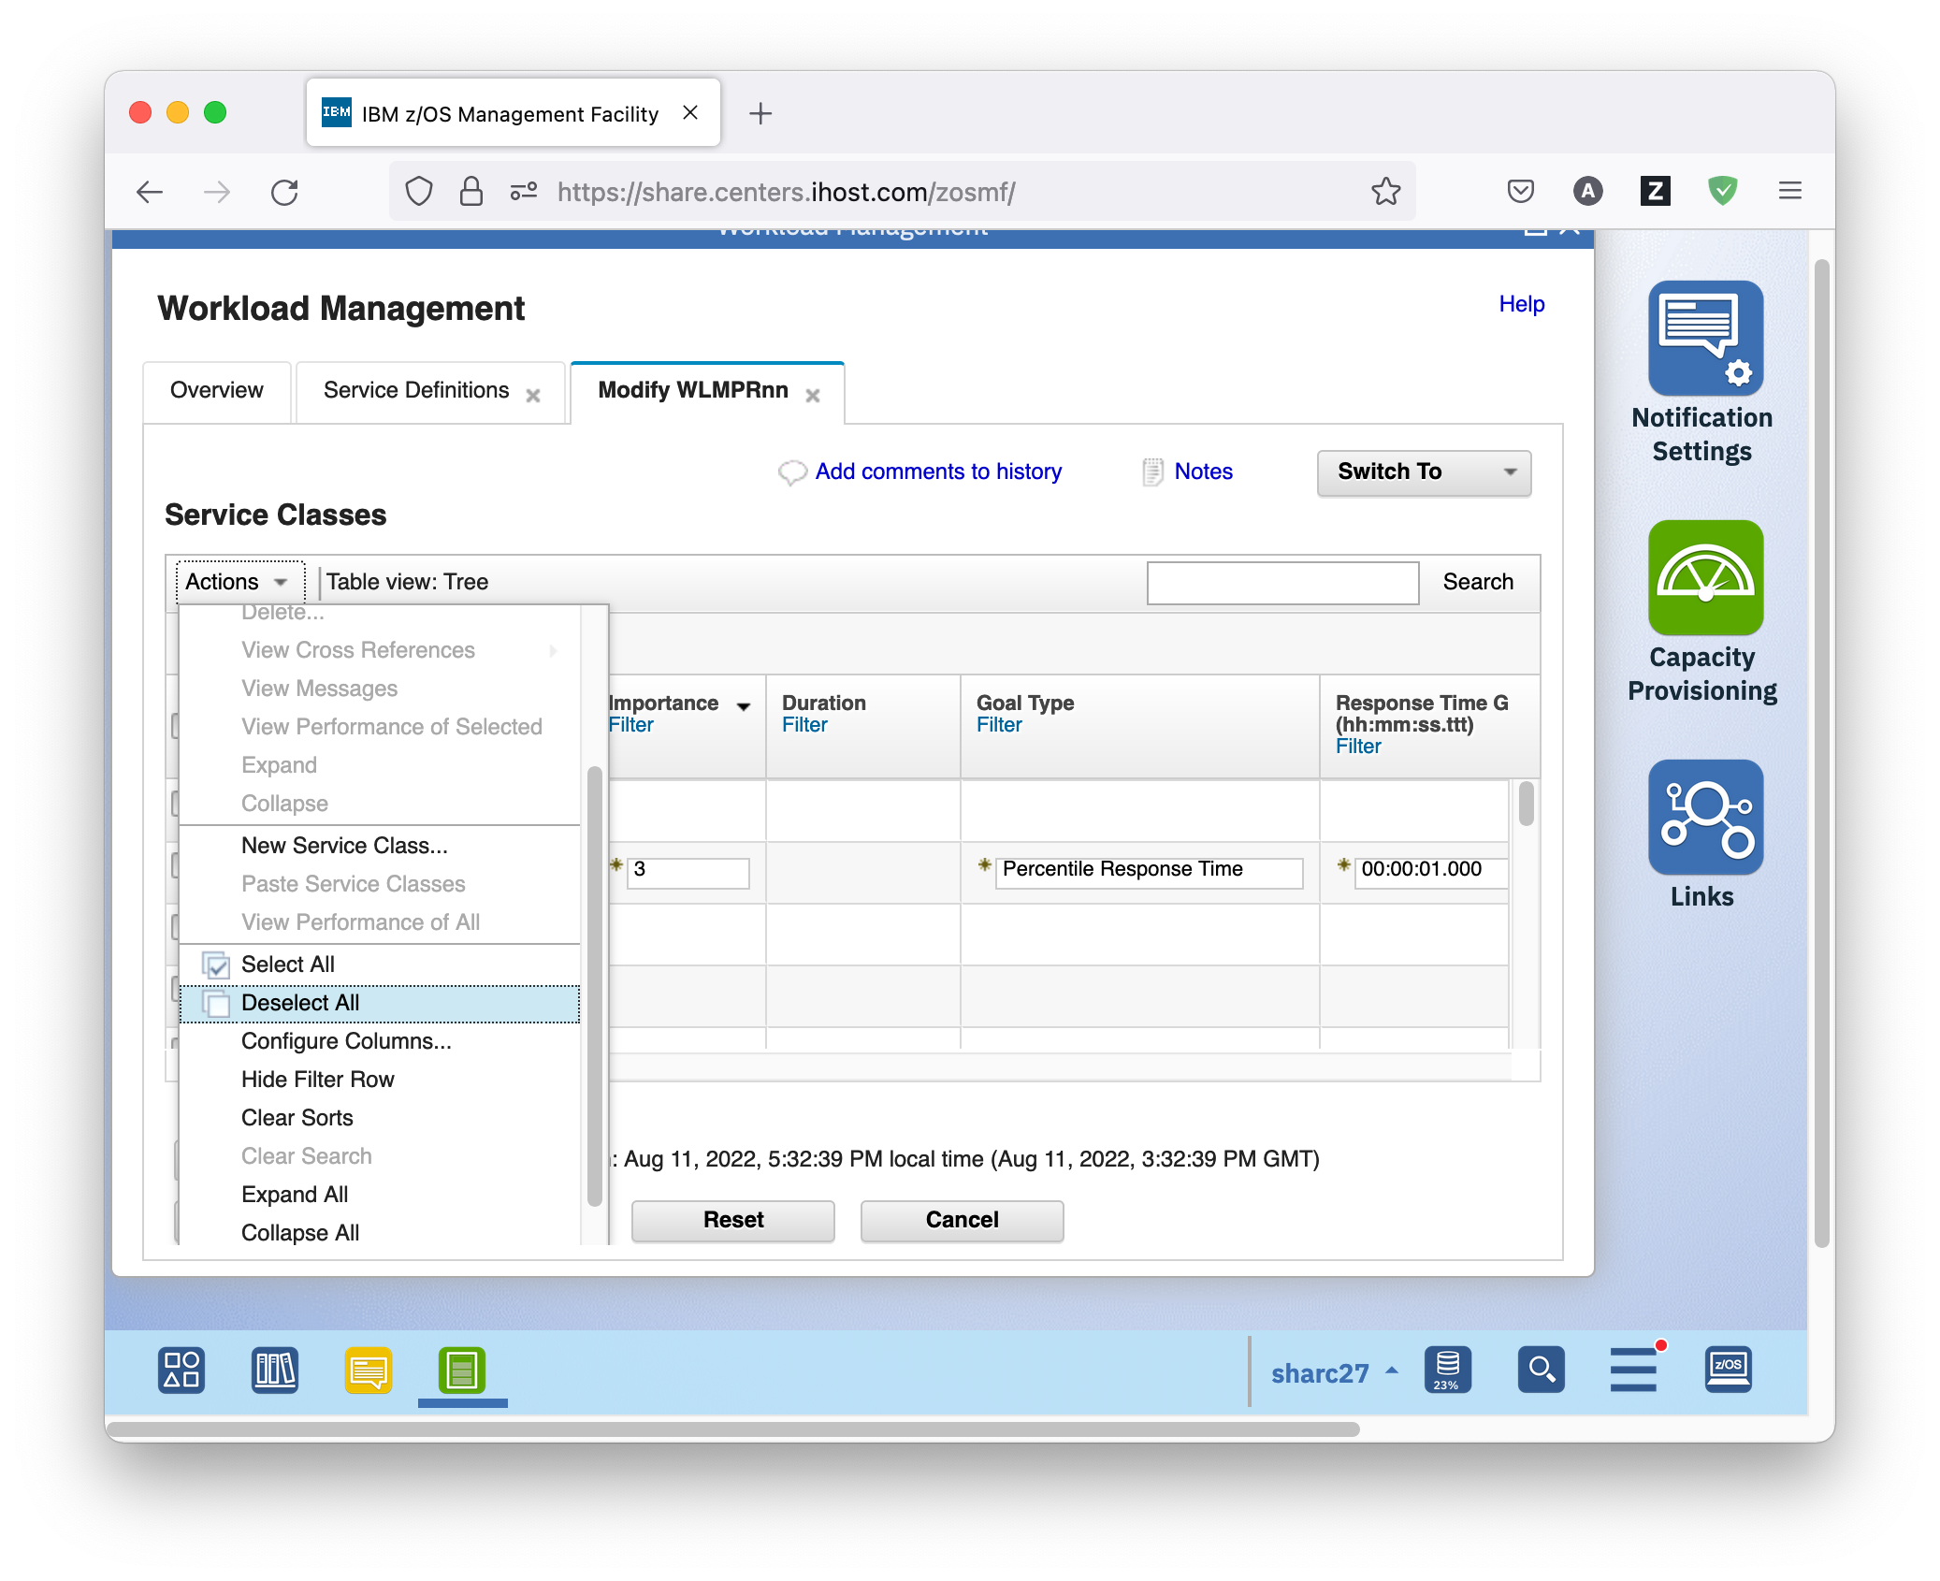

* Then scroll to service class SOAKI1, expand it, and select its first period. Then click on *Actions – Copy to Clipboard*.

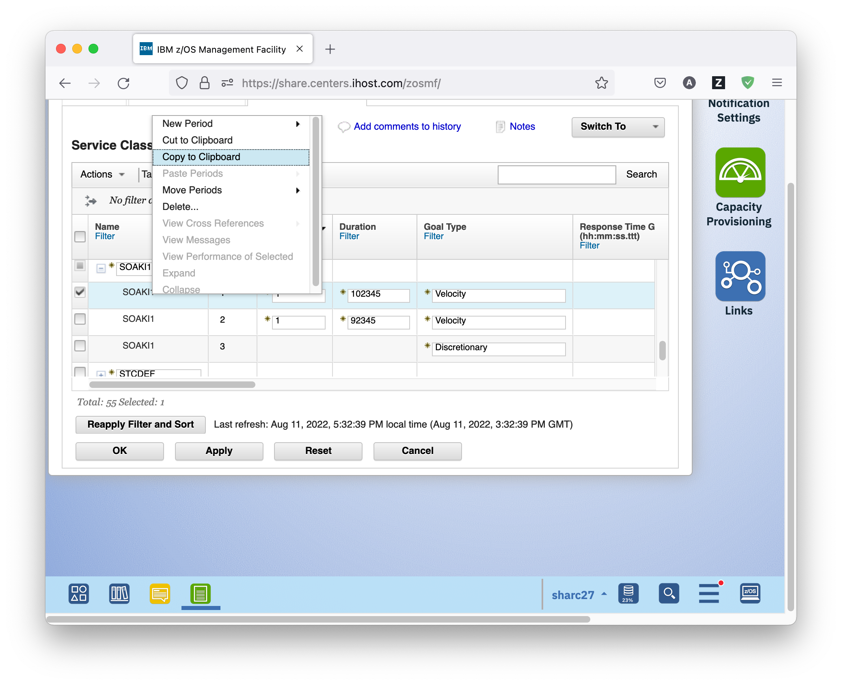

* Then, click again the Deselect all action again. Scroll to your new service class NEWSC, select its period, and click on *Actions – Paste Periods – Before*. It is important that just the period was copied and not the whole class, otherwise paste period will not work.

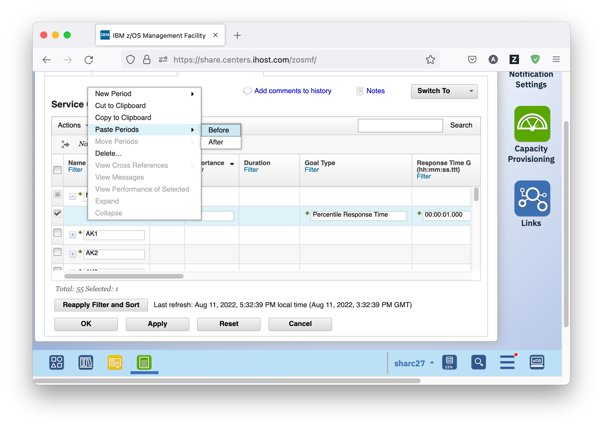

* If you scroll to the right, you see that there is a warning message for the second period in the Messages column. To view the detailed error messages, click on the *Error* hyperlink in the Messages column. A Messages window opens that displays detailed information about the error.

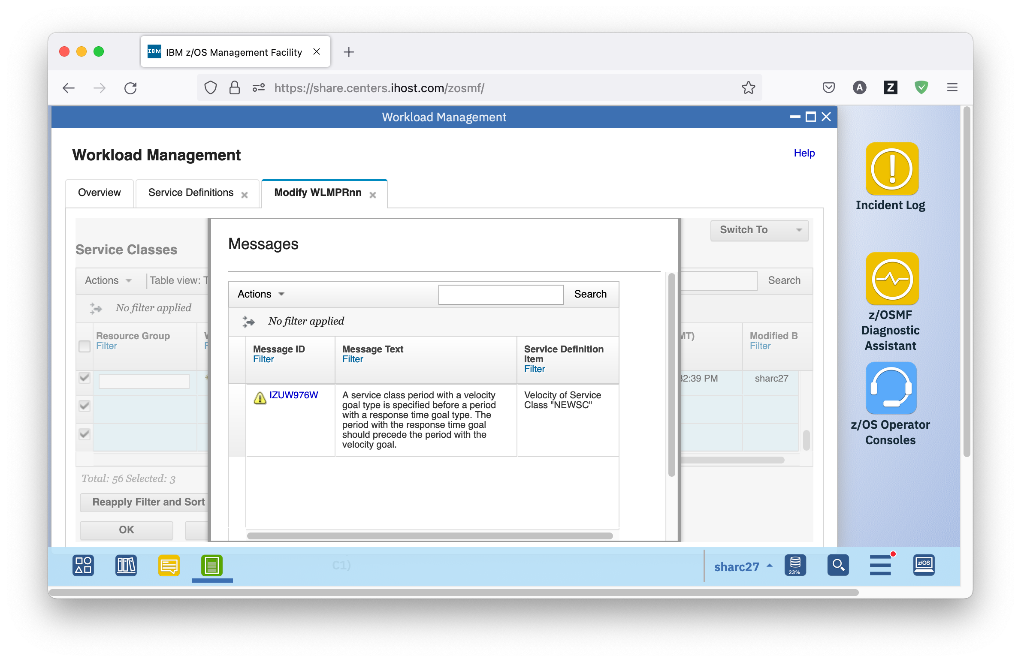

* To fix the error, select the velocity period of your new service class, and select *Actions – Move Periods – Down*. This moves the velocity period after the Percentile Response Time period. However, this leads to two new error conditions being indicated for the Importance and Duration columns. If you mouse over the error icons, you see that both fields are not valid. To see detailed information about the errors, scroll to the right, and click on the *Error* hyperlink in the Messages column of the new service class. A Messages window opens that displays detailed information about the errors. To see more detailed explanations, click on the Message IDs in the Messages window. There, you learn that a duration value must be specified for the (now first) Percentile Response Time Period, and that the importance of a period must not be greater than the importance of the preceding period.

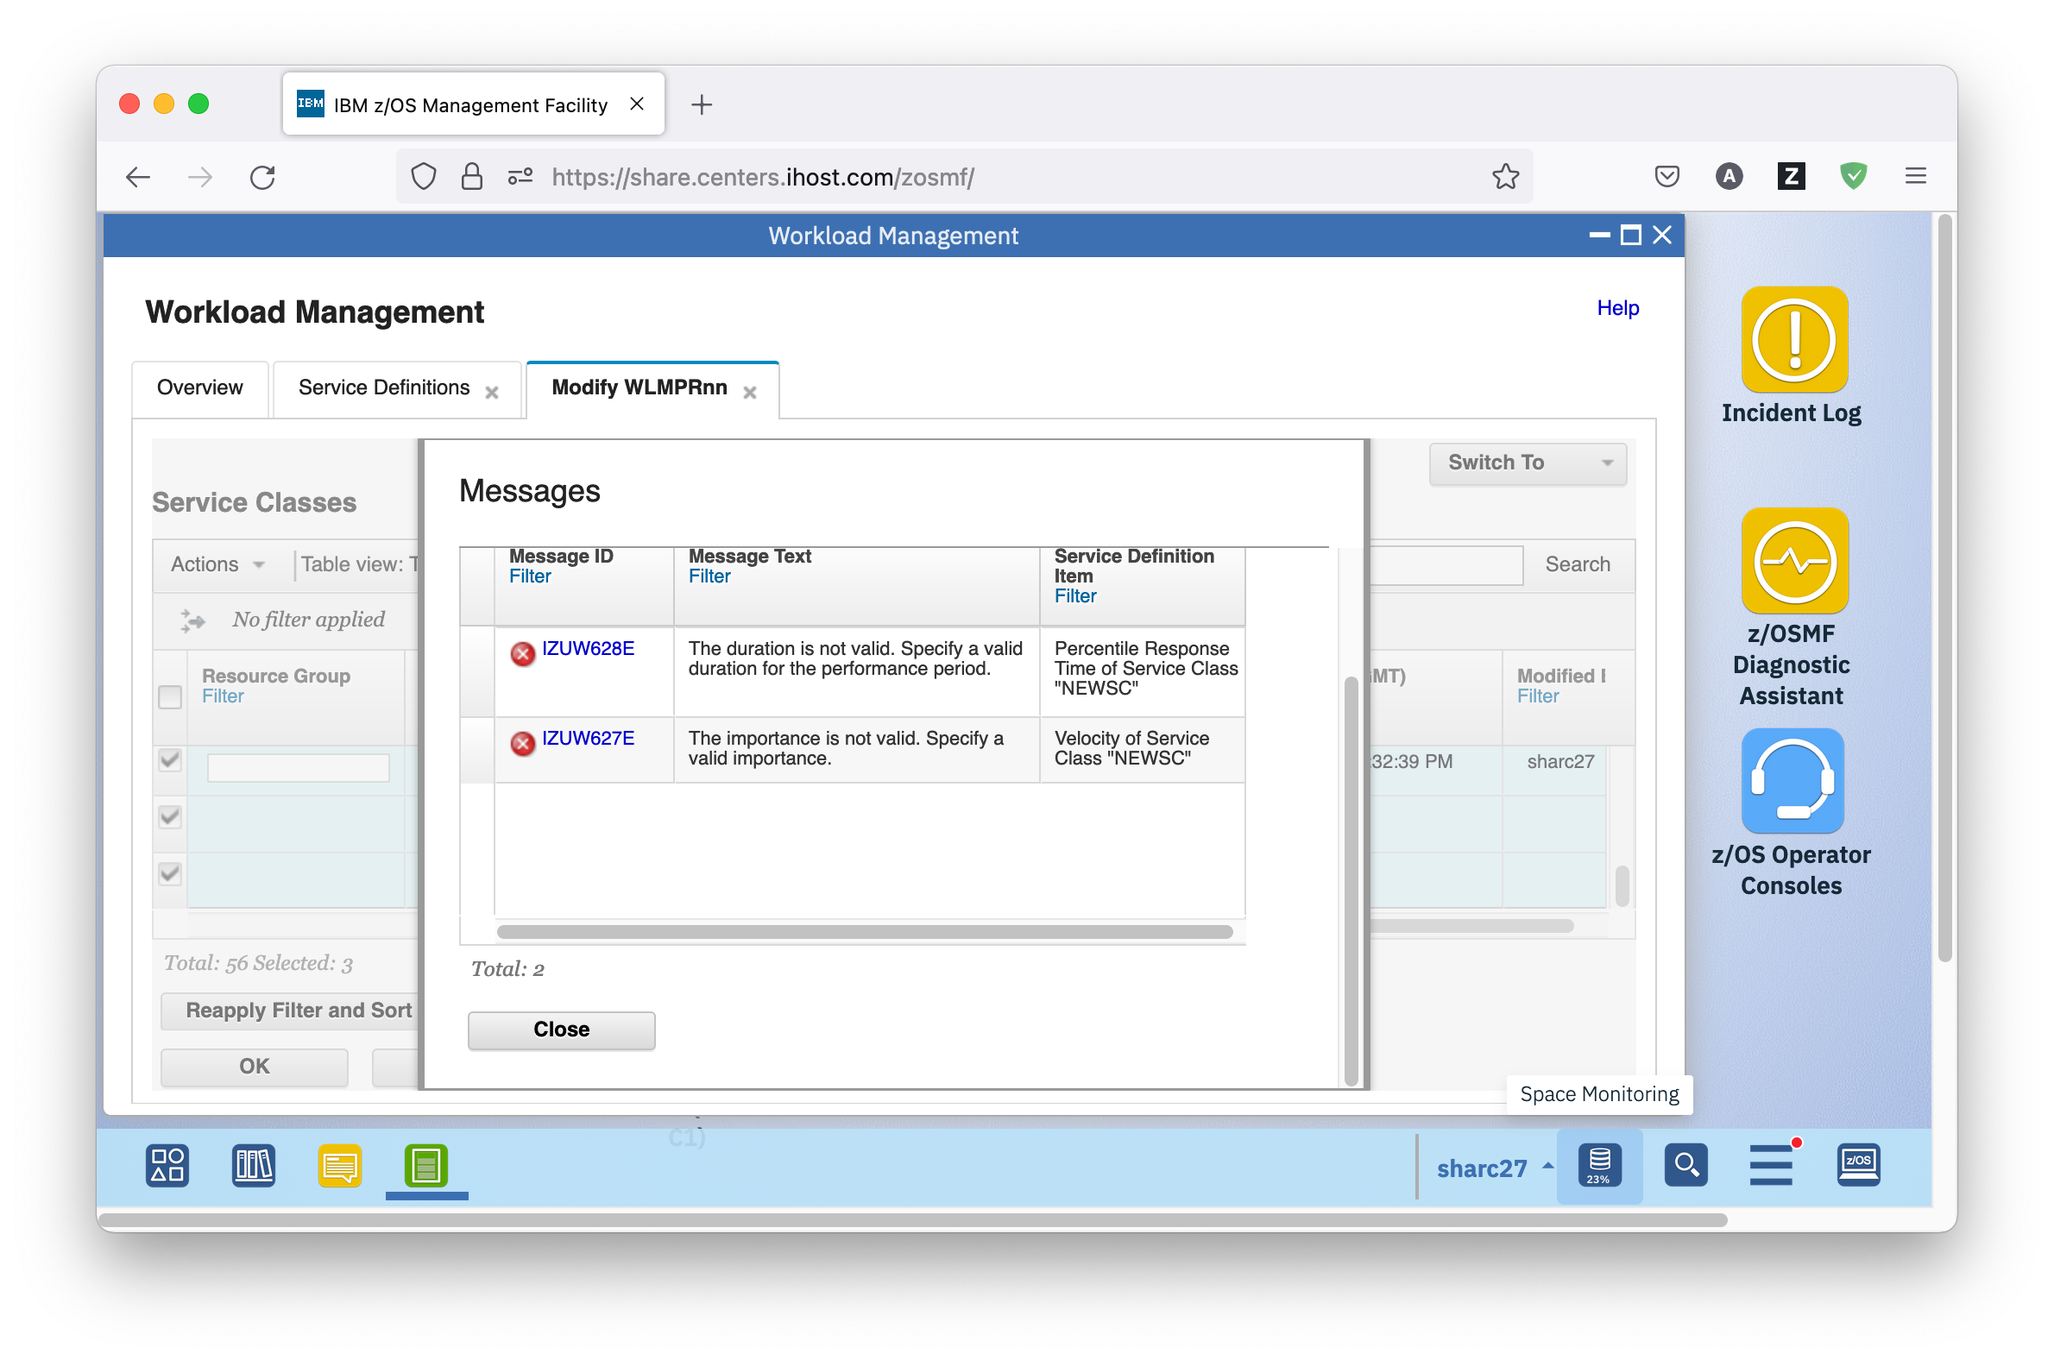

* To fix the problem, double click the Duration field of the Percentile Response Time Period, and enter a duration value, for example, 3333. Then, double click the Importance field of the velocity period, and select value 4. Now all error and warning messages are gone.
* The z/OSMF Workload Management task allows copying service definition elements not only inside one tab, but also between different tabs of a service definition. Suppose you want to specify a service class override for your new service class in your night shift policy NSHIFT. To do so, select the one service class periods of your new service class, and click on *Actions – Copy to Clipboard*.
* Navigate to the Service Policies tab by selecting *Switch To –Service Policies*. Click on the *NSHIFT* hyperlink to get to the night shift service policy. There, create a new service class override by selecting *Actions – New Service Class Override*. Double click the Service Class field, and select your new service class NEWSC. Then, select the default discretionary period of the service class override, and select *Actions – Paste Periods – Before*.

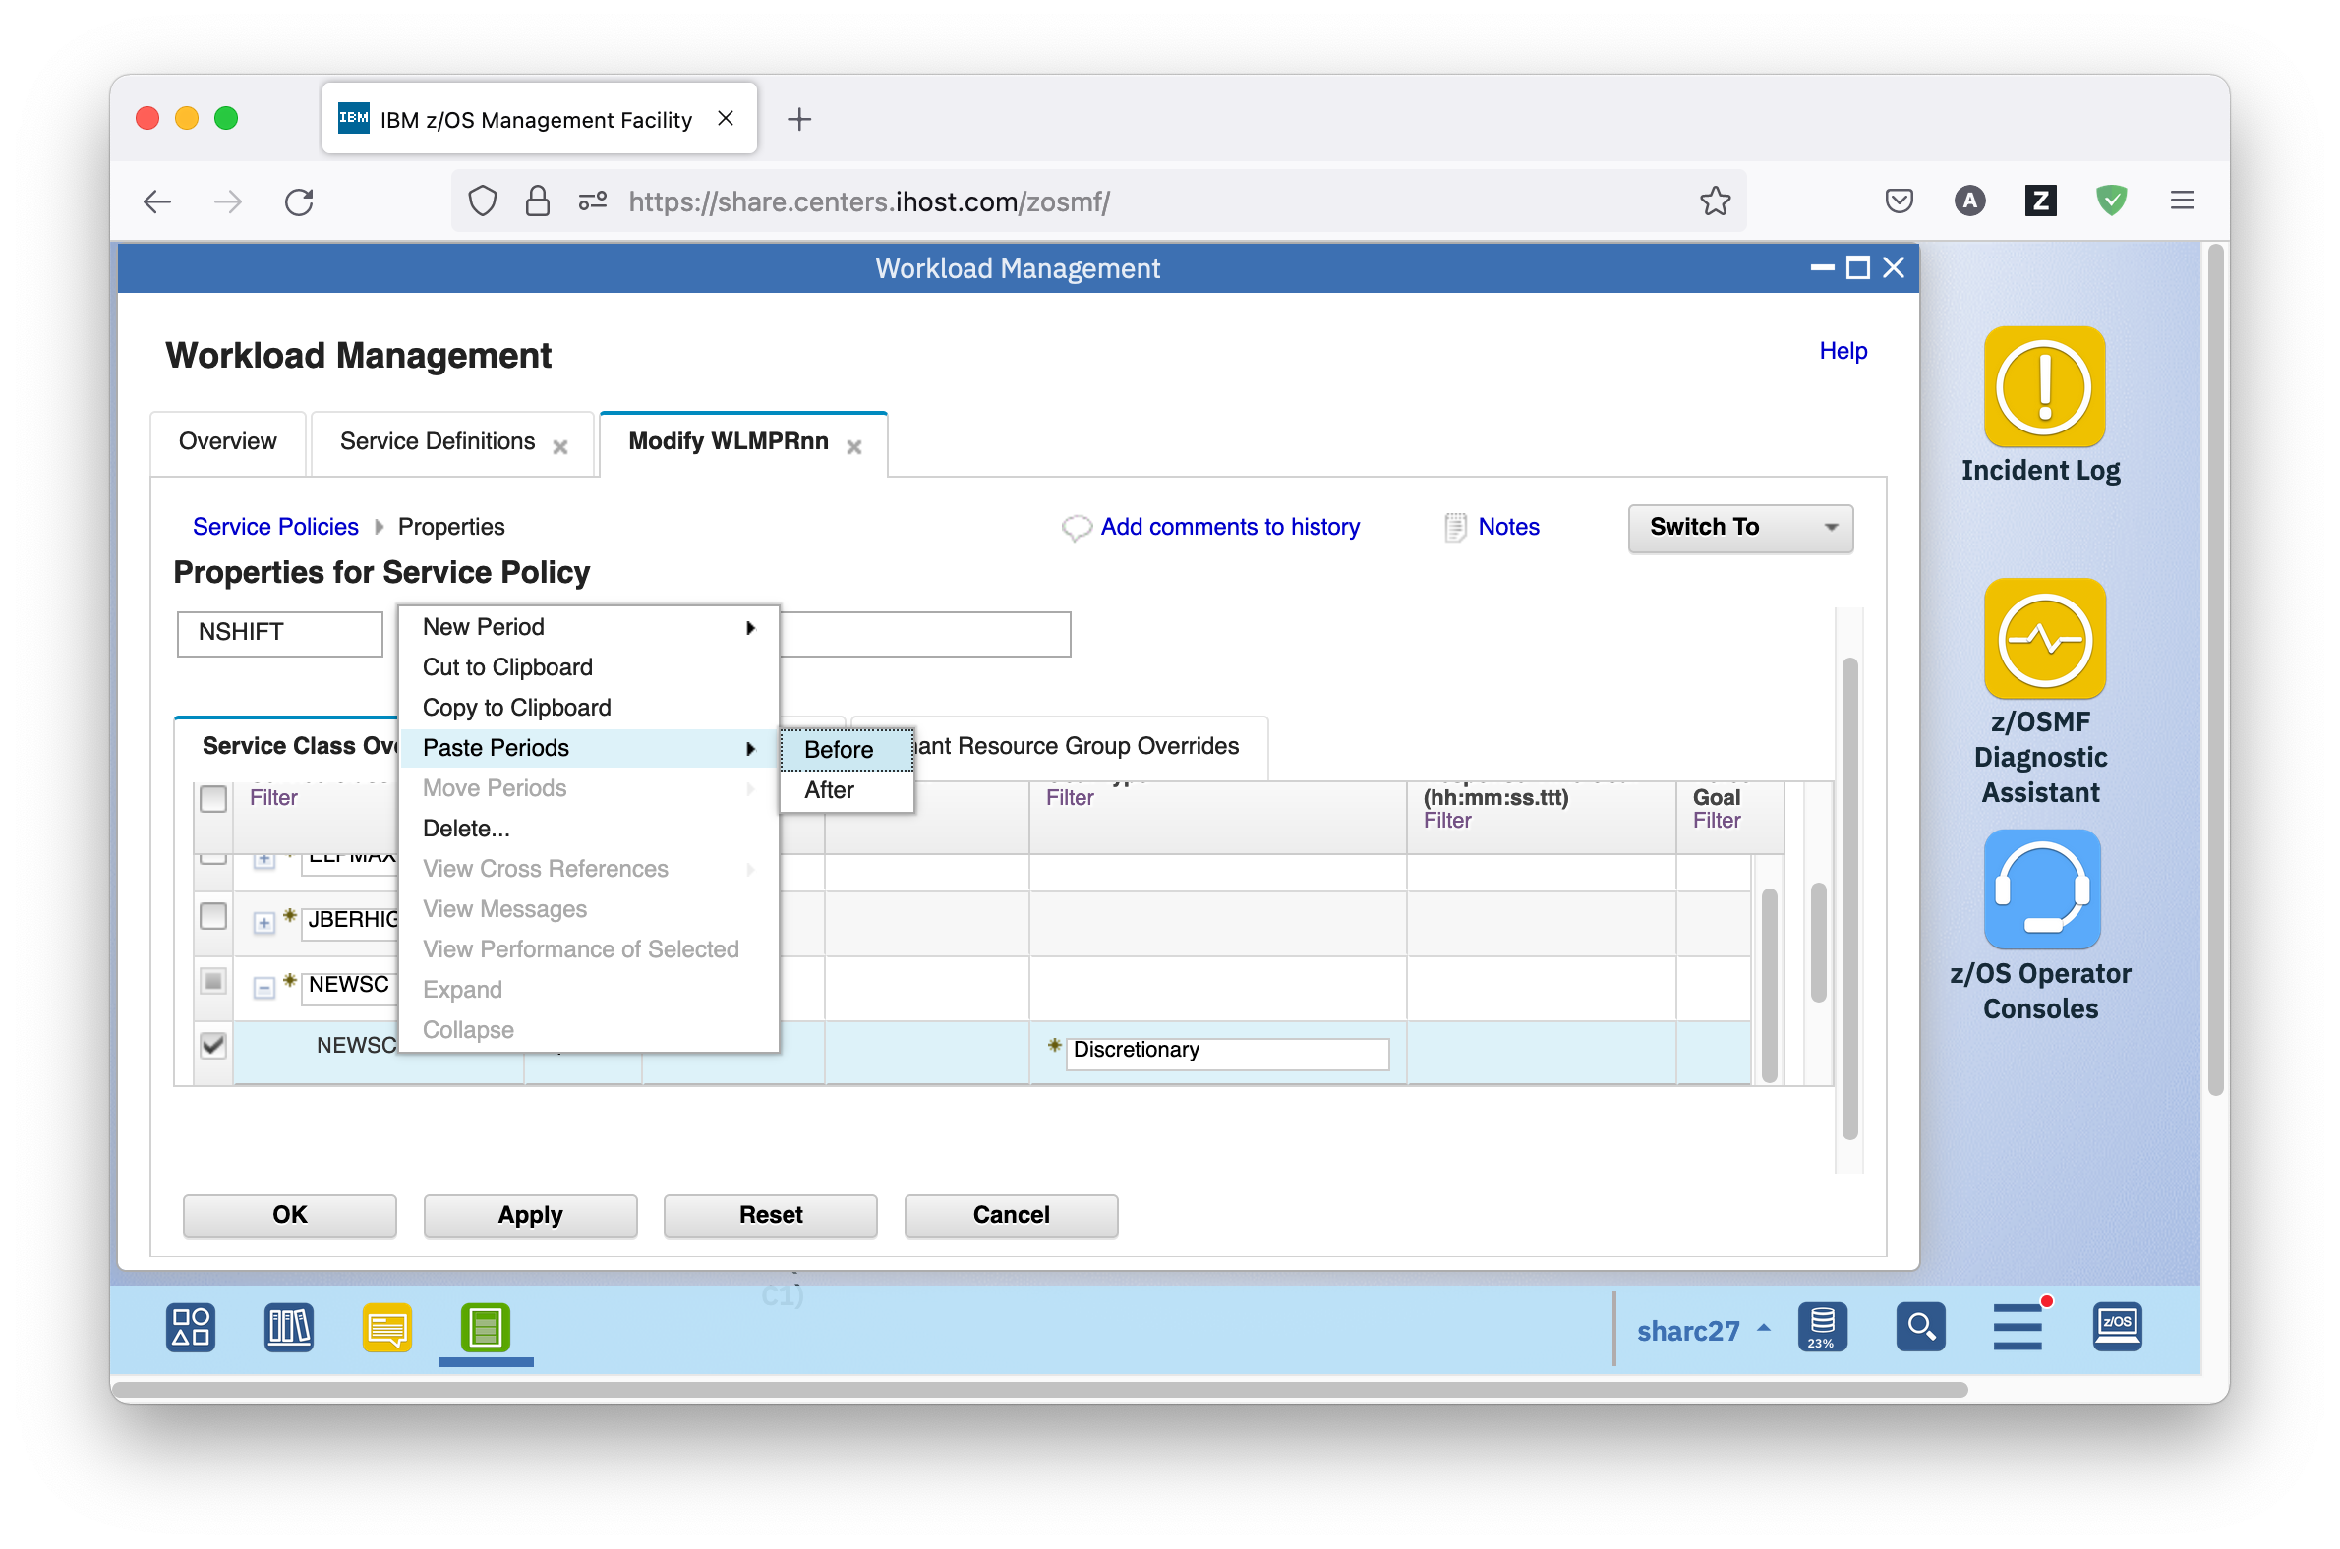

* Select the default discretionary period, and select *Actions – Delete*.
* Now you can modify your goals with more relaxed values for the night shift, for example, a Percentile Response Time Goal of 1 minute, and a Velocity Goal of 20.
* Click the Apply button to save a temporary copy of your changes to the server.

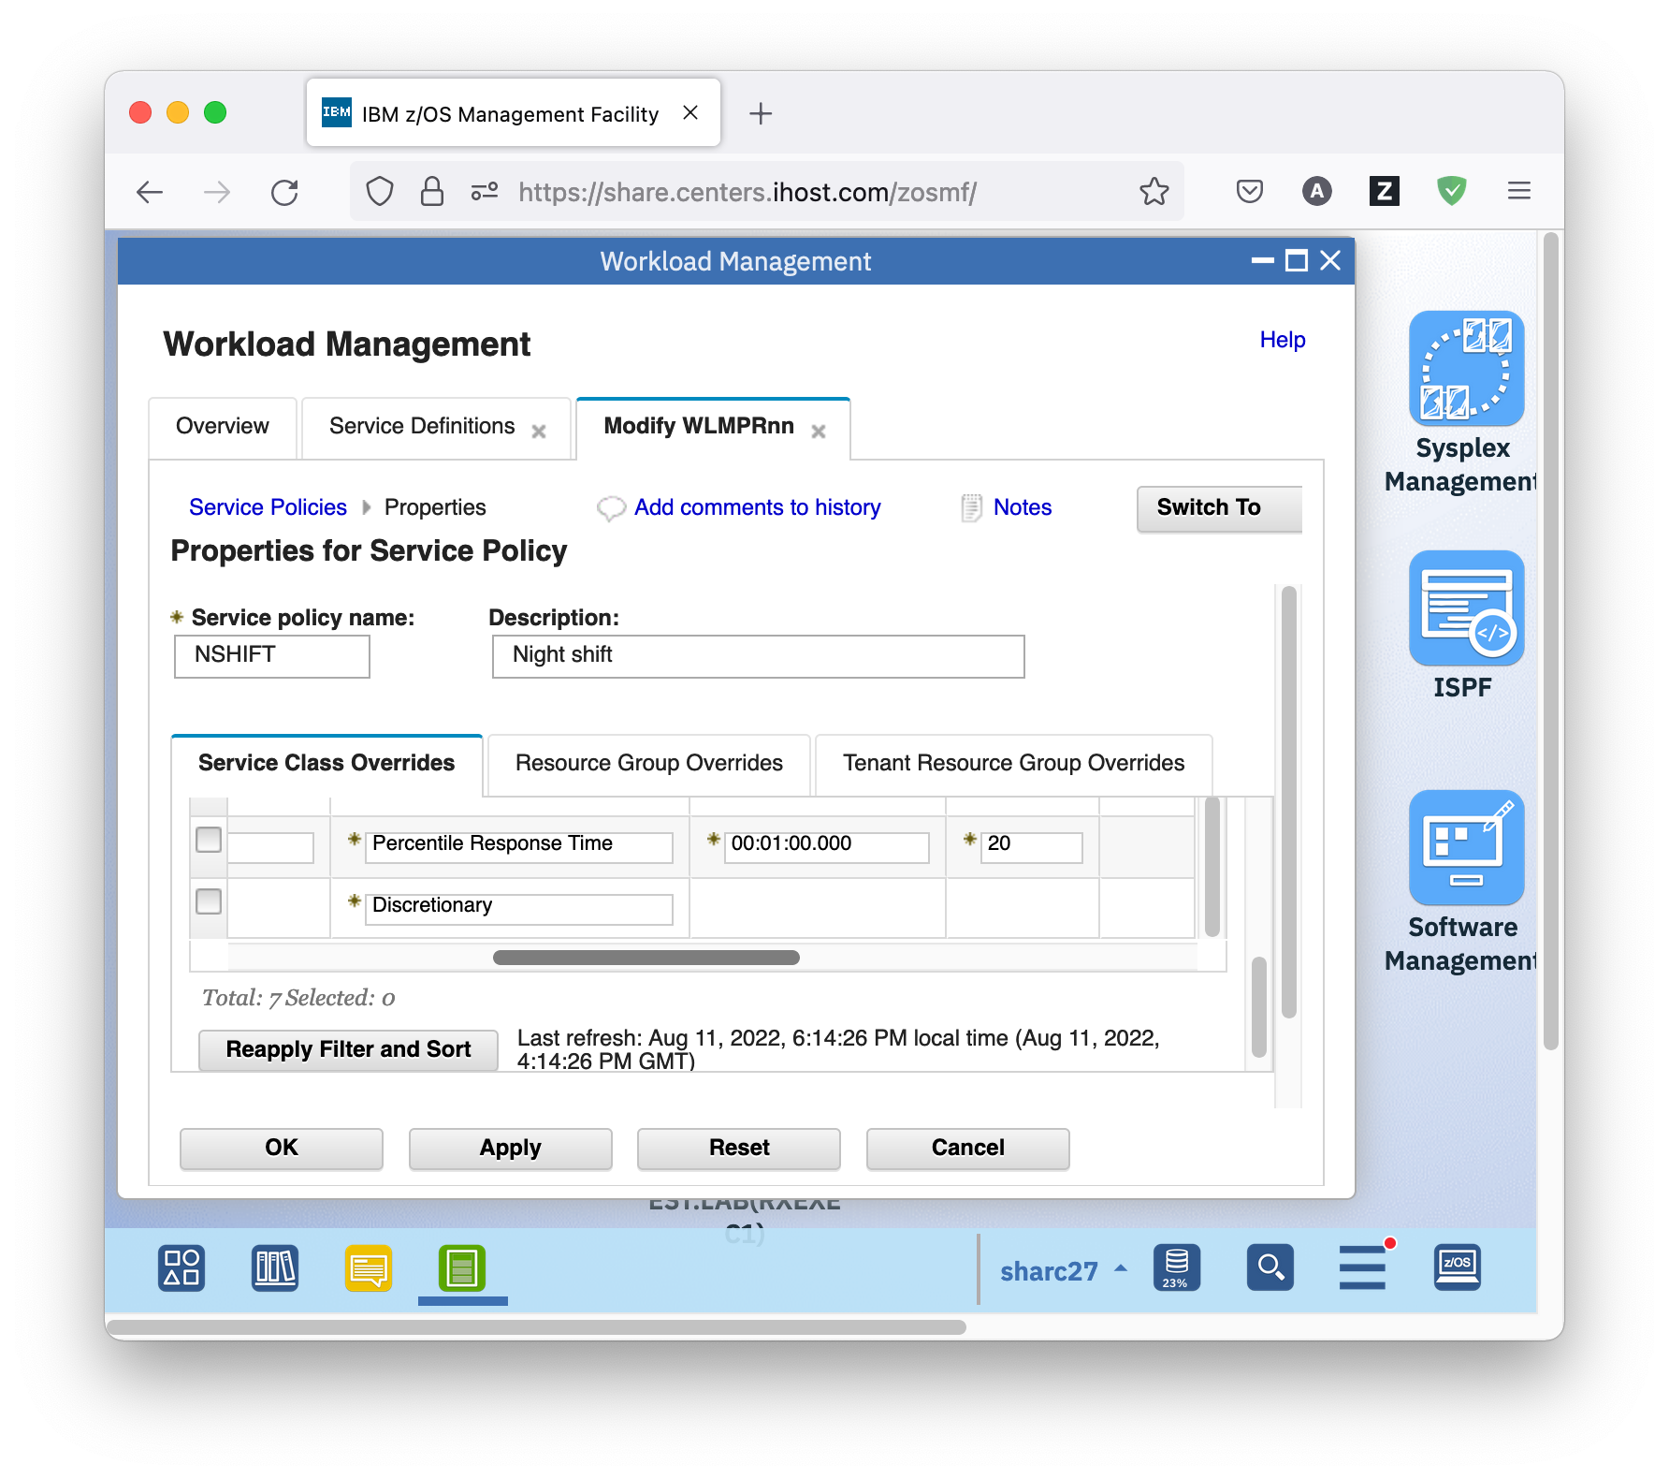

* Copy and paste even works between different service definitions. Now that you already are on the Service Policies tab, let’s add a new service policy copied from another service definition. To do so, on the Service Definitions tab, select service definition WLMTSTnn and either right-click it, or open the Actions menu, and choose *View Service Definition – Service Policies*. On the View WLMTSTnn tab that opens, select the day shift policy DSHIFT, and select *Actions – Copy To Clipboard*.

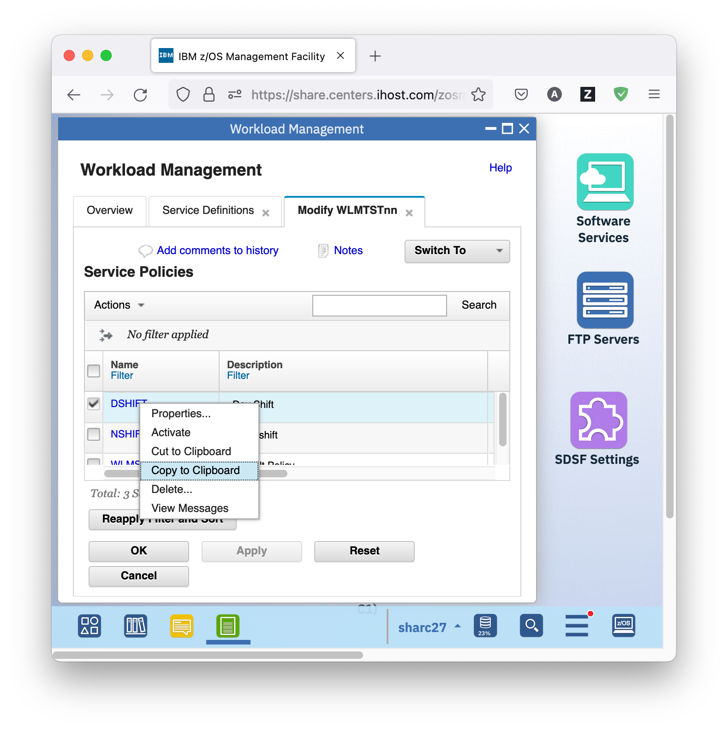

* Open the Modify WLMPRnn tab, navigate to the Service Policies tab by selecting *Switch To –Service Policies*. Then, select *Actions – Paste* to paste the new service policy DSHIFT.

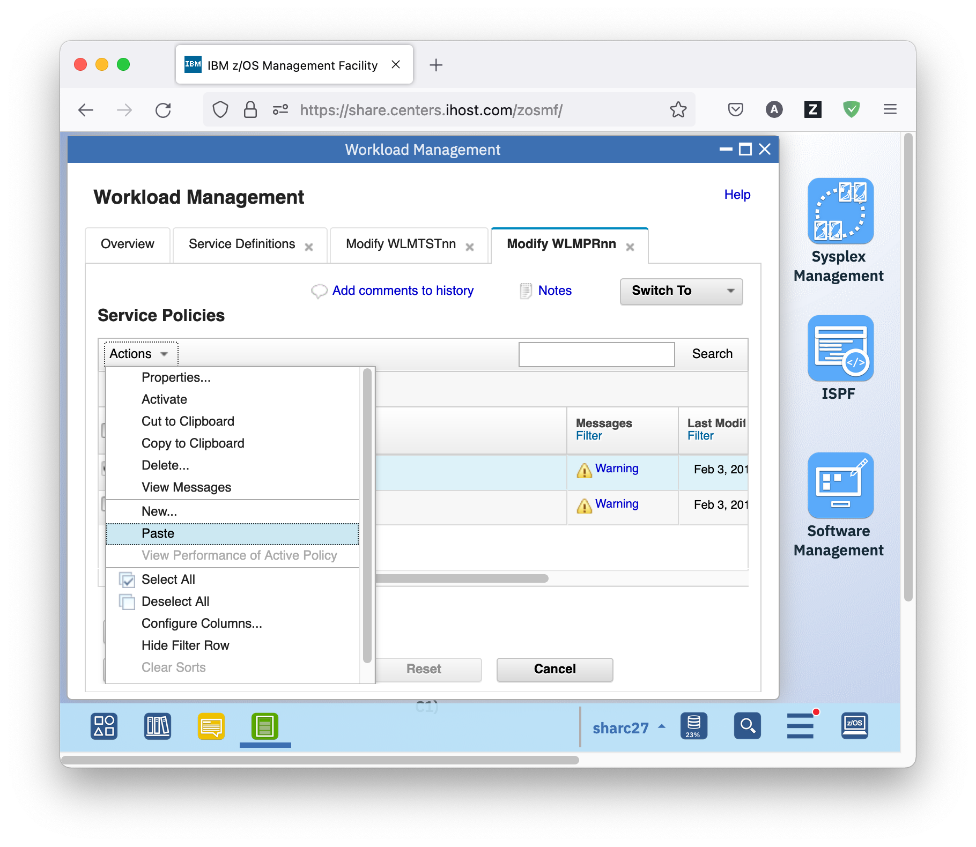

* Apart from this guidance, the z/OSMF Workload Management task also offers cross-referencing. So for example if you select a service class, you can view where it is used in the service definition, and which other items it references in the service definition.
* On the Modify WLMPRnn tab, select *Switch To – Service Classes* to switch to the service classes. There, scroll to service class ELPMAX, and select *Actions – View Cross References*.

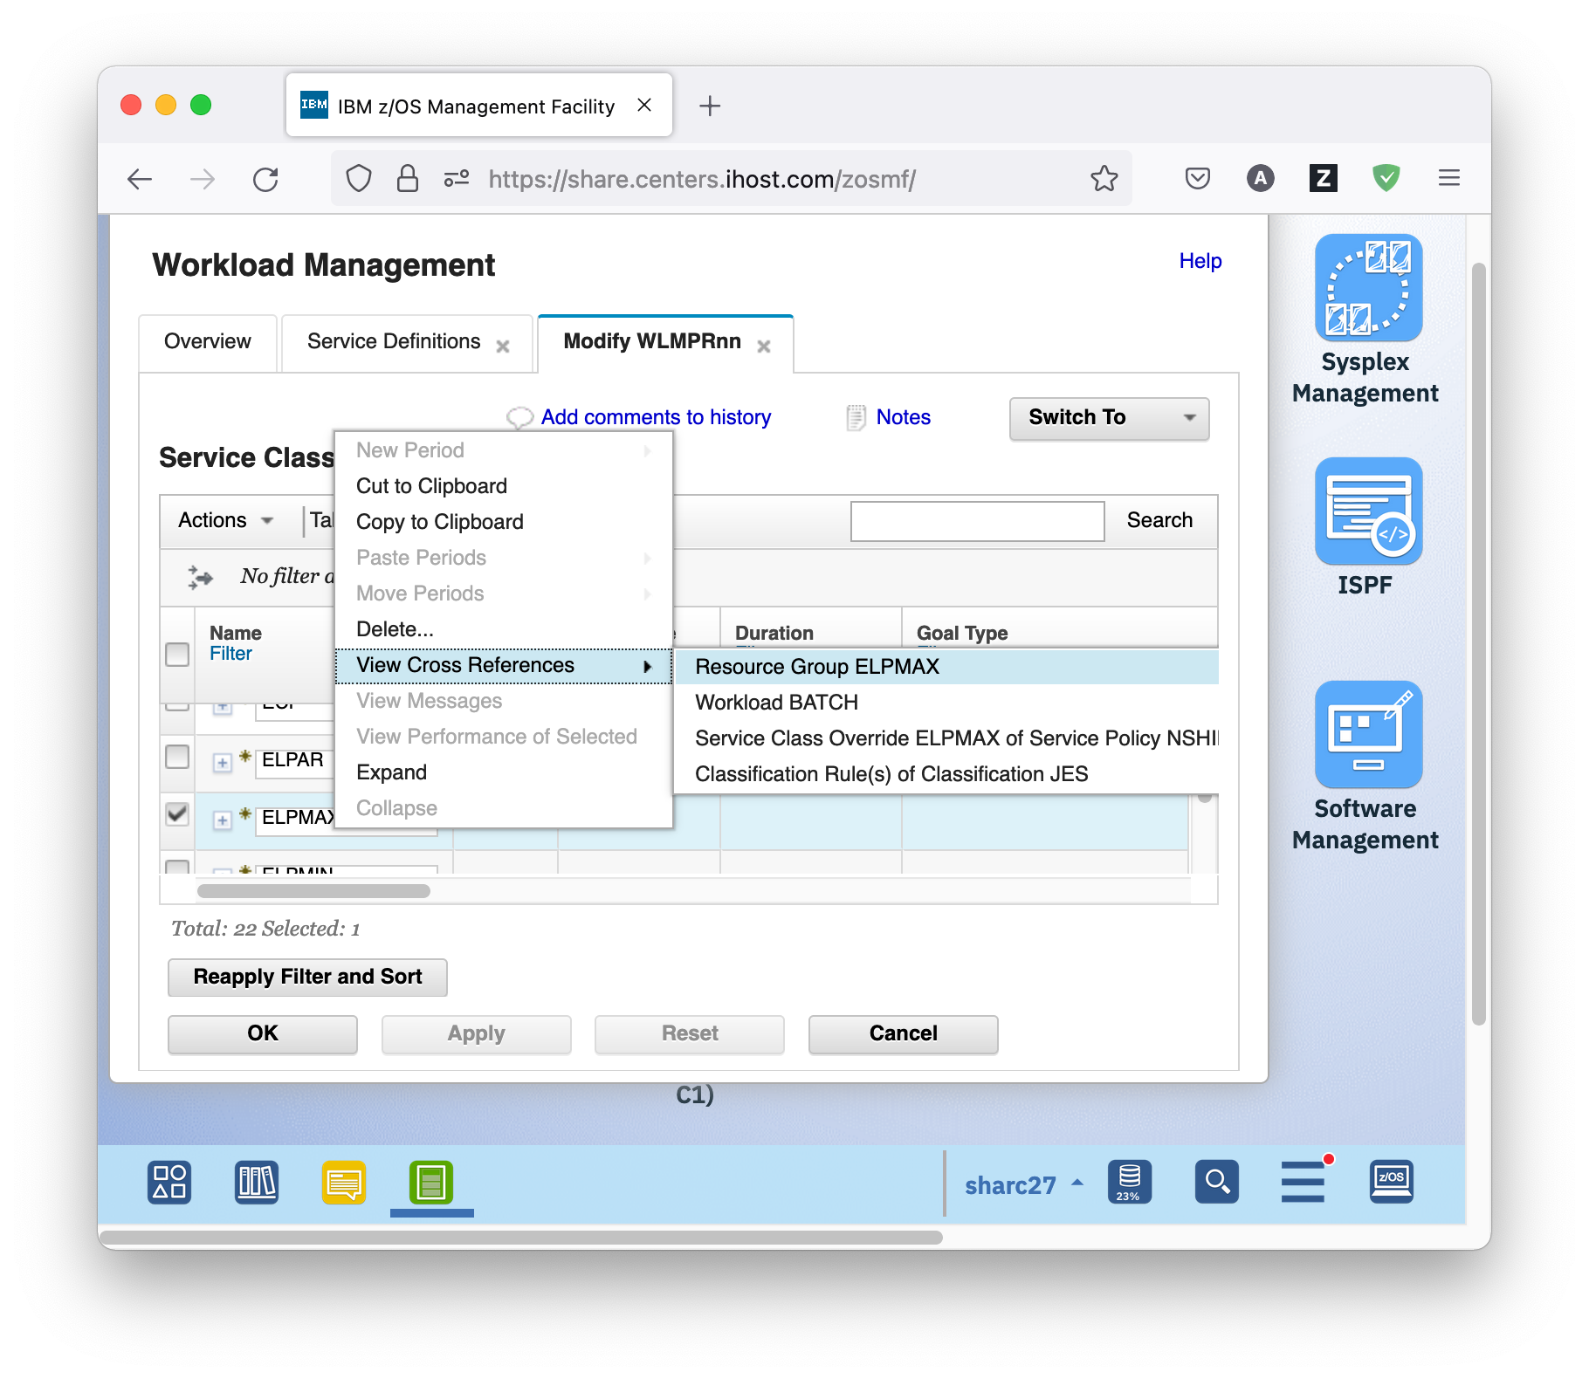

* The submenu that opens shows that service class ELPMAX is assigned to resource group ELPMAX and to workload BATCH, that there exist service class overrides for it in the night shift policy NSHIFT, and that it is used in classification rules for subsystem JES. Explore each of the entries. To get back to the Service Classes panel, use *Actions – View Cross References – Service Class ELPMAX* on each of the panels that opens.
* Press the OK button to permanently save the modified service definition and close the Modify WLMPRnn tab. You have to enter a comment for your modifications. Also close the View WLMTSTnn tab.
  1. Optional: Workload Management and Resource Monitoring

The definitions of Workload Management determine the performance behavior of the systems. Resource Monitoring visualizes the performance behavior. In z/OSMF, WLM and Resource Monitoring can be linked to each other. That is, when you work with your service definition, you can jump to Resource Monitoring to visualize the resulting performance, and vice versa, when you detect abnormal metric values in Resource Monitoring, you can jump to your service definition to look at what you have specified.

## Exercise

* The z/OSMF Workload Management task allows viewing the WLM status in the sysplex. To do so, on the Overview tab of the z/OSMF Workload Management task, click the *View WLM Status* hyperlink. The WLM Status panel opens. It shows the Active Service Policy in the sysplex and on each system in the sysplex as well as the service definition installed in the WLM couple data set. Basically, it is the same information as the *display wlm* console command provides.

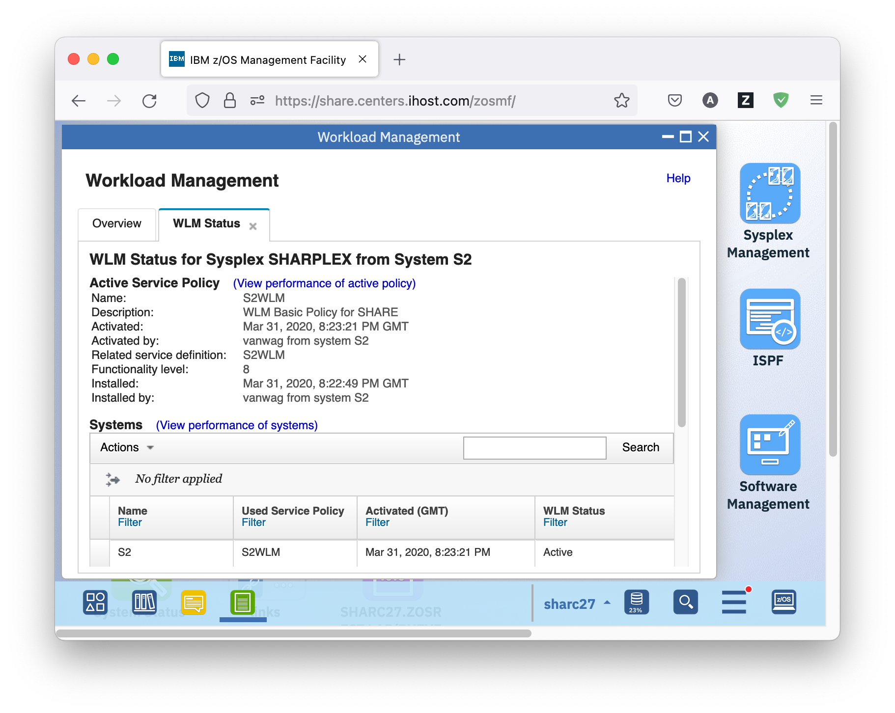

* Apart from this information, there are hyperlinks *View performance of active policy* and *View performance of systems*. The former enables you to view the performance of the active service policy, the latter the performance of the systems in the sysplex. If the links are not displayed a provider of appropriate performance data is not available. On our system, RMF is up and running, so performance data is available.
* Start with the *View performance of systems* hyperlink. This link opens the System Status panel that is also directly accessible under heading Performance in the navigation tree on the left hand side. The System Status displays z/OS sysplexes (and other system complexes) that are monitored in the Resource Monitoring task. In our case you will see at least LOCALPLEX and SHARPLEX.

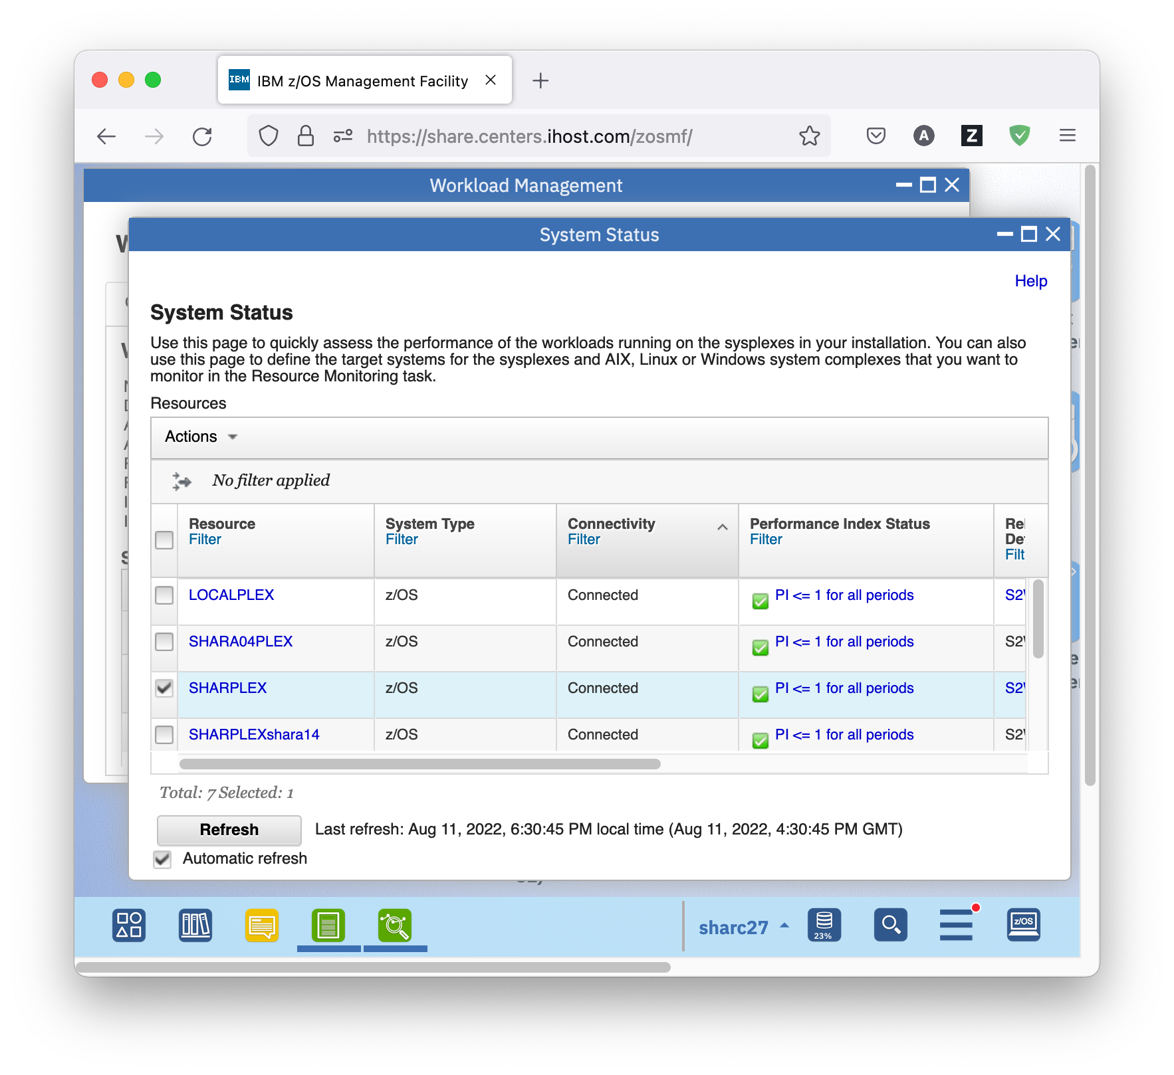

* The table displays the system type, connectivity to Resource Monitoring, the Performance Index Status, WLM service definition, and policy. The Performance Index Status gives an overall view how the system is doing. It indicates whether all or some of the service class periods are achieving, exceeding, or missing their goal. The status column can have one of the following values:
* PI <= 1 for all periods (green). The PI is less than or equal to one for all active service class periods; therefore, all of the active service class periods are achieving or exceeding their goals.
* PI > 1 for unimportant periods (yellow). The PI is greater than one for at least one service class period that has an importance level of three, four, or five; therefore, at least one unimportant service class period is not achieving its goal.
* PI > 1 for important periods (red). The PI is greater than one for at least one service class period that has an importance level of one or two; therefore, at least one important service class period is not achieving its goal.
* You can now view the performance index details for our sysplex, either by clicking on the hyperlink in the Performance Index Status column, or by using *Actions – View Performance Index Details*.
* The Performance Index dashboard that opens in Resource Monitoring displays the performance index for important active service class periods, for all active service class periods, and for report classes. You see that there is not much activity on the systems when I did the screen shot, this might be different during the lab session.

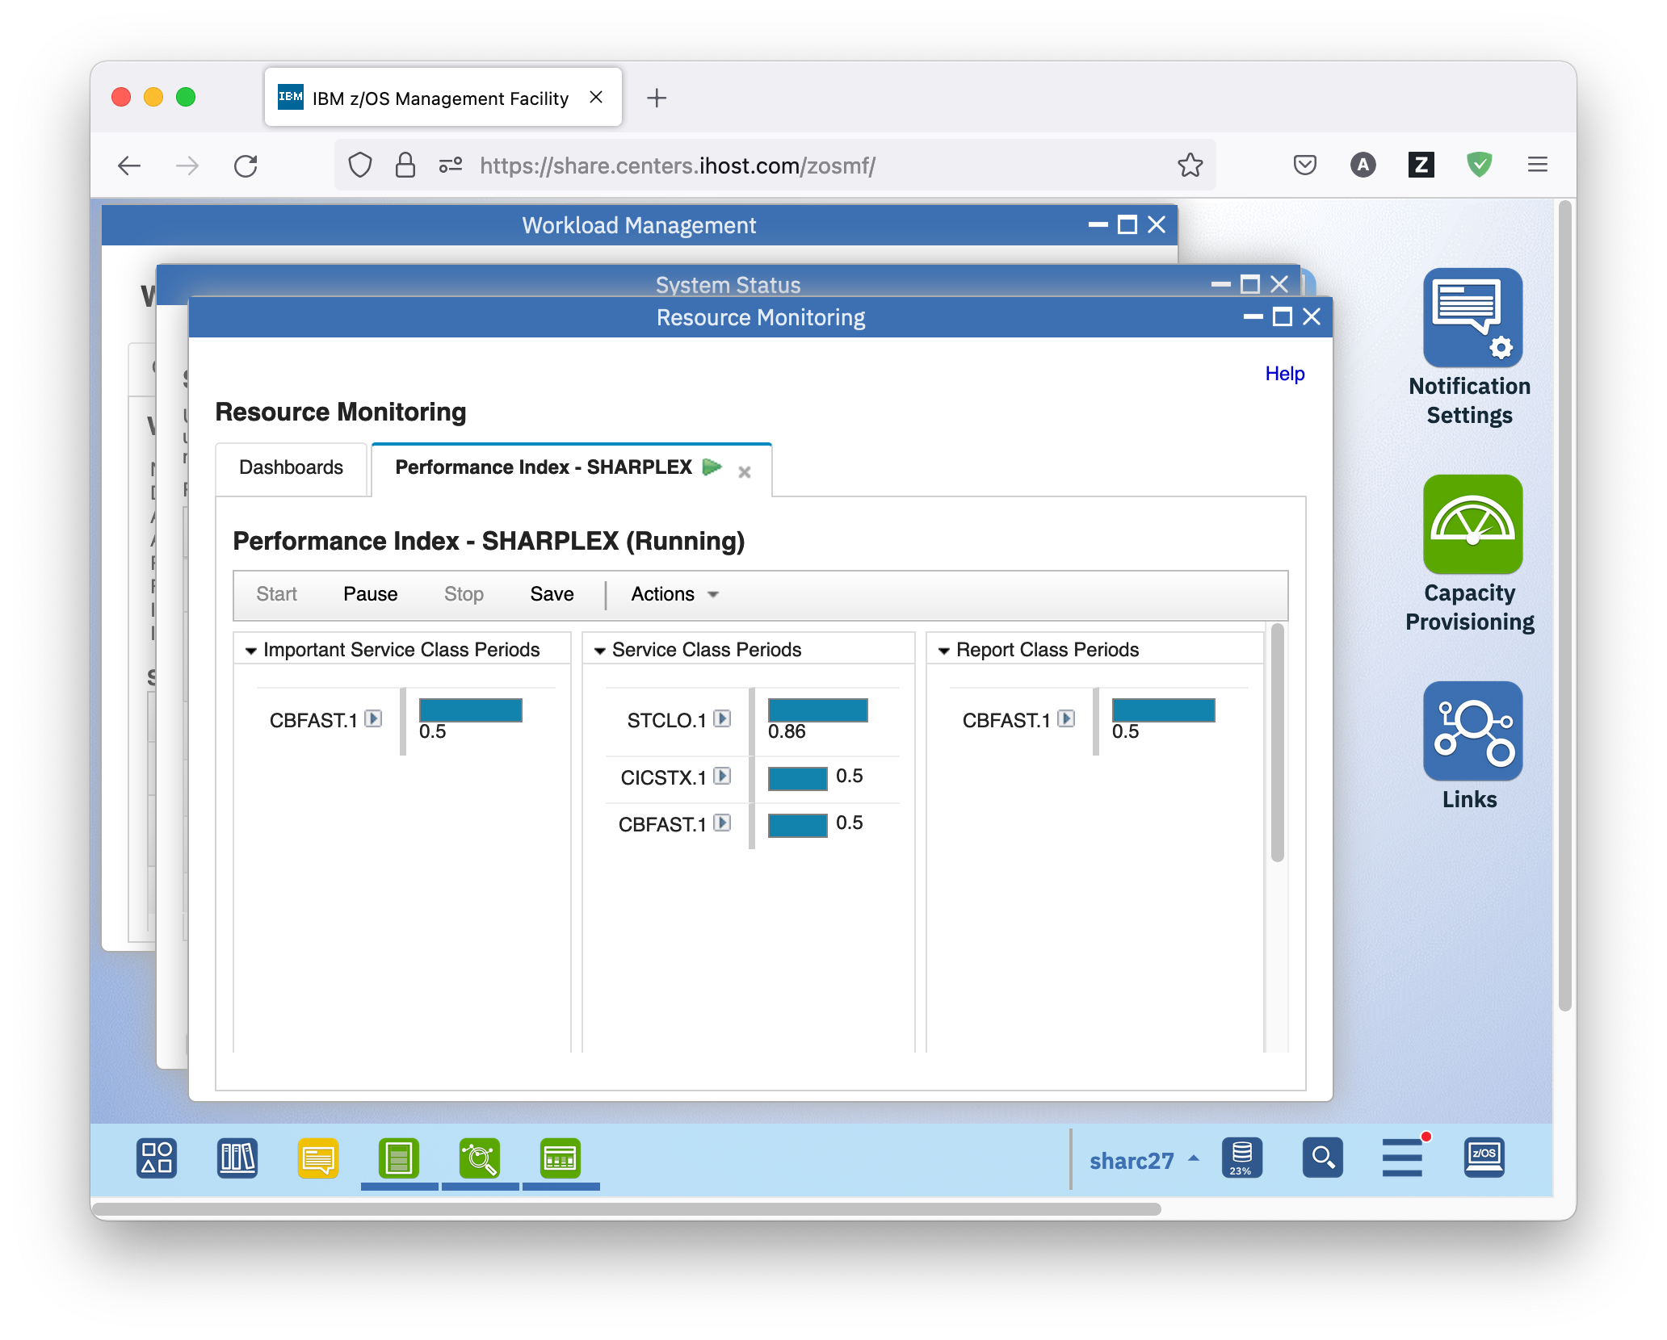

* When you click on the little arrow next to the service class name, you can view the service class definition in the active WLM service policy, and start thinking why the performance index is bad (if it is bad).

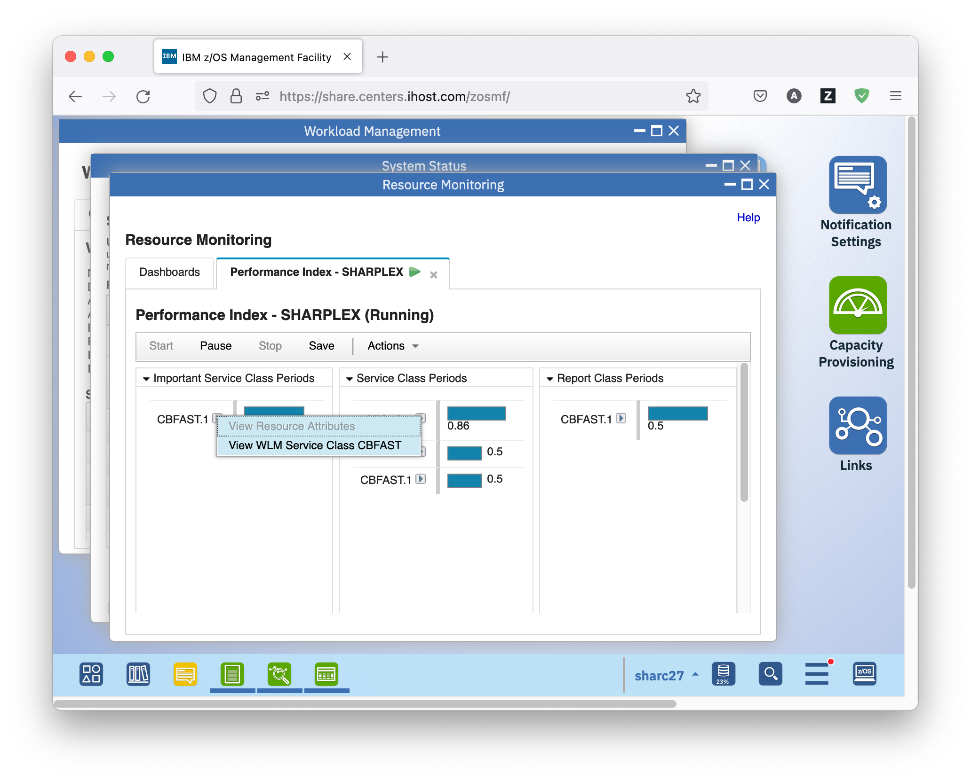

* From there, you can go back to Resource Monitoring by selecting *Action – View Performance of Selected*, to see more details about the performance index.

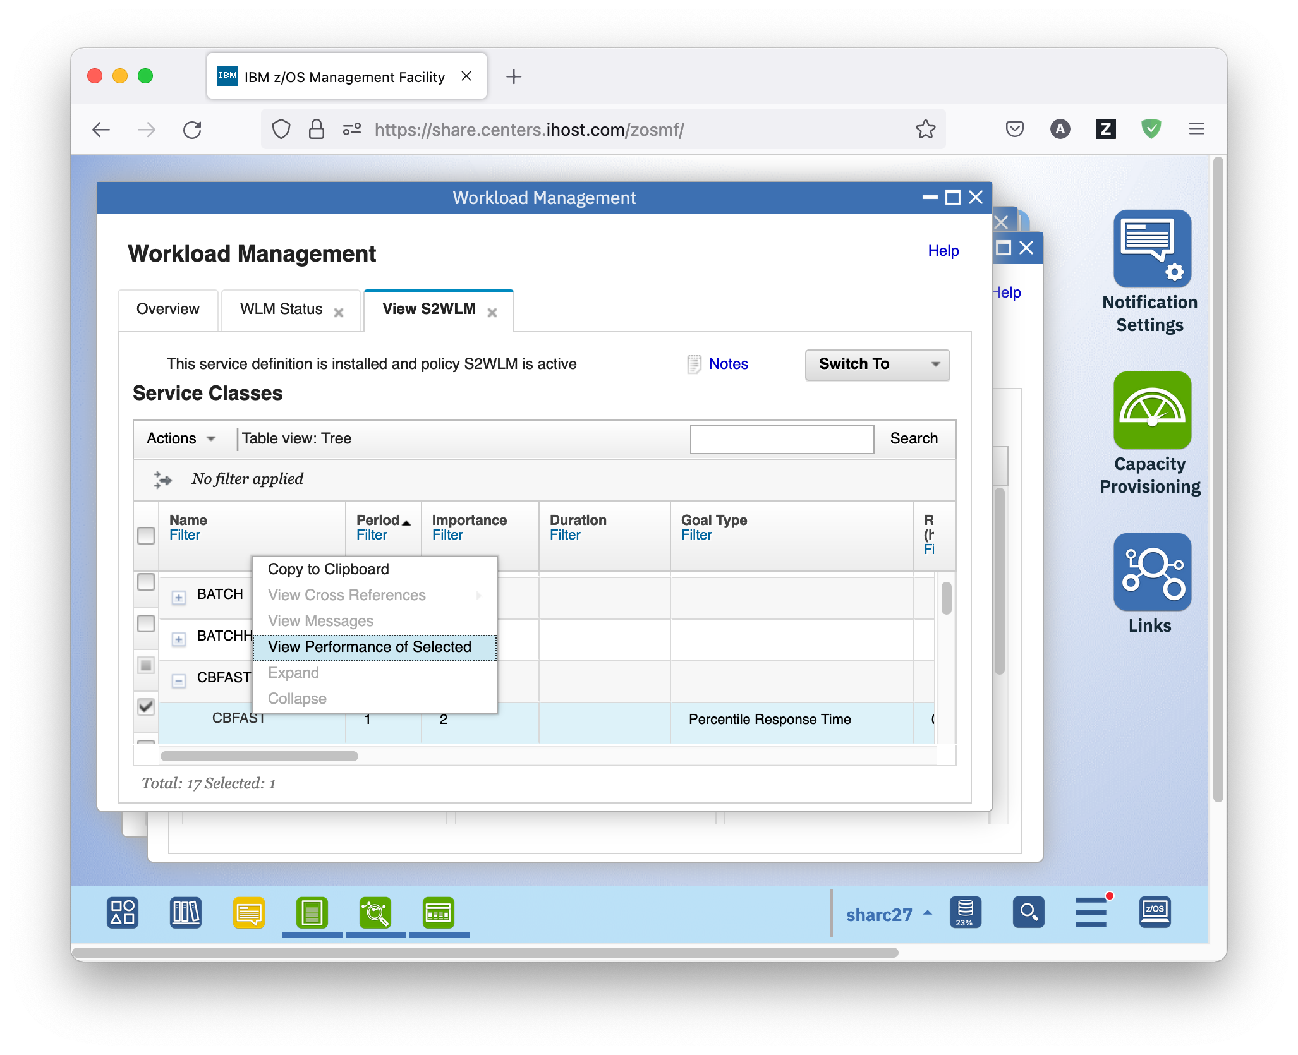

* The Resource Monitoring dashboard that opens displays more information about the performance of the selected service class. Because there was nearly no activity on the system when I took the screen shots, you see that the actual execution velocity of the service class is 100, which is way above the specified velocity goal of 80.

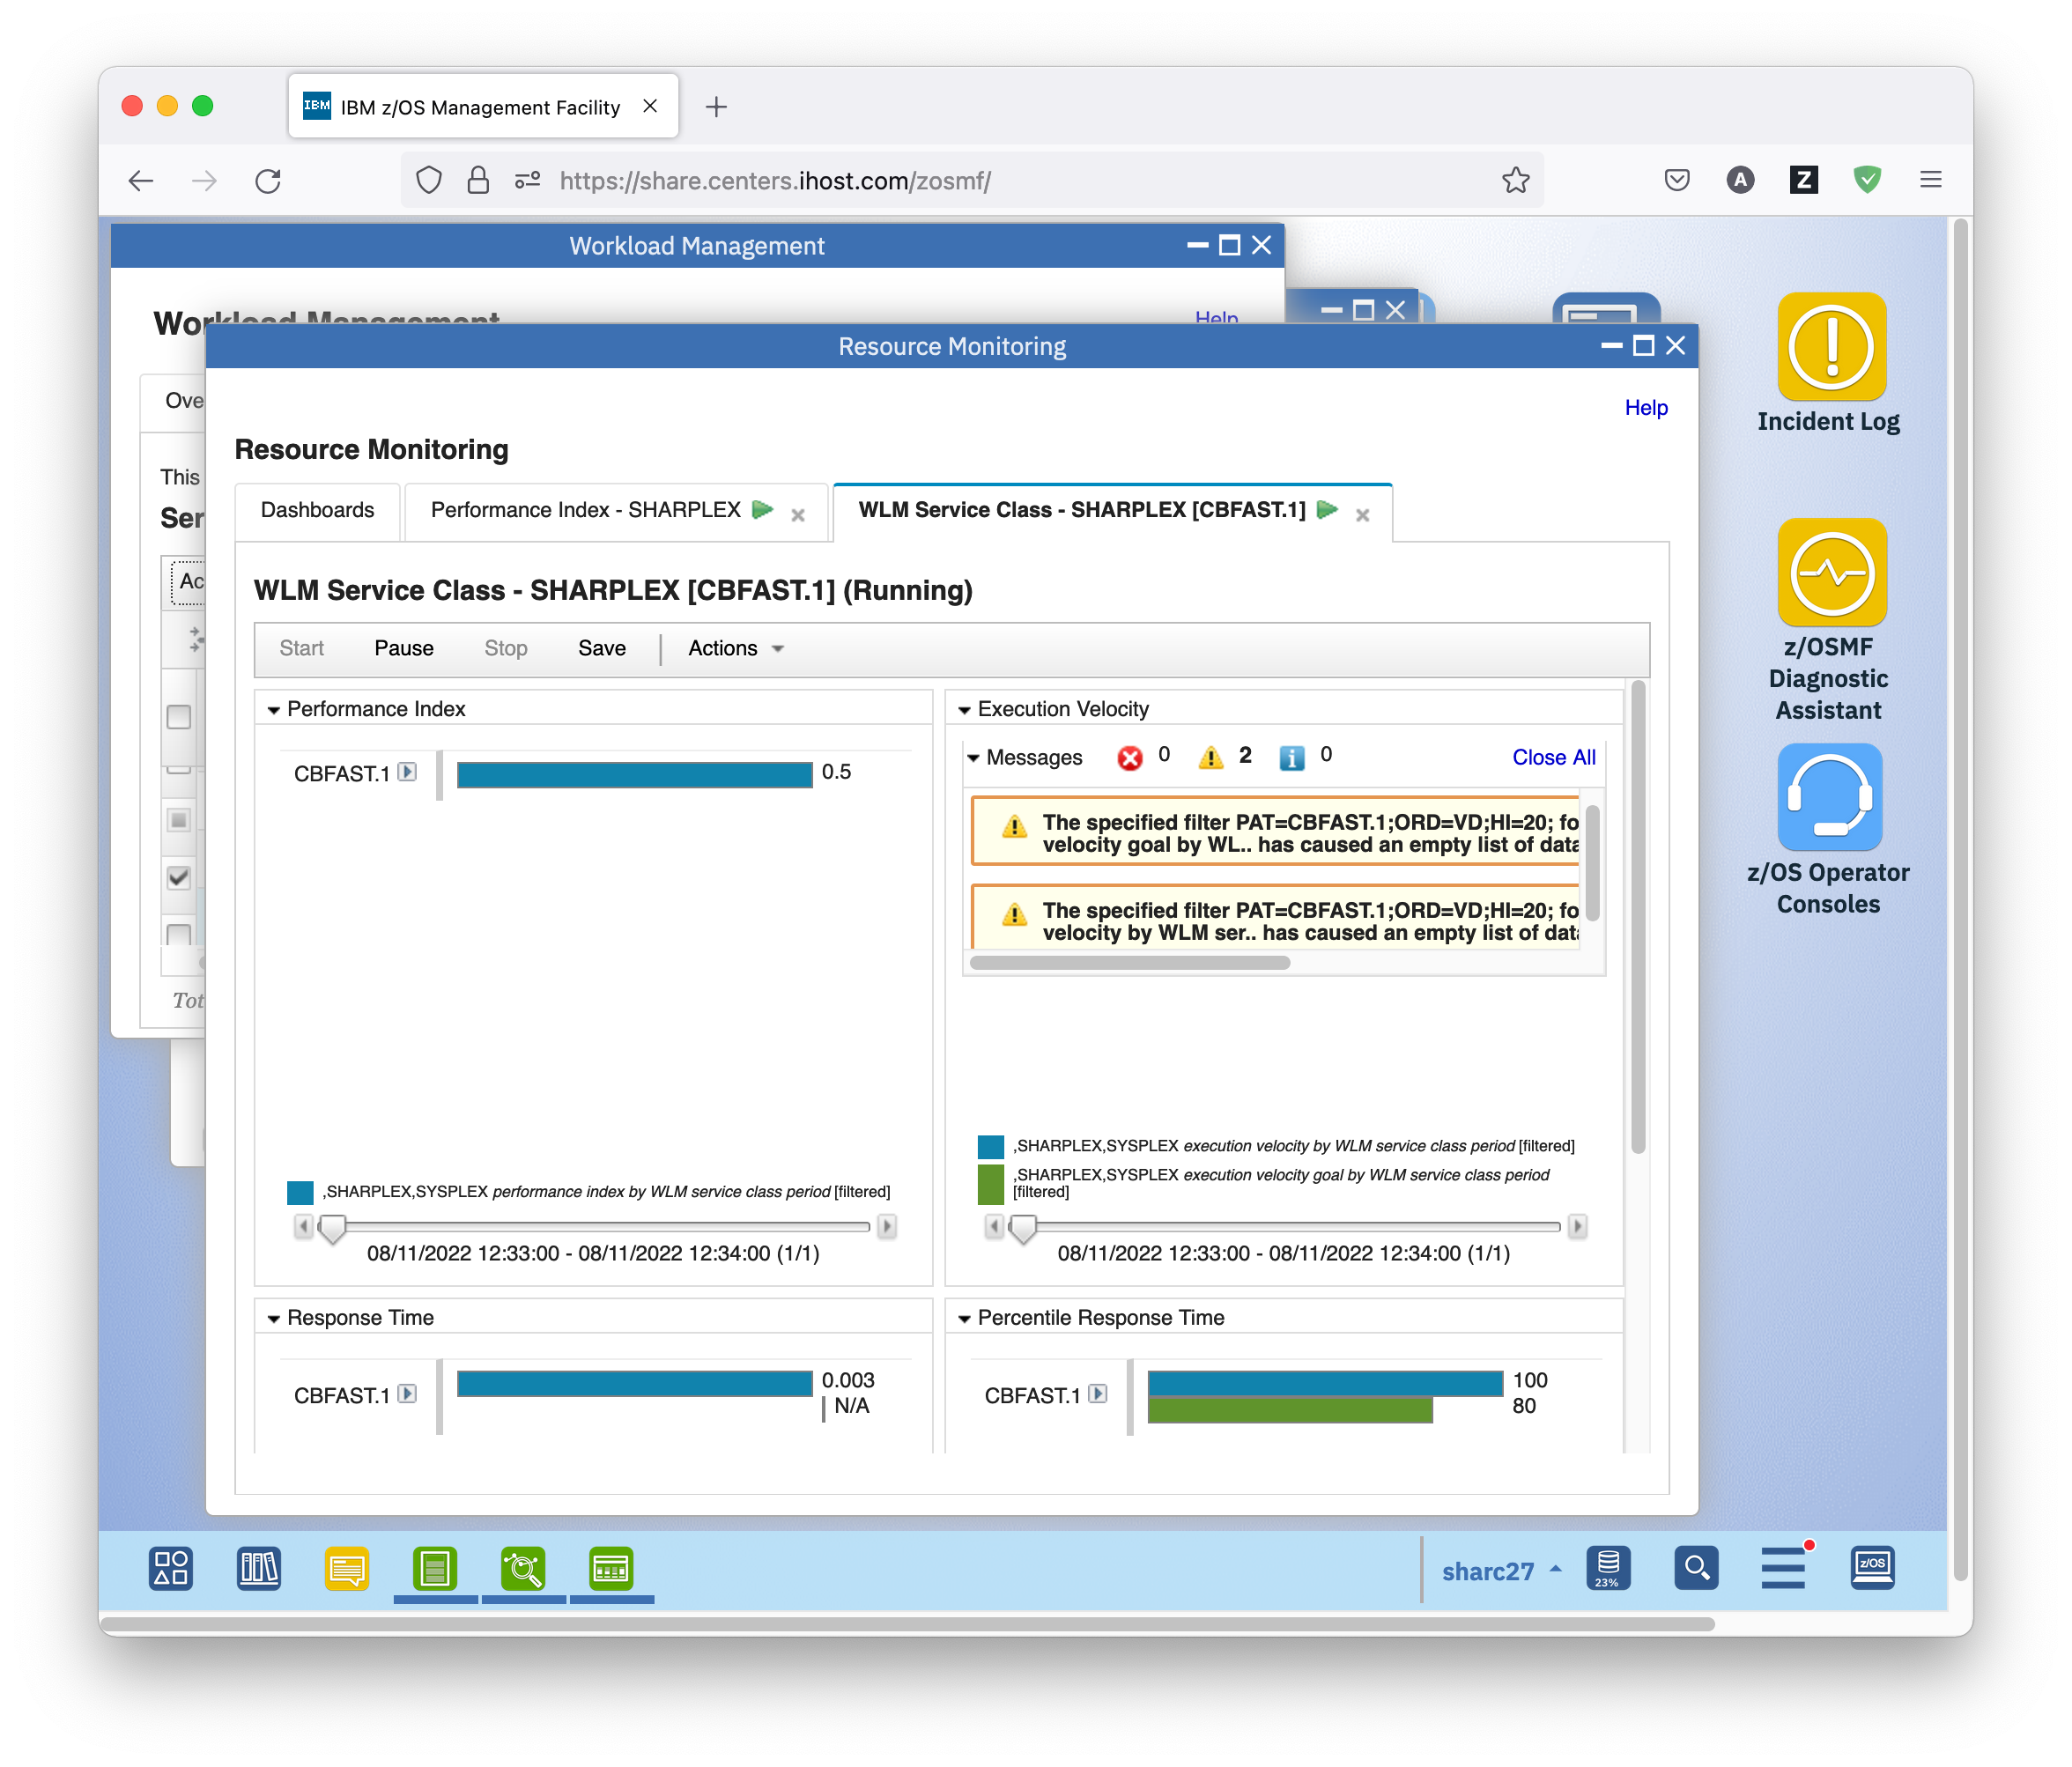

* Similar data is available for the active service policy. Go back to the WLM Status panel and click on hyperlink *View performance of active policy*. The Resource Monitoring tab that opens displays the performance index for all active service class periods, the execution velocity for velocity goals, the response time for average response time goals, and the percentile achieving the response time goal for percentile response time goals. As on the previous tab, you can get back to WLM by clicking on the little arrows next to the service class names, to view the service class definitions.

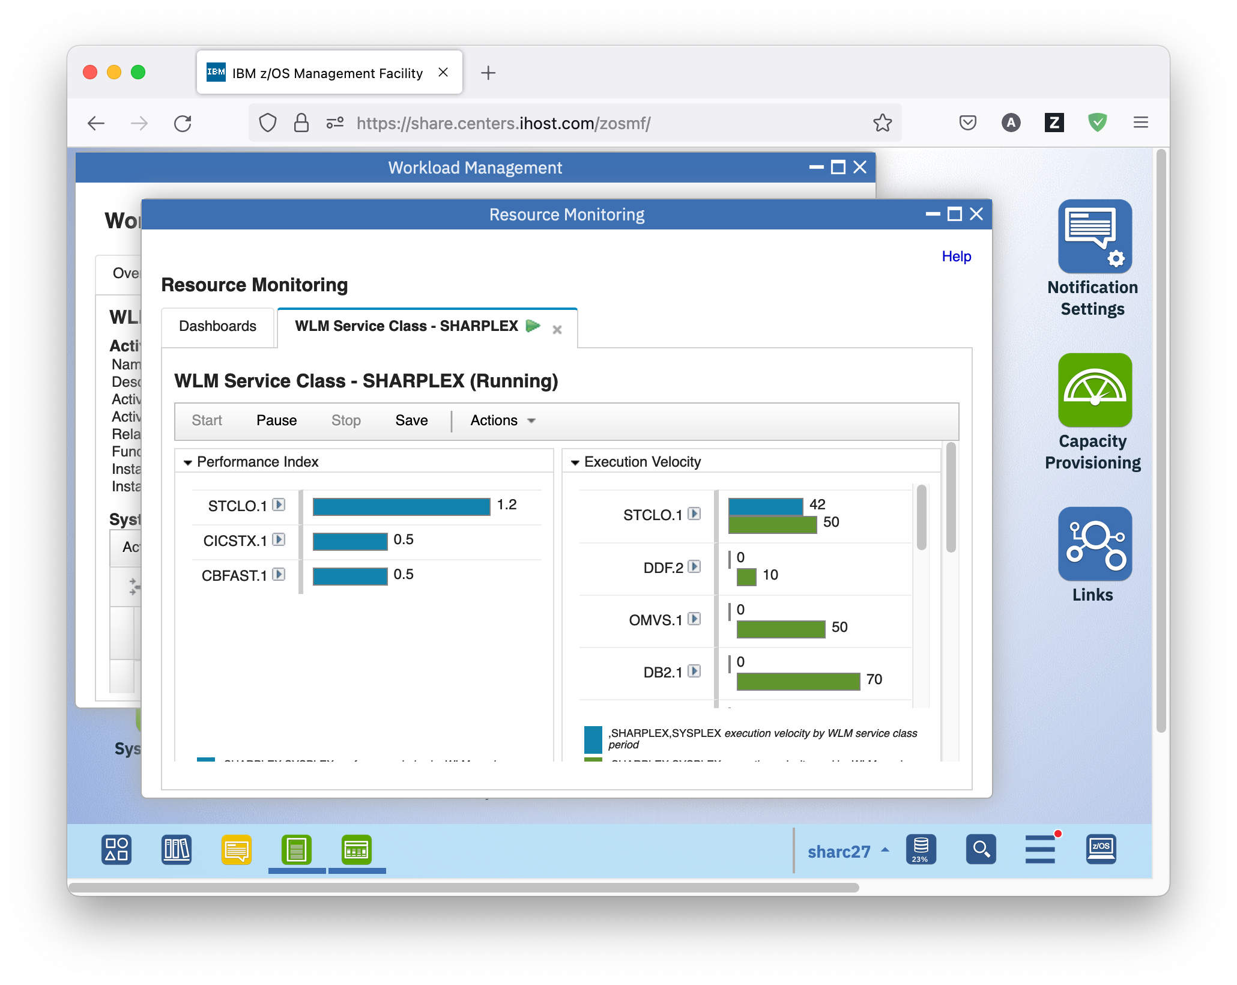

* Switching from the z/OSMF Workload Management task to Resource Management is supported for quite some entities in the service definition, for example the active policy, service classes, report classes, and workloads – watch out for actions *View performance of selected* and *View performance of all*.
* And back from z/OSMF Resource Management to WLM, watch out for the little arrows next to the names of service and report classes.
* Close all tabs that opened up, and do not forget to execute the cleanup exercise on the next page.
  1. Cleanup

In order to wipe out all of your traces for the next lab participants there is just one easy exercise remaining:

## Exercise

* In the Workload Management task, close all WLMPRnn, and WLMTSTnn tabs
* On the Service Definitions tab, select service definition WLMPRnn and either right-click it, or open the Actions menu, and choose *Delete*. A warning window opens where you need to confirm that you really want to delete the service definition. Click the *OK* button to confirm and continue.

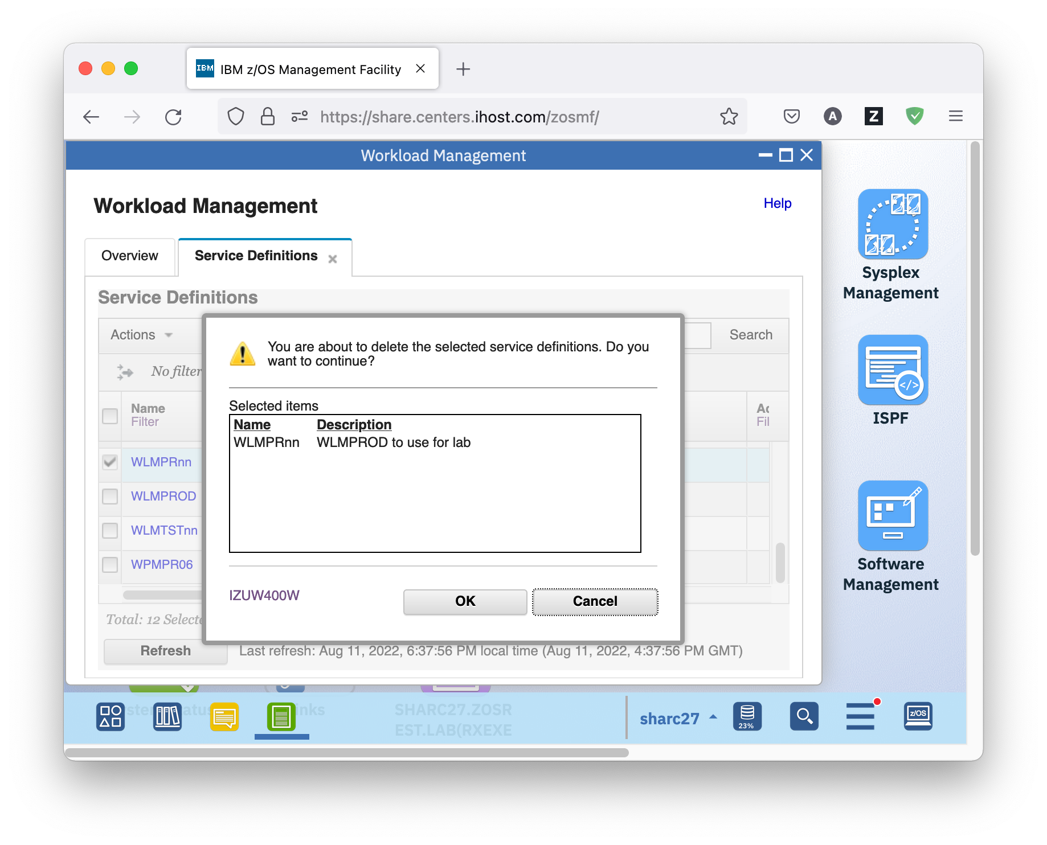

* On the Service Definitions tab, select service definition WLMTSTnn and either right-click it, or open the Actions menu, and choose *Delete*. A warning window opens where you need to confirm that you really want to delete the service definition. Click the *OK* button to confirm and continue.
* Log off from z/OSMF by clicking the *Log out* hyperlink top right